**A PROJECT REPORT ON**

**(Car Parts Application)**

**By**

**(Yousuf Mohamed Alzadjali, 18F17861)**

**Guided by**

**(Dr .Mounir Dhibi)**

**A Project report submitted in partial fulfillment of the requirements for the award of**

**(Bachelor) in (Software Technology)**

**MIDDLE EAST COLLEGE**

**Knowledge Oasis Muscat, Muscat, Oman**

**January, 2023**

# 

# A PROJECT REPORT

ON

(Car Parts Application)

By

Yousuf Mohamed Alzadjali (18f17861)

January, 2023

**DECLARATION**

I, “Yousuf Mohamed Alzadjali”, hereby declare that the work presented herein is genuine and has not been copied in part or in whole from any other source except where duly acknowledged. As such, all use of previously published work (from books, journals, magazines, internet, etc.) Has been acknowledged within the main report to an item in the references or bibliography lists.

**Copyright Acknowledgement**

I acknowledge that the copyright of this project and report belongs to MEC.

Yousuf Mohamed Alzadjali

18F17861

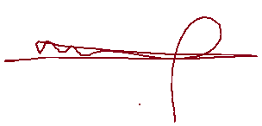

**APPROVAL FORM**

The project report entitled **Car Parts Application** Submitted by **(18F17861 Yousuf Mohamed**

**Yousuf Alzadjali)** Is approved in partial fulfillment of the Requirements for Bachelor’s degree

in **Software Technology.**

Supervisor

Full name

Department

Date:

Examiner

Full name

Department

Date:

**Ethics Approval:**

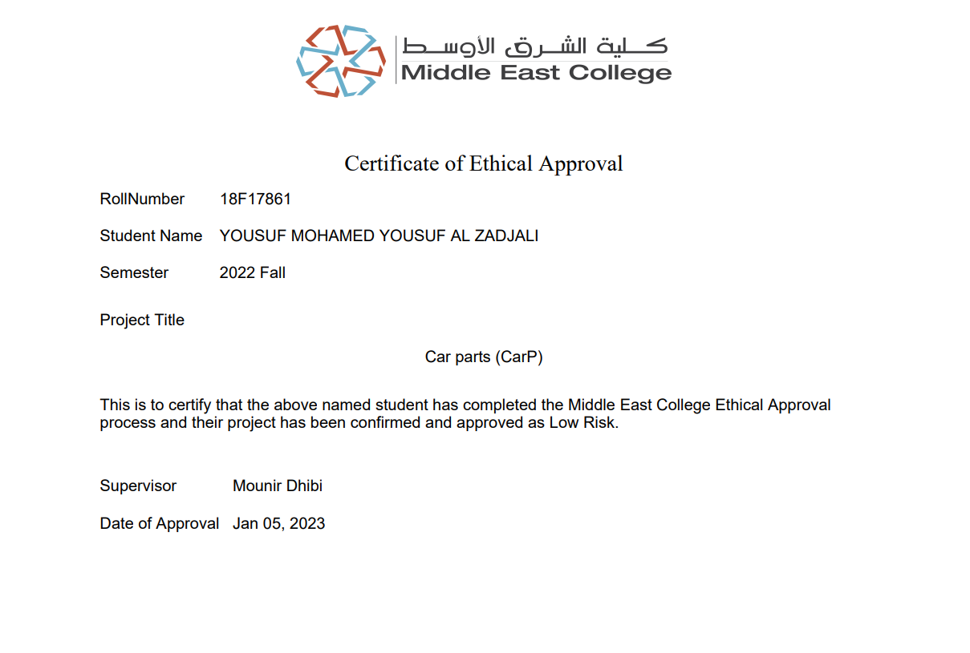

**ACKNOWLEDGEMENT**

The writer desires to express his most sincere appreciation and thanks to everyone who helps him for his encouragement and advice through the course of this study and for his help in the preparation and writing of this report.

Thanks go to the faculty members of Department of Computing and to the Head, Faculty of Computing for supplying the source of information for this work. Thanks are also due to Supervisor “Dr. Mounir” for successfully guiding the project work towards its completion.

**ABSTRACT**

this project has published to give the details of Car Parts Application and how the application will be helpful for the community, I advise the reader to take a look on the next pages carefully, regards.

**Table Of Contents**

Declaration2

Approval Form3

Ethics Approval4

ACKNOWLEDGEMENT5

Abstract6

**Chapter** **One**8

Introduction8

Problem Statement8

Scope9

Stakeholders9

Aims & Objectives10

Contribution 10

Points Of Chapter Two10

Chapter One Conclusion 10

**Chapter** **Two**11

Introduction11

Literature review11

Introduction Of Feasibility Study11

Feasibility Study12 & 13

**Chapter** **Three**14

Introduction14

Methodologies Type “Water Fall”14

Spiral & DSDM & SWOT15&16

Methodology used in details17

WBS & Gant chart18

Time Table 19

Data Analysis20 To 22

CarP Project Requirements 23 To 24

DFD 0,1 & Use Case & Flow Chart & Prototype25 To 29

**References**30 To 31

**Chapter one**

**1.1 Introduction**

As we know the cars are important in our life and every car must be care from the owner like changing the parts of the car the need to be changed and the oils , but many of people’s they don’t know from where they can buy the parts of the car , and many people who don’t like to go for searching parts because it’s takes a lot of time and they may can be cheated with non-genuine parts from the seller , so I have created this application that named CarP stands for Car Parts this application can give the user the easiest way to find there own car parts and all the parts are original from the agency itself and there will be an warranty for the parts , and the app will give new experience for the people’s who live in Oman because the application it can be used in Oman only and the payment will be only online and the customer after he\she will click on buy ,it will directly open the payment page and there will be all the payment process .

**1.2** **Problem Statement**

In general the problem are facing the people’s in Oman that there are no applications that can provide the car parts from the agency itself, and there are a specific problem that many of the sellers in Oman they sell unoriginal parts ,also many people don’t know the real prices of the parts.

Unfortunately there are consequences of buying unoriginal parts from the sellers because the parts can bring a high possibility to make an accident and the unoriginal parts can be damaged faster then the original, and the unoriginal parts can impact the agencies of the cars because most of people will prefer to buy a cheep parts because they don’t know the consequences.

My suggestions that the people’s must buy the parts from trusted shops not from any shop , and the agencies must give aware for the community to not buy the parts from anonymous shops and sellers , and that’s why I have created this program , to make the people’s buy the original parts .

The application that I have created it will solve the problems that I have talked about it , because the parts that I will sell it it’s from the agency itself and the prices it’s the same if you will buy it from the agency directly , and my application will avoid the cheating on car parts , the app will be cash less because the payment process will be online only ,Debit or visa.

There is an a website that provide the car parts in China and it’s name is auto spare parts and if have different feature as my application has and but in our country there are no application that give the same service that my application provide and that’s why my application is unique.

**1.3 Scope**

The application will impact the people’s who want to buy car parts for there cars and the community will get the benefits from the application .

The expectation of the duration that it will take four months and the working on the application will start in February 2023 and it will finish in may 2023 .

The application will cost me above 1500 Rial Omani , because will pay for the programs that will help me to develop my application and my project in general .

I will use android studio to develop my application (CarP) and for sure I need to use a server to save and store the information for the customers ,so for that I will use SQlite for the database .

CarP will have many functions that can help the user to make buying car parts easier , the first page in the application will show the user if he need to register the application should create a username and password and he have a he already have an account it will bring him to other page that can write his username and password ,after entering the application successfully the second page will be the home page that have a list of the parts of different types of cars and when he will click on any type of the parts ,the application directly will enters him to the details page that include the details of the parts ,like the model of the part and the price and so on ,in details page there are button named as buy , when the user will click on it the app will open the payment page to complete the payment process .

**Stakeholders 1.4:**

In my application there are many stakeholders , the first stakeholder is the customer and it can be impact by the decision that I make because they need a high quality products with low price ,and also the government because they take a tax and that depends of how much I get in a year , and the owner also a stakeholder and there are the suppliers (car agencies) and the last one is the manager.

We have two types of stakeholders ,the first one is internal and I have an examples , like the owners and the second type is the external ,like the customers, government and the suppliers(car agencies)and the manager .

|  |  |
| --- | --- |
| **Internal** | **External** |
| Owner |  |
| Manager |  |
|  | Customers |
|  | Government |

**Interfaces 1.5:**

CarP application can work in android operating system .



**Aims and objectives 1.6 :**

This application will provide for the customers the easiest way to buy parts for there cars and the second aim for this application that the program will be available in all the cities of Oman ,and the objective of this application is that I will provide a special experience for the users those will enter my application ,and it’s a secure app for the customers to buy from it .

**Contribution 1.7:**

CarP application will improve the sales of the agencies in Oman and the customers will be very comfortable when they use the application because the parts are original and the app it’s secure .

**M1.8:**

In chapter two there will be the feasibility study and I will describe the types, chapter three there will be comparing between the methodologies , in chapter four there will be a use case diagram ,in chapter five there will be the codes and an introduction for the system itself , in chapter six there will summarizing for the work and discussion for the application .

**Conclusion:**

In conclusion. The app will be helpful for the customers and the community itself and they will find less prices and easier way to buy parts.

**Chapter Two**

**Introduction:**

CarP application can give an easier way to buy a car parts from online and there are many features the application provided ,

In this chapter I will talk about the applications that have the similar things of my application and I will talk about four applications or websites and after that I will use five sources that can help me in my application ,after that I will talk about the Feasibility analysis and I will describe the cost of the all the things that I will use it in my project .

**Similar Work:**

(Carparts.com2018) have created for American people’s and there are many types of car parts with different types and there are also accessories after market ,and the second website it’s named (online car parts 1969, December) and they give a lot of features for the customers in UK but they don’t have an original parts from the agency exactly but they have after market parts and also they have oils for different brands . Rock Auto they provide the car prats plus the tools that you need it to fix your car but they deliver only in America and Canada, car-parts.com this something different because they provide parts the used before and also they don’t deliver to middle east .

**Literature** **review:**

The reason that I have created this application is that there are no application in Oman that sell car parts and most of the websites that sells a car parts they don’t deliver in Oman ,the differences between my application and other different websites and application that I will bring the original parts and the location of the company will be in Oman so that can in one come and take his parts without needing to go to another country to search for the part that you need.

**Feasibility study:**

The feasibility study it’s like a details for analysis to check if the project will success or not , although the feasibility study can check if the work will success or not but the manager should check from all the sides if it will work or not and after that the manager will make the decision ,we have different types of feasibility analysis like the technical feasibility and it’s focusing on the technical resources ,and there are economic feasibility it’s all about the cost and how much that will cost and so on ,and there are legal feasibility it’s to check if the project respect the rules or not and if it’s legal or illegal ,there are also the operational it’s used to see how the project going on with everything .

**Feasibility Study**

**Hardware tools:**

|  |  |  |  |  |  |
| --- | --- | --- | --- | --- | --- |
| No. | Hardware Device | Model | Usage | Quantity | Cost |
| 1 |  | Brother DCP-L3551CDW -Wireless connectivity | For print all chapters . | 1 | 115 R.O |
| 2 |  | Samsung phone | To install the app on it | 1 | 75 R.O |
| 3 |  | Flash Memory Stick 32 GB | To store the project files | 1 | 3 R.O |
| 4 |  | Dell -latitude | To use it to create the app | 1 | 250 R.O |
| 5 |  | SanDisk Portable SSD 1TB | For saving my work | 1 | 49 R.O |
| 6 |  | Pens | To write notes | 4 | 1 R.O |
| 7 |  | Papers | To write notes | 1000 | 15 R.O |

**Software tools:**

|  |  |  |  |  |
| --- | --- | --- | --- | --- |
|  | **Software** | **Model** | **Description/Use** | **Cost** |
| 1 |  | Photoshop | To design | 4 R.O |
| 2 |  | Android Studio | Create the application | free |
| 3 |  | Office 365 | -Word  -PowerPoint  -Excel | 39 R.O |
| 4 |  | YouTube | To learn more about android studio | free |
| 5 |  | Google chrome | For searching purpose | free |

**Total Price of hardware tools = 508 R.O**

**Total Price of software tools = 43 R.O**

**Total price after feasibility analysis = 551 R.O**

**Chapter Three**

**Introduction:**

In this chapter I will chose the methodology that I will use it in my project and I will compare between them to see what is better to my project and will use questionnaire for my project and I will include some questions to see if the application is helpful for the community or not and I will share the questionnaire by the internet for 30 person and I will ask them personal questions at the first ,like the name ,last name and the what they have studied , at the end I will design some basic pages for my application .

**Methodology:**

**Water Fall:**

Water fall used to divide the project in different parts or phases and any phase have his own process or work , in waterfall when you will start the phases you must to complete the phases one by one but if you didn’t you will not able to complete your work unless if you will complete the phases one by one ,in any methodology we have advantage and disadvantage ,so the advantages of water fall is that water fall is perfect for the small projects because it’s declare everything and it’s great for the basic projects and also you can do the changes during you are working in the project ,and the disadvantages of this model it’s that if you faced any errors you can fix it during the phase only and you can’t do it later or after doing the all phases .

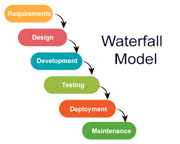

**Spiral Model:**

The spiral model have four different phases and any one of them have different work and different process and there are some requirements to start the spiral, like if you have a new system and you want to work on it you must collect information about it and write details as much as possible , and the advantage of spiral is that it’s perfect for the projects that have large size or for big projects and also it’s used for high risk projects , disadvantages of spiral is that it’s not good for the small projects and it’s very expensive for the small projects and also the projects that have low risk it’s not suitable for them .

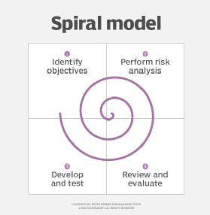

**SWOT:**

**DSDM:**

In DSDM there are principles like demonstrating the controlling and it have something special that they can deliver the work on time but also there are some of disadvantages like there must be a complete or full app of the principles and DSDM it’s not the perfect methodology for the large projects .

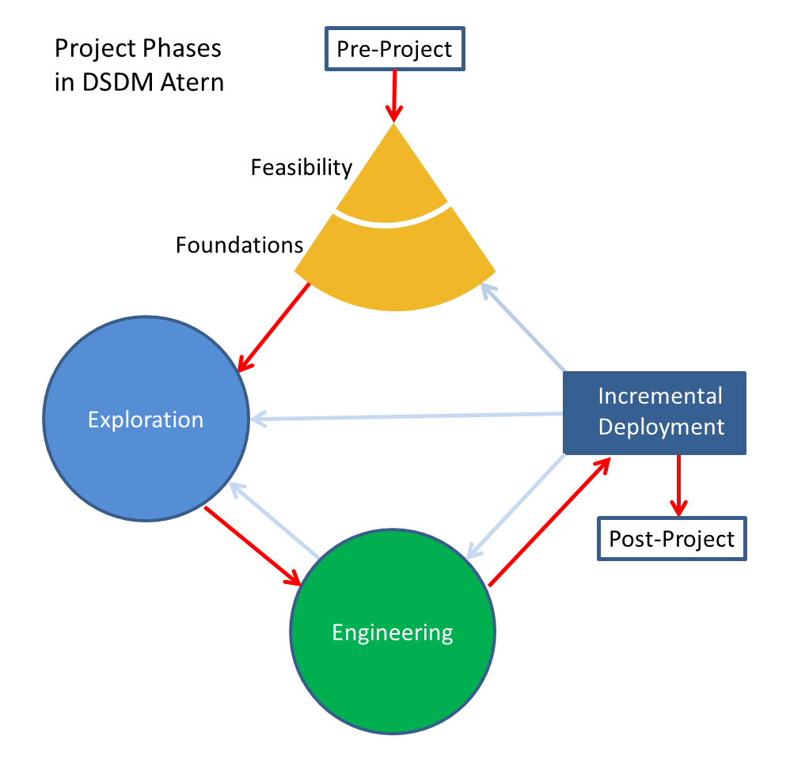

|  |  |  |  |  |
| --- | --- | --- | --- | --- |
|  | **S**trength | **W**eaknesses | **O**pportunities | **T**hreats |
| **Waterfall** | High | Normal | High | Low |
| **Spiral** | Normal | Normal | Low | High |
| **DSDM** | Low | High | Low | Normal |

**Choosing the methodology:**

I will choose **waterfall** because it’s perfect for small projects and my projects is small and there no a lot of risk on it and the strength are high and opportunities are high also, the threats are low because there no a lot errors.

**Describing Waterfall Stages:**

In waterfall we have six phases that the project will be use it, the first step in the waterfall is the analysis phase and every methodology they start with analysis phase, this phase to know more about the requirements and do the feasibility study for the project itself to know how much the project will cost.

The second phase is the design, this phase to design the app based on what we have done in the requirements and do the designing phase based on the requirements or the analysis phase.

The third phase is the implementation or development, it’s used to work on the software programing to create the app or the project and.

The fourth phase is testing and it’s for test the program if it’s okay or it’s need to recheck again and if it’s okay and there no issue it will go to the next phase.

The fifth phase is deployment and it’s that the organization will deploy the app and the people’s can use it, and the sixth phase it’s for the maintenance, it’s mean if there any issue in the app the organization will maintenance the app.

**What is Project Planning?**

Project planning it’s like a stages that used to know everything about the project like finding a resources ,doing a survey to see the community opinion about the project and also making feasibility study t know how much the project will cost and calculating the hardware and software needing.

**The Communication between stakeholders and the users:**

|  |  |
| --- | --- |
| Contact way To CarP | Social Media |
| Phone Number | Instagram App (CarP.OM) |
| Email | Twitter App (CarP.OM) |

**WBS Of Project Planning:**

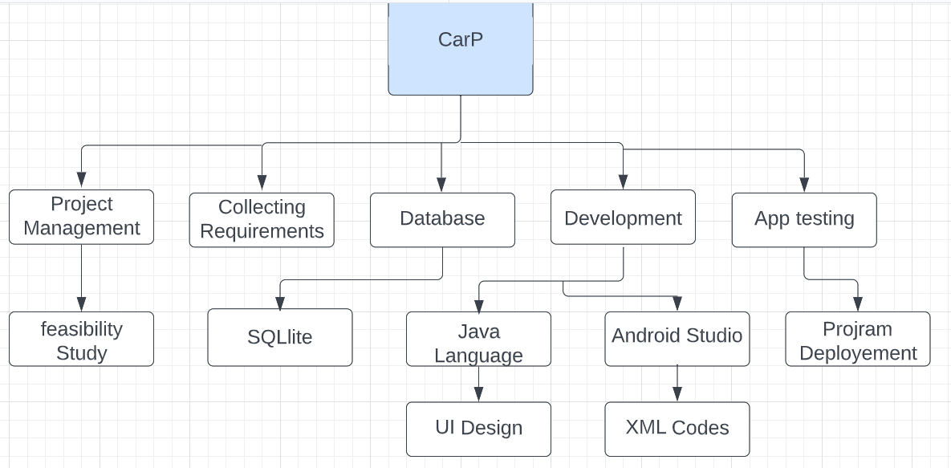

**Gant Chart :**

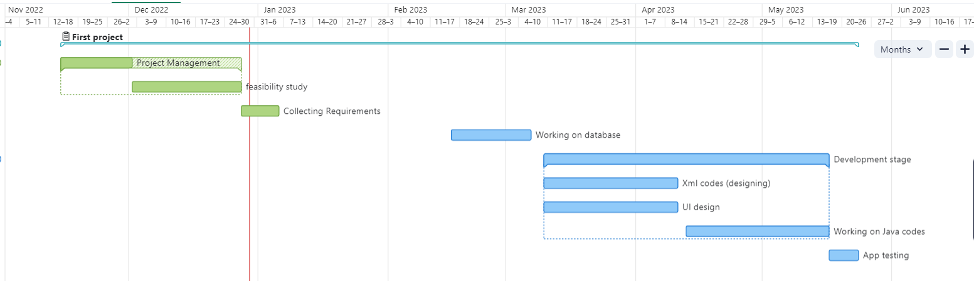

**Time Table:**

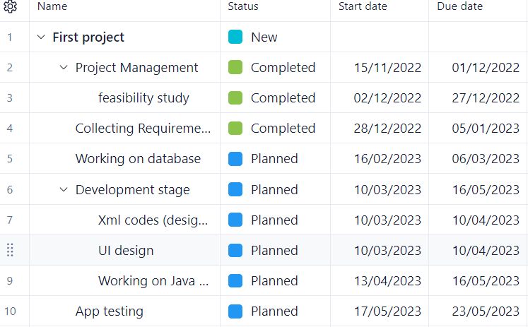

**Data Collection &Analysis:**

**‘Questionnaire’**

For the data I will do a questionnaire that have six questions and each question I will describe it with the analysis ,I will send the survey for general public people’s ,first three questions was personal like the name ,age, gender and the last three questions it’s about the application and these six questions can give a clear idea about the app and what the community think about it ,I have did this questionnaire for 10 people with different ages and genders .

**Q2 Ages:**

The ages was between 18 and 42 years old to see all different generations ideas about the app .

**Q3 Gender:**

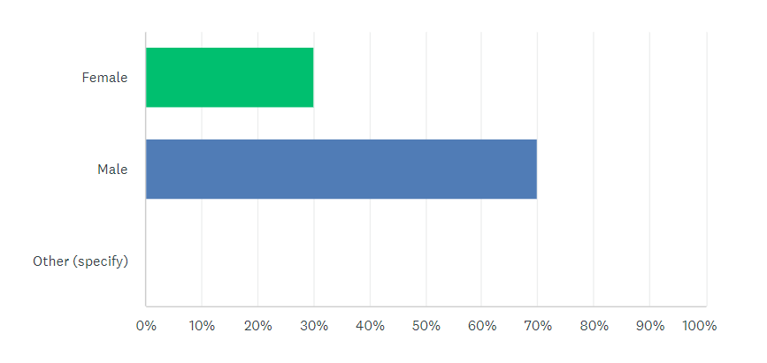

Gender : in gender question they was 30% of the response are female and the rest of the responses was from the male for 70%.

**Q4 Do you know others Car parts (Application) in Oman ?**

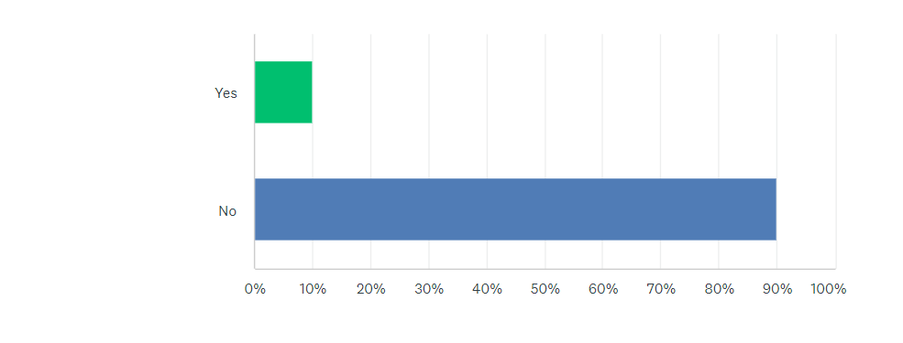

Q4:10% of response they know other app the selling parts but the app it’s not specific for the cars, and 90% of people’s they don’t know other car parts app.

**Q5 Do you think (Car Parts Application) helpful for the Community?!**

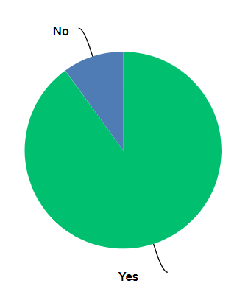

Q5: 10% of responses says that the app it’s not helpful but 90% of response says it’s helpful for the community.

**Q6 Do you trust to buy items from the internet?**

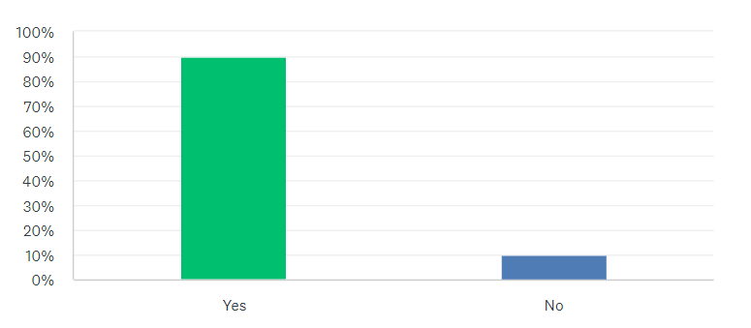

Q6: 10 % of responses says they don’t trust of buying from the internet but 90% says they trust on the internet apps.

**Final result:**

I saw that 90% of people they have agreed that the app will be helpful for the community and it’s new idea that combine all the types of cars in on app, that why I will complete the project and I will do this application to bring the benefits for the community.

**CarP Project Requirements:**

|  |  |  |  |
| --- | --- | --- | --- |
| No. | (Car Parts) Hardware Device needing | Model | Usage |
| 1 |  | Wireless connectivity | For print all chapters . |
| 2 |  | Samsung phone | To install the app on it |
| 3 |  | Flash Memory Stick 32 GB | To store the project files |
| 4 |  | Dell -latitude | To use it to create the app |
| 5 |  | SanDisk Portable SSD 1TB | For saving my work |
| 6 |  | Pens | To write notes |
| 7 |  | Papers | To write notes |

|  |  |  |  |
| --- | --- | --- | --- |
|  | Software(CarP needing) | Model | Description/Use |
| 1 |  | Photoshop | To design |
| 2 |  | Android Studio | Create the application |
| 3 |  | Office 365 | -Word  -PowerPoint  -Excel |
| 4 |  | YouTube | To learn more about android studio |
| 5 |  | Google chrome | For searching purpose |
| 6 |  | SQLlite | To save the customer data |

**Illustration:**

**DFD Level 0:**

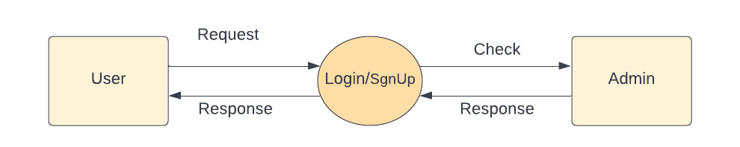

**DFD Level 1:**

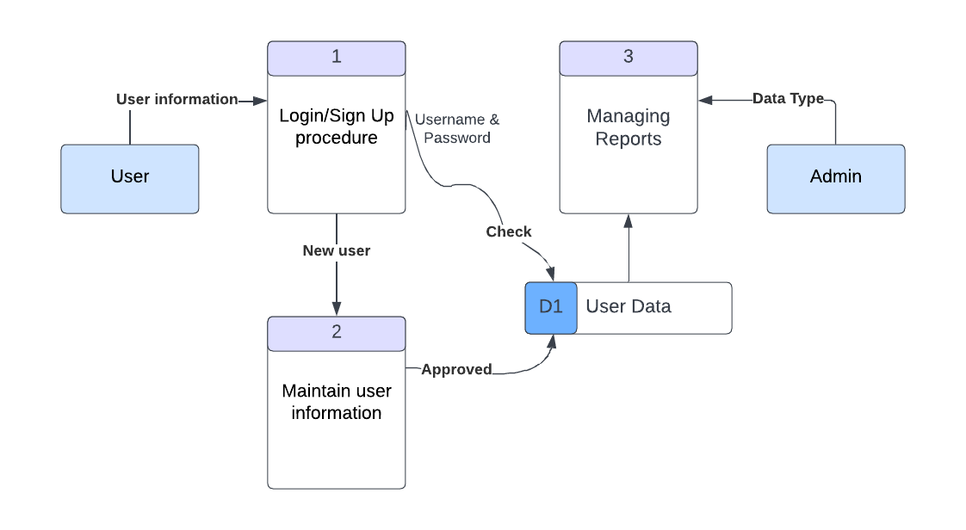

**Use Case Diagram:**

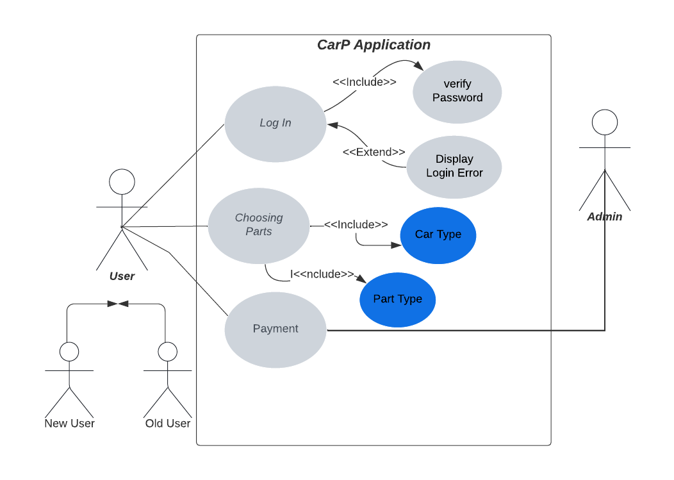

The application provide an option for the old user and for new user and the data will be stored in database, the user will have the access to choose the car agency and the car type and also the part type and after that the payment page will be shown for the user to complete the payment process.

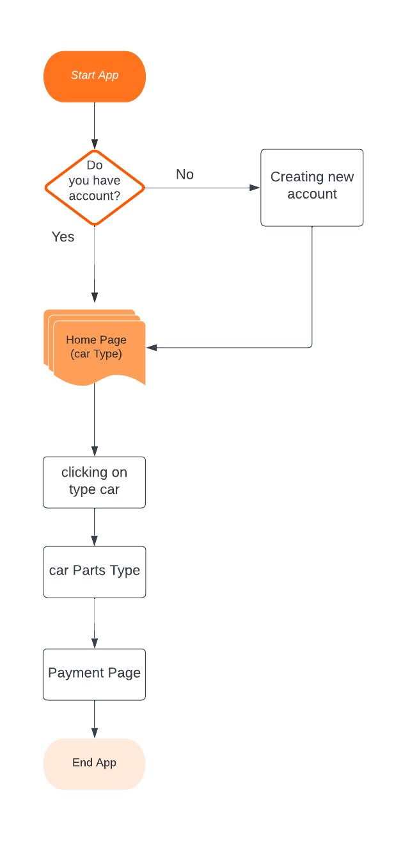**Flow Chart:**

**Prototype for the CarP App:**

I have designed three standard pages that I will created ,

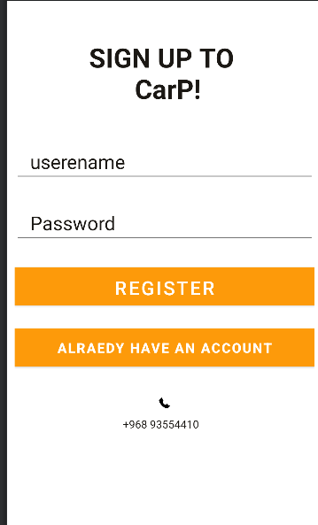

The **first** page is the sign up page that if the user has don’t have an account he will write his username and password .

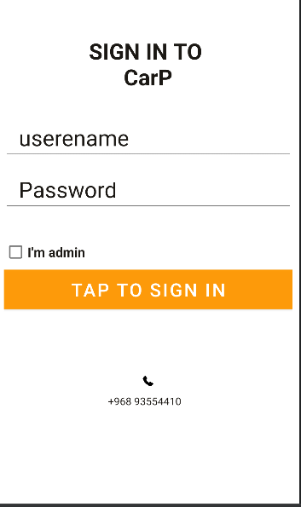

The **second** page is for the user that have already an account so he can enter the app directly.

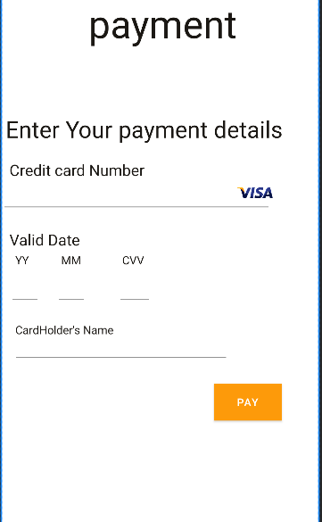

The last **third** page is for payment processing.

**Chapter Four**

**Introduction:**

The purpose of this chapter that I will go through the project that include the use case for the application and use case specification diagram, also the chapter will include the sequence diagram and ER diagram and there will be some diagrams that will be explained again but in details like the context diagram ,flowchart and prototype , and also there will be an explanation for the tables that I will use in the data base like the user table and there will some explanation for the security of the database that I have used in the application ,this chapter will include some screenshots of the application pages.

Step 2:

**Use Case**



**Flow Chart**

The app start with asking you if you have an account or not and after creating the account the application will move you to the home page and when you will click on one of the agencies it will move you to the type of the car, and when you will click on one of the cars it will move you to parts of that car and after clicking on the part that you need to buy it will move you to the payment page.

**ER Diagram:**

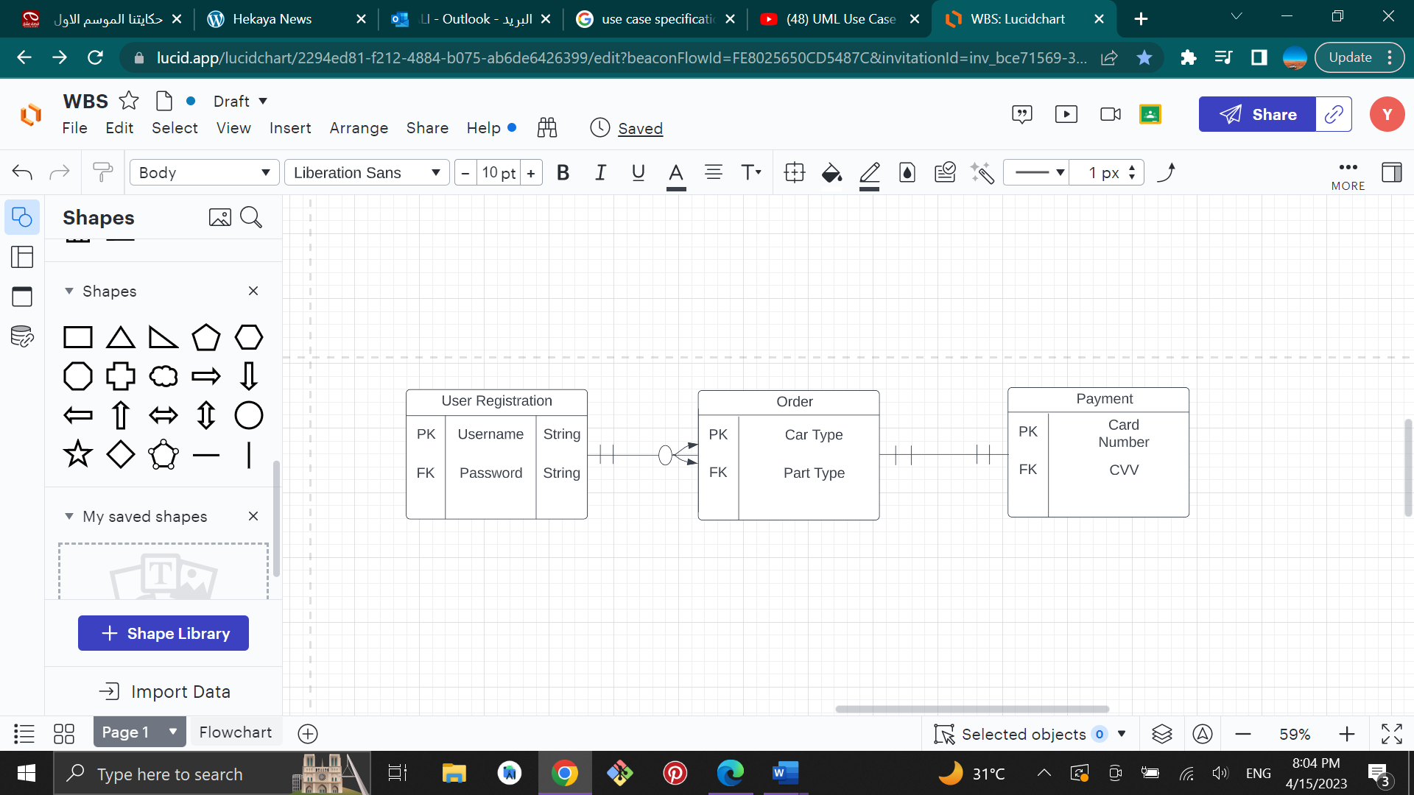

Step 4:

in this application there will be a database that will be save the data of the user ,the table that I will be using in this application is for the data user , the table will be include the username of each person that have register the application and also the password, in this table every username must be unique ,otherwise the system will not allowed the user to enter the application ,the username must be used only by the user.

Step 6:

The SQLite database can check the username and the password every time the user want to enter into the application , so there are no problems to check if the username and the password are available in the database or not .

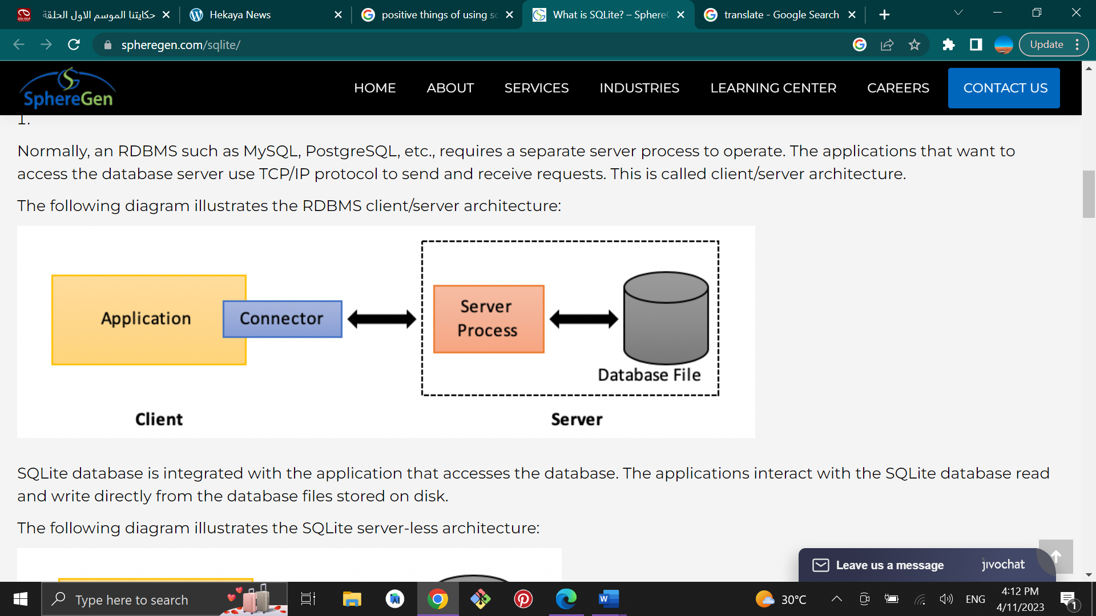

This is the relation between the application and the SQLite database ,the database here it’s out of the application ,when the user will enter the username and the password the application will ask the server to check in the database file if this user have registered before or not and after that the application will do the rest of work after checking, so this process will make the database more secure because there are complex process to reach into the database .

Step 7:



**Sign Up Page:** when you will open the application this is the first page that will show for you and it’s asking for the username and password and after that you can register the application with a new account ,the username must be a unique because the username and the password for a new user it will be saved directly in the database ,so every user must have his unique username and it can be a number or letters in this page we have a button that you click on it if you have already an account and it will directly move you to the next page .



**Sign Up:** the signup Page will ask from the user to enter his/her username and password and the system will directly check if the username and password are available in the database of the application or not ,if yes it will directly enter the user to the application and if username and the pass are not available they will ask to check what you have written again .



**Payment Page:** after collecting the part that user needed it will show the payment page to complete the payment process.

**Chapter five**

**Introduction:**

In this chapter will be included the screen shots of the application starting from log in page to the payment page and there will be an explanation for each page ,and after that the codes of the log in page and the other pages will be shown like the java codes ”back end” for the functions and the xml codes for the “front end” ,the programmers knows that testing the app is very important and this chapter will include that also (how’s the testing are important) , after that there will be an explanation of the strategy has been used to test this application and there will be test case for the application and there will be like a table that included the functions on the application to test them ,after testing the app there will be an analysis for the test that we have done and how’s the application works ,after that there will be an explanation of if the user need to have specific requirement skills to use the application or not and how I can train the user to know how to use the application ,and the last thing will is be comparing the application between what was the plan when I have started working on the application and there will be also check list, in general in this chapter there will discussion about the application after I have finished working on it.



**Application Pages:**

In this parts of the chapter there will be a detailed discussion about the pages and screenshots of the application.

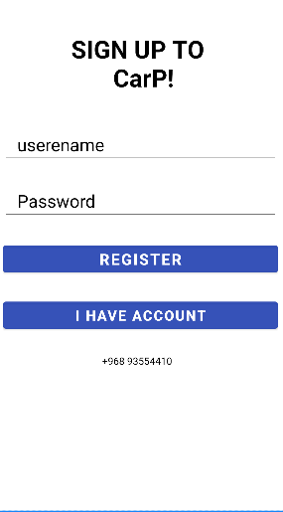 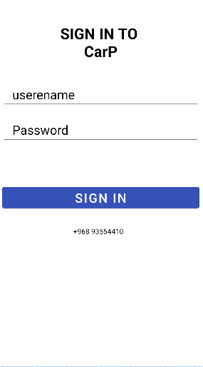

This is the first page will show for you this is the sign in page if you already

Sign up page that askes to register if don’t if you already have an account you

Have an account ,but if you have an account can enter you details and sign in .

You can just click on I have an account.

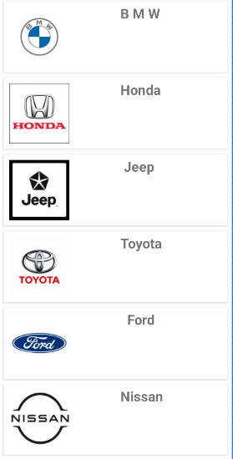**Home Page**

**Home Page:**

This the home page that will show for you after entering car parts application and here you will see the car agencies that available in the application and when you click on one of them the application will move to their cars type.

**BMW**

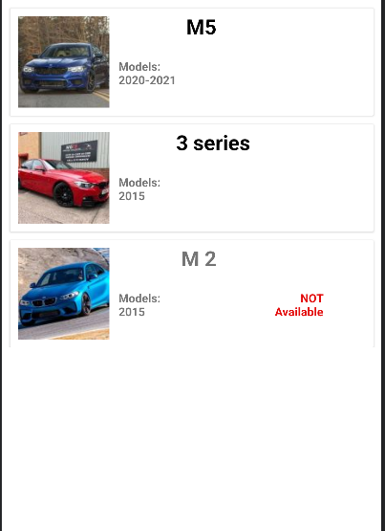

**BMW page:**

When you will click on the BMW card view it will show you this page and it contain the BMW cars , the last card view in this page you can’t click on it and that’s mean the parts of this cars are not available right now .

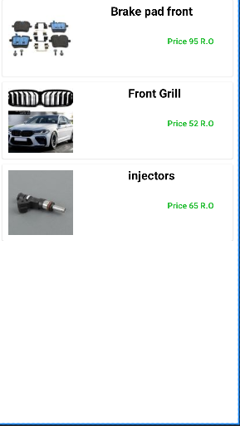

**BMW M5:**

If you have clicked on M5 (first card view) it will bring you to this page and this page contain the parts of M5 and if you have clicked on any one of them it directly will move you to the payment page.

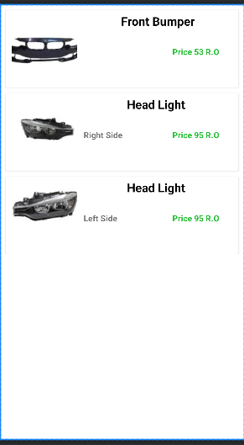

**BMW 3 series:**

This is the BMW 3 series parts and it will be shown for you when you will click on the second card view in BMW page .

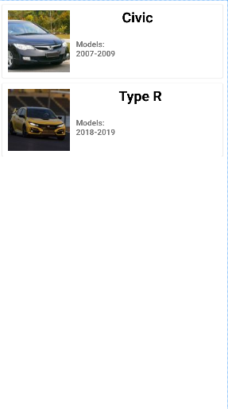

**Honda Page:**

This page it contain the type cars from Honda ,and if you clicked in one of them it will move you to the details page of the cars .

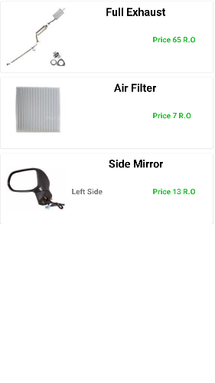

**Civic Page:**

When you will click on civic card view it will show you this page that have the parts of civic and it show the price there are also images, if you have clicked one of them it will move you to the payment to complete the payment process.

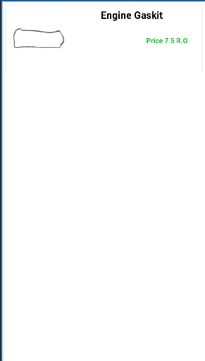  
**Type R Page:**

When you will click on the second card view in Honda Page I will show the parts of the type R.

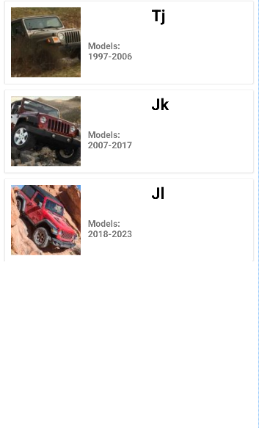

**Jeep Page:**

In jeep page we have three types of jeep’s car and there has been written the models of the car and if you have clicked of one of them it will move to there details page.

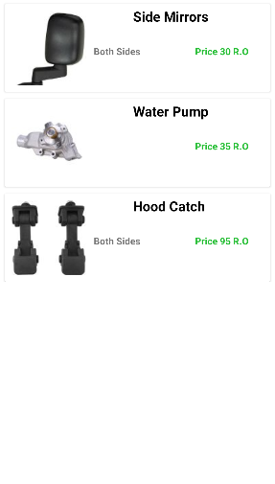  
**TJ Page:**

When you will click on the TJ card view in jeep page it will move you to this page and if you have chosen one of the parts and click on it, it will move you to the payment page.

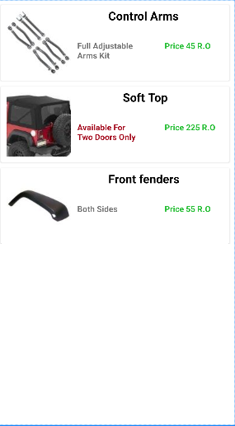  
**JK Page:**

This page will show when you will click on JK in Jeep Page and if you have clicked on one of the parts it will move you to the payment page.

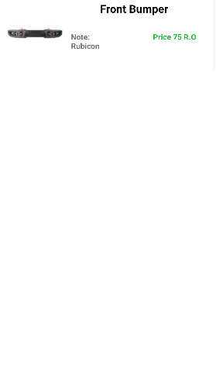

**JL Page:**

This is the JL parts that will show you if you have clicked on the JL car view .

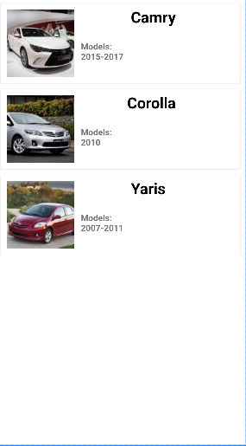

**Toyota Page:**

This is the car types of Toyota and it will show you this page when you will click in Toyota card view in home page and Toyota contain three types of cars like Camry ,Corolla and Yaris.

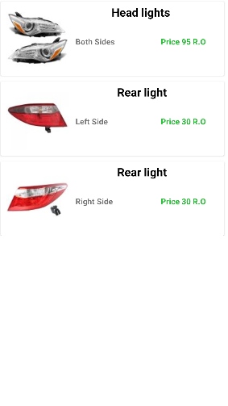  
**Camry Page:**

This the page that will open to you when you will click on Camry option in Toyota page.

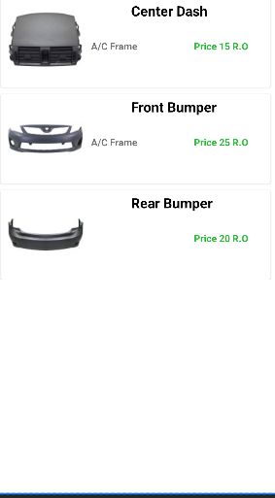

**Corolla Page:**

When you will click on Corolla card view it

Will show you this page that contains the parts of Corolla.

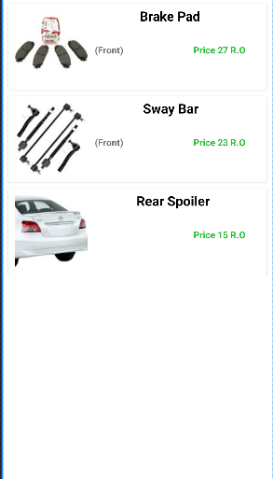

**Yaris Page:**

When you will click on Yaris Card view it will show you this page that contains the parts of the Yaris and if you have clicked one of them it will move you to the payment page.

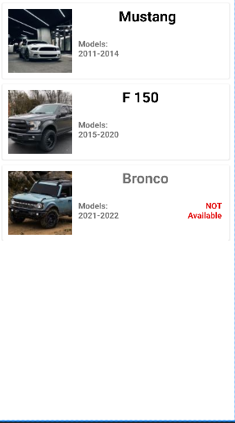

**Ford Page:**

When you will click on ford card view in home page it will show this page that contain type of cars in ford agencies and as you can noted that the last card view says ‘Not Available’ and that’s mean there are no parts available for this car right now.

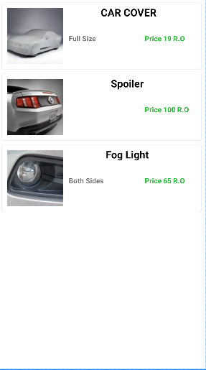  
**Mustang Page:**

When you will enter the ford card view and will you choose mustang card view ,it will show you this page that contain the parts of the mustang and if you have clicked on one of them it will move you to the payment page.

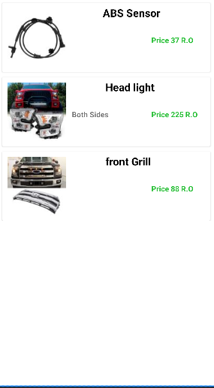  
**F 150 Page:**

In this page it contain the parts of the ford F150 .

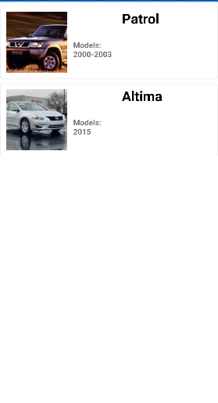  
**Nissan Page:**

When you will click on Nissan card view it will show you this page .

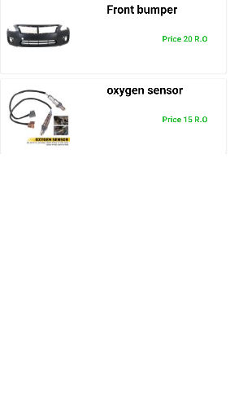

**Altima Page:**

When you will click on Altima card view it will show you this page and if you have clicked on one of the products it will show you the payment page.

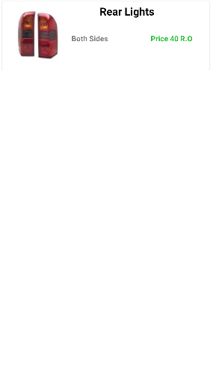

**Patrol Page:**

When you will click on patrol card view it will move you to this page that contain the parts of Nissan patrol and if you have clicked on that product it will move you to the payment page.

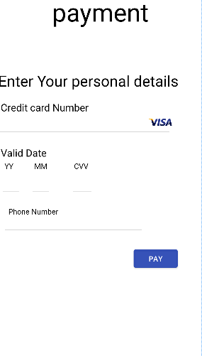

**Payment Page:**

This is the payment page that user will enter the personal credit card number and user phone number to complete the payment process when the user choose a product to buy it.

**Main Page (Sign Up):**

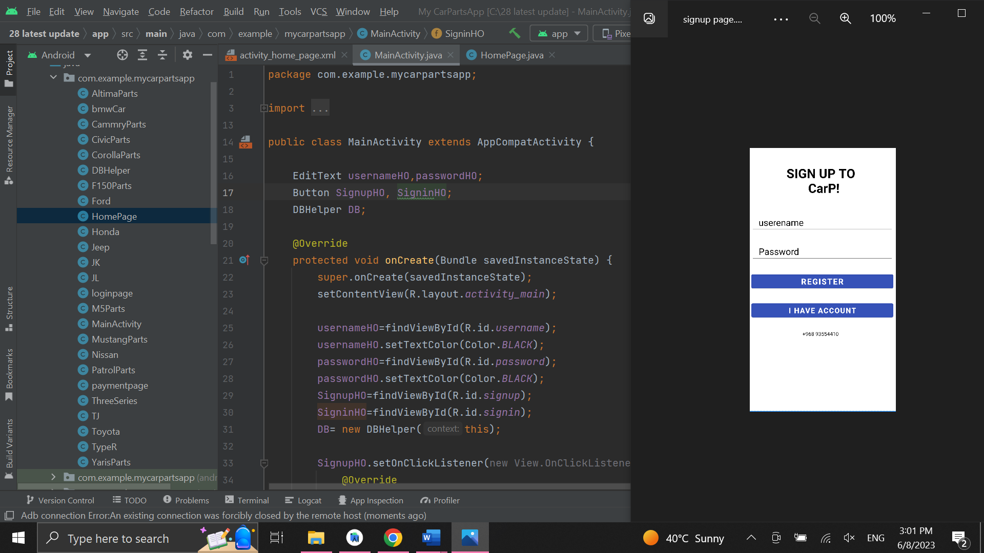

**Log in Page:**

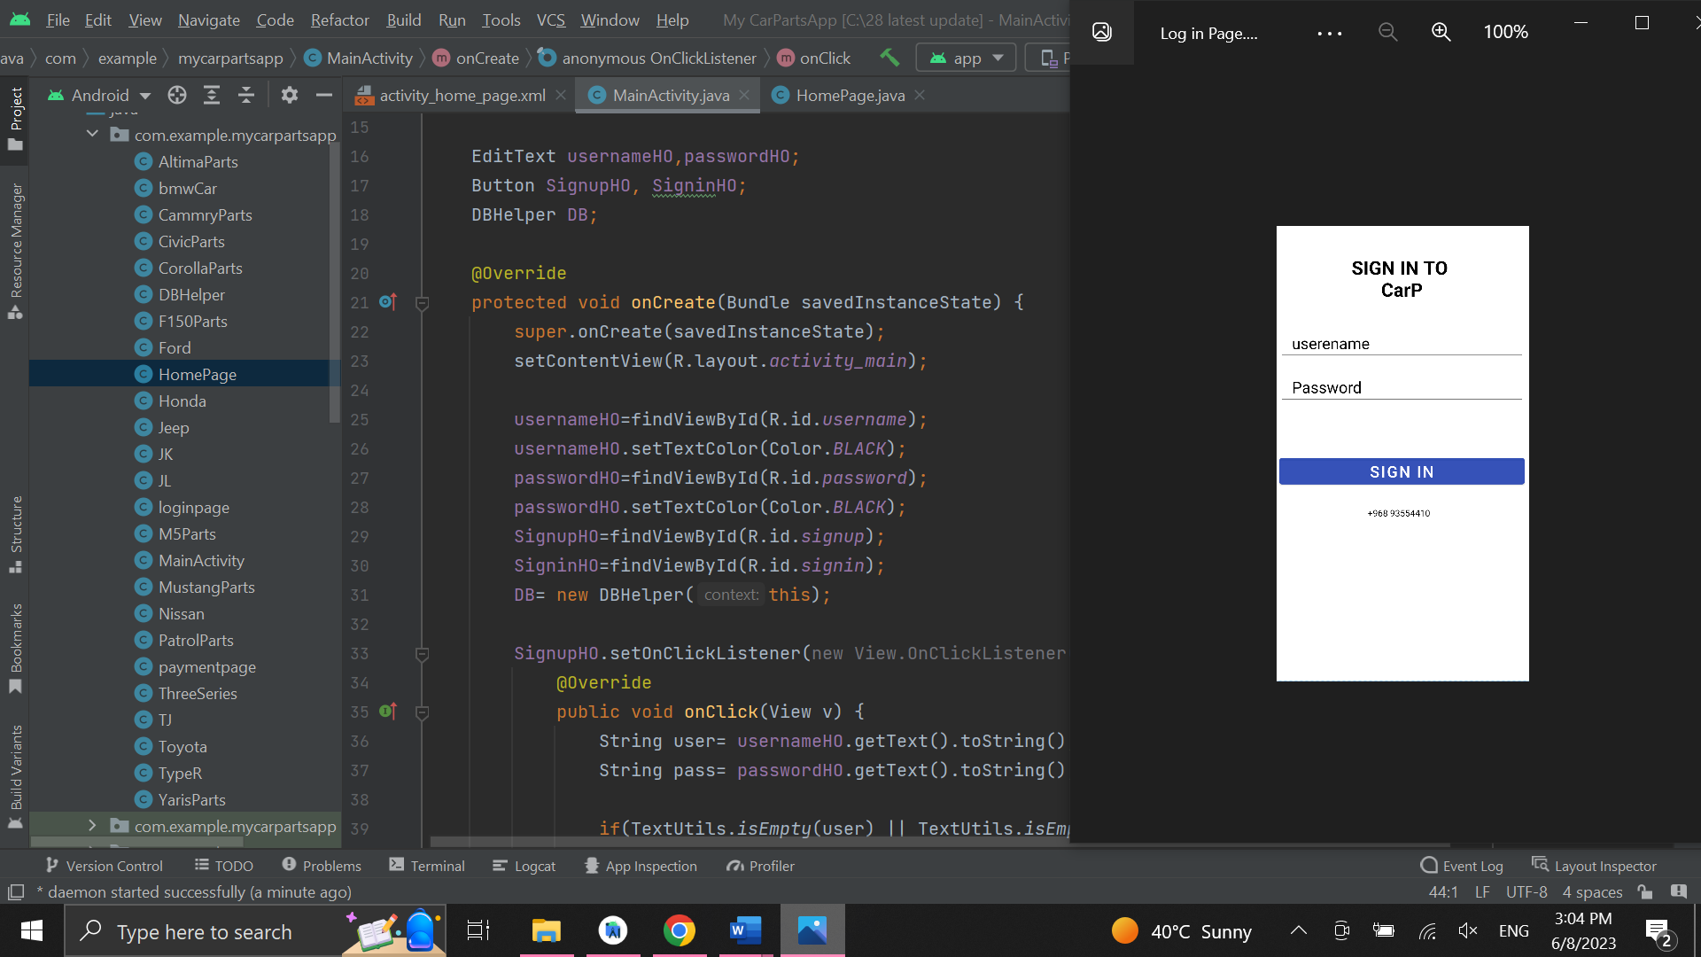

**Home Page:**

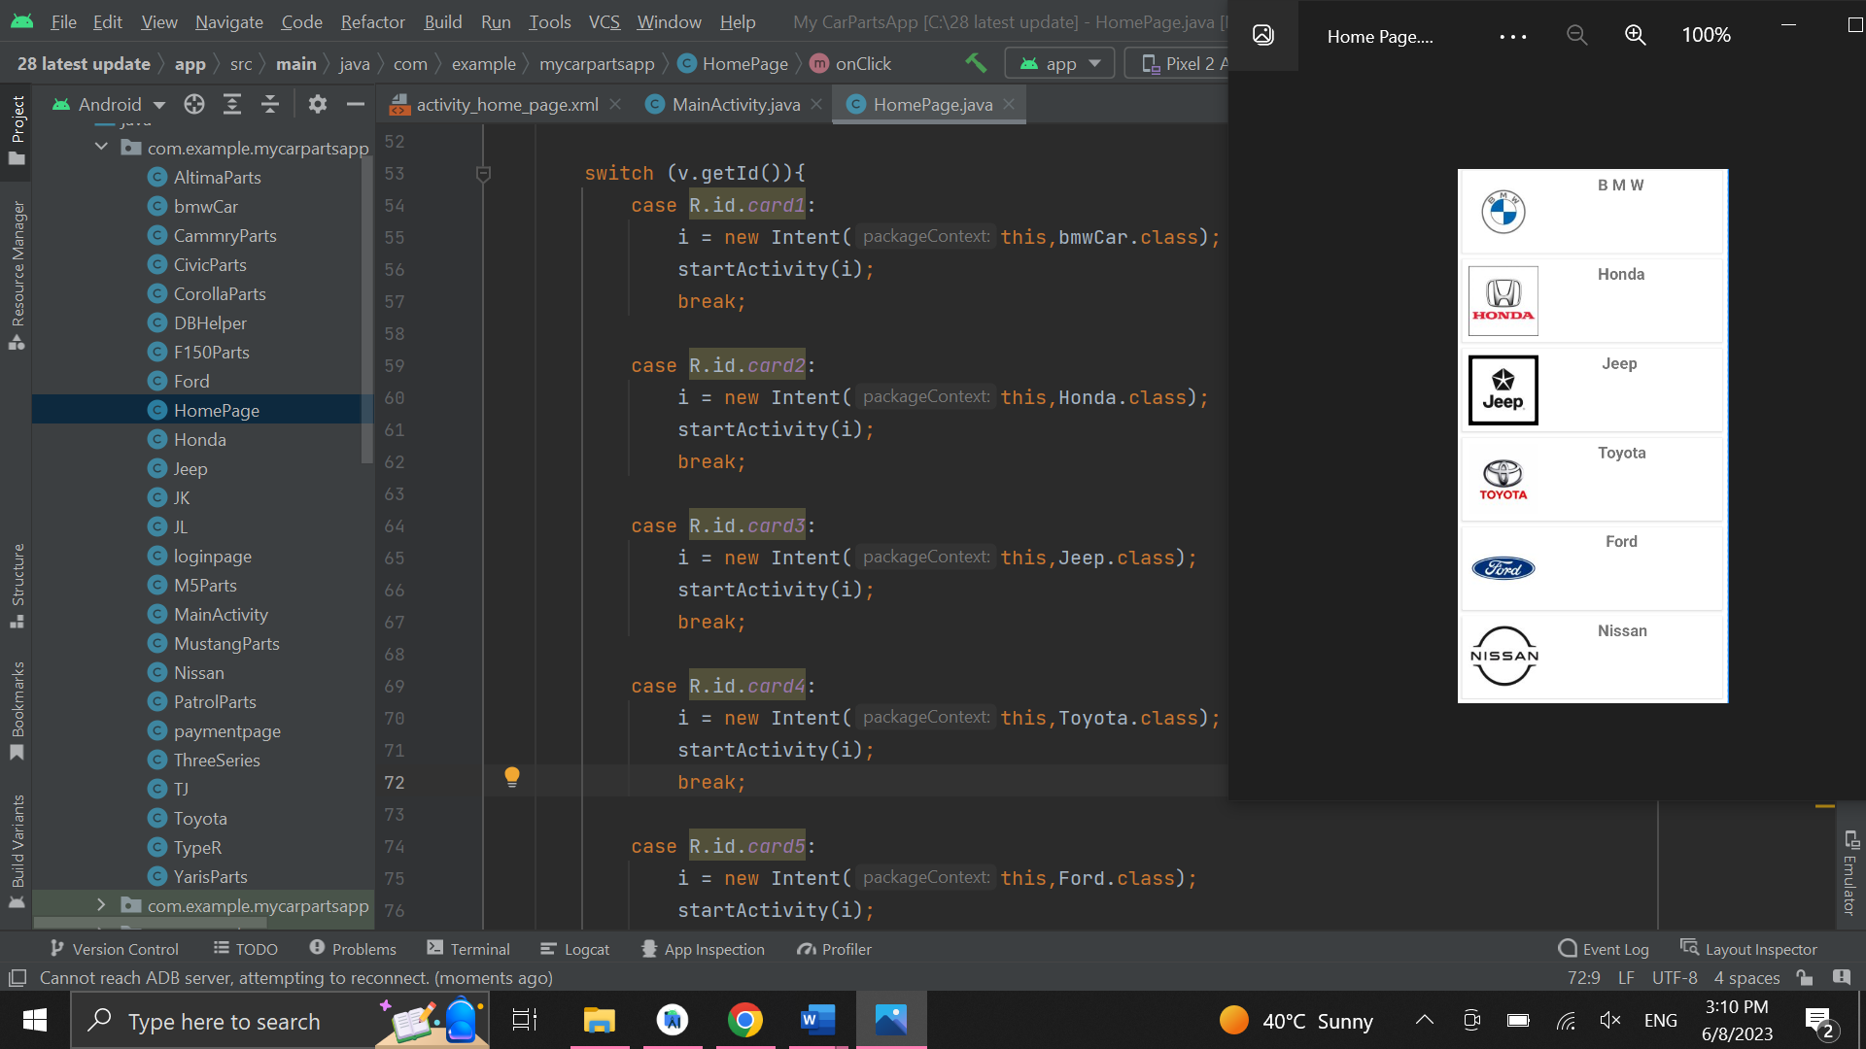

**Jeep Page:**

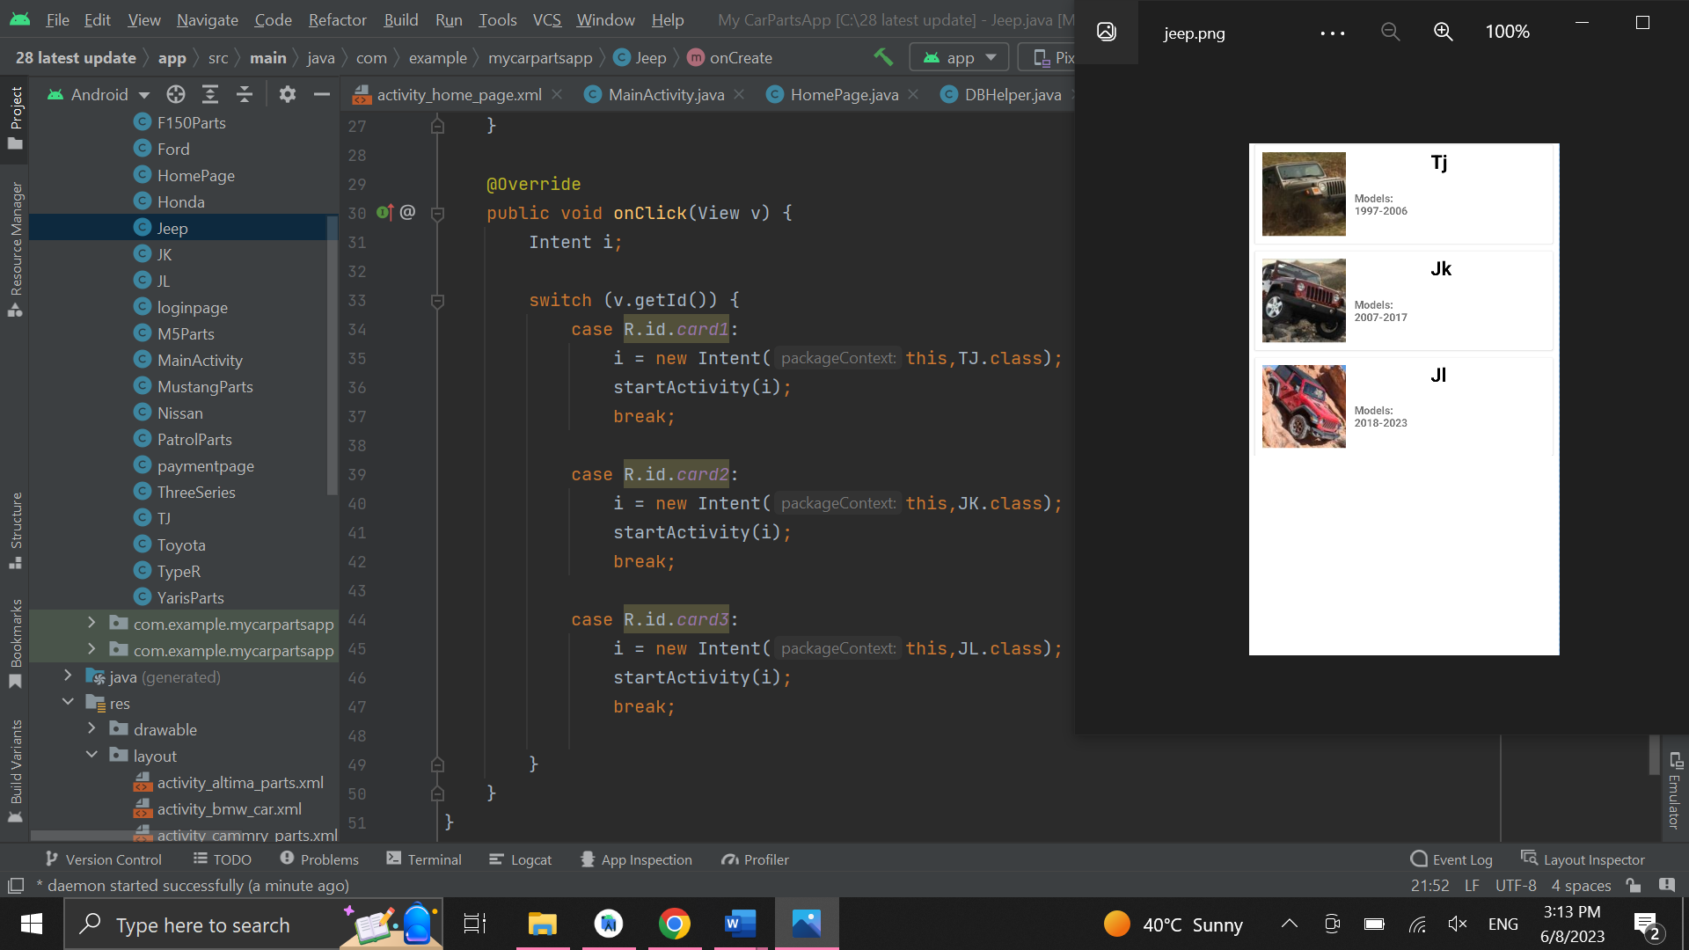

**Jeep TJ:**

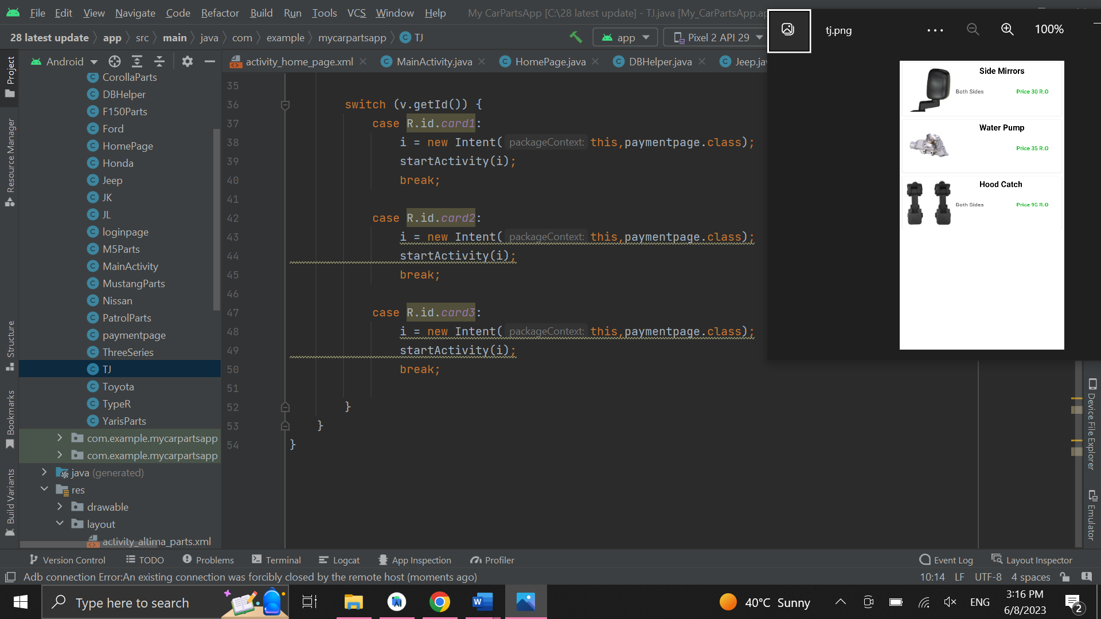

**Testing & Evaluation**

**Importance of testing:**

There are many advantages of testing anything, but when we talk about application the test come more important to do it for the application ,and it’s important thing before the customers use the application because if there a problem or you’re facing some errors you can solve the issue before delivering the application to the user ,and the testing have different ways to do it like to check if the application can open all the pages and if the functions are working perfectly, in the other side we as a programmers we must to check the security of saving the username and the password in a secure database, and if there any mistakes on the saving process you can solve the pro problem, and also when talk about testing we must talk about the front end(the design that will appear for the user) colors, fonts and the sizes of the images ,all that must be checked during the testing part.

**Test strategy**

There are different strategies to do the test and the test must do it with a thoughtful plan to test every single part of the application, in this application there will be a table that have contain the functions of the application and there will also check list and there will be a brief describing for the functions and after that there will be a test result and from there we will if the program need to change anything or not.

|  |  |  |  |  |  |  |  |  |
| --- | --- | --- | --- | --- | --- | --- | --- | --- |
| NO | Environment | Description | Target | Expected Result | Actual Result | Pass / Fail | Date | By |
| 1 | Main page (sign Up page) | This page will show as the first page in the application. And it contain the sign up and (already have an account) | This page contain creating new user and the. | As specified in the description. | As specified in the description. | Pass | 12/6/2023 | Yousuf |
| 2 | Main Page (Sign Up Button) | after entering the username and password the application must save the data and open home page and the data will be saved in SqlLite | To open new account for the user | As specified in the description. | As specified in the description. | Pass | 12/6/2023 | Yousuf |
| 3 | Main Page (Already have an account) Button | When the user click on the button must move log in page |  | As specified in the description. | As specified in the description. | Pass | 12/6/2023 | Yousuf |
| 4 | Log in Page | This page for the users that already have an account. | The user should insert the username and password that has been created before. | As specified in the description. | As specified in the description. | Pass | 12/6/2023 | Yousuf |
| 5 | Log in Page | If the user has written the username but didn’t insert the password | Show a small message that say(all fields are required | As specified in the description. | As specified in the description. | Pass | 12/6/2023 | Yousuf |
| 6 | Home Page | the application will show all the agencies in this page | The user must have the access to click on any agency | As specified in the description. | As specified in the description. | Pass | 12/6/2023 | Yousuf |
| 7 | Home Page | The user must have the ability to scroll down or up | To make the home page comfortable for the user | As specified in the description. | As specified in the description. | Pass | 12/6/2023 | Yousuf |
| 8 | BMW Page | The application will show all the cars in BMW | The user must have the ability to click on any car and goes to the parts page | As specified in the description. | As specified in the description. | Pass | 12/6/2023 | Yousuf |
| 9 | BMW M5, 3series Pages | This page contain the parts of M5 BMW | the user must have the access to click any one of the parts to move to payment page | As specified in the description. | As specified in the description. | Pass | 12/6/2023 | Yousuf |
| 10 | Honda Page | It contain the car types of Honda | The user must have the access to choose any one of the cars | As specified in the description. | As specified in the description. | Pass | 12/6/2023 | Yousuf |
| 11 | Civic , Type R Pages | This pages contain the civic , type R Parts | The user must have the access to click any one of the parts and move to payment page. | As specified in the description. | As specified in the description. | Pass | 12/6/2023 | Yousuf |
| 12 | Jeep Page | It has the types of jeep’s cars. | The user should have the access to enter in any type of car | As specified in the description. | As specified in the description. | Pass | 12/6/2023 | Yousuf |
| 13 | TJ , JK , Jl Pages | It contain the parts of the cars | The user should have the access to click on any part and it must move him to the payment page. | As specified in the description. | As specified in the description. | Pass | 12/6/2023 | Yousuf |
| 14 | Toyota Page | It contain the Toyota car types. | The user must have the access to click on any one of the car types. | As specified in the description. | As specified in the description. | Pass | 12/6/2023 | Yousuf |
| 16 | Camry, Corolla, Yaris Pages | It contain the car parts. | The user must have the access to click on any type of parts and it must move him to the payment page. | As specified in the description. | As specified in the description. | Pass | 12/6/2023 | Yousuf |
| 17 | Ford Page | This page contain the ford car types | The user must have the access to choose any one of the cars and move to the next page. | As specified in the description. | As specified in the description. | Pass | 12/6/2023 | Yousuf |
| 18 | Mustang, F150 Pages | It contain the car parts of Mustang ,F150. | The user should have the access to click on any of the parts and must move to the payment page | As specified in the description. | As specified in the description. | Pass | 12/6/2023 | Yousuf |
| 19 | Nissan Page | It contain the types of Nissan’s cars | The user must have the ability to choose any one of the cars | As specified in the description. | As specified in the description. | Pass | 12/6/2023 | Yousuf |
| 20 | Patrol Page | It contain the parts of the Nissan Patrol | The user must have the access to choose any one of the parts and move to the payment page. | As specified in the description. | As specified in the description. | Pass | 12/6/2023 | Yousuf |
| 21 | Altima Page | It contain the parts of the Nissan Altima | The user must have the access to choose any one of the parts and after that must move to the payment page | As specified in the description. | As specified in the description. | Pass | 12/6/2023 | Yousuf |
| 22 | Payment Page | It contain the Payment process and some personal data needed | The user must have the access to enter the data without any problem or any crushes | As specified in the description. | As specified in the description. | Pass | 12/6/2023 | Yousuf |

**Test case result:**

The table shows test tasks and I had 22 tests and all the functions has worked properly and passed the test perfectly without any crushes in the application and the database has worked perfectly, so after testing the application I saw that, the application worked 100% and ready to deliver it to the customers.

|  |  |  |
| --- | --- | --- |
| Salford | |  |
| Testing: | NO. of test case: |
| Number of tests | 22 |
| Number of Passed tests | 22 |
| Number of Failed Tests | 0 |
| Test Results | Pass 100%  Fail 0% |

**Deployment**

CarP Application it has been created from android studio and to put the application in google play I must to pay 10-15 to them.

**Clint machine specification:**

This application has been created for android’s operating system and mobile phone.

**User experience**

The application no need to have an experience to use it, although I have created an account in Instagram application for CarP Application and there will be instructions for how to use the application.

**Training requirements**

As I talked before there will be a video that explain how the user can create a new account and how to use it.

**Critically evaluating the system**

This type of evaluations or analysis it’s important to know if the application can reach the requirement or not ,from the beginning the application has been created to meet the objectives and there are many benefits of this application ,there are no application in Oman has provide this idea before like this application ,after working on the project I saw the application meet the main goal of creating this application and provide the features and the easiest way for the user to buy a car parts without any complicated functions that make the application maybe hard to use, and the questions below can give more explanation of the benefits of the application and what the future planning.

|  |  |
| --- | --- |
| **HIGH-LEVEL QUESTIONS** | |
| **What are the benefits that you will after doing this project?** | **In general I got many benefits from doing the project because most of the things I didn’t know how to do it in programming side and in the management side also, and I have learned how to manage the time during working on the project.** |
| **The application has been created for each operating?** | **This application has been created for android’s operating system and mobile phone.** |
| **What the features of the application?** | **User registration :the application will save the username and the password, and the user can move to any page in the application.** |

|  |  |
| --- | --- |
| **CHECK LIST** | |
| **What the functions that application needed and you didn’t put it?** | **the features that I hope to do it in future is to create different page for the admin to have the control to delete or insert or update.** |
| **Does the user must to pay to have this register this application?** | **The application is free for the users and it’s available for the android operating system.** |
| **Do you will add new agencies in the future?** | **Yes this is only the beginning and in the future maybe will have different functions.** |

**Chapter 6**

in chapter six there will the conclusion that contain the aim and about the system and the impact of this application from legal side, ethical and others.

**Conclusion:**

The aim of creates this application was to give the user the easier way to but the car parts without any difficulty and the application can be develop again and again for the next generations and to combine all the agencies in Oman in one place as I did.

The result of creates this project and with all the difficulties that I has been faced and how’s difficult to manage your time and how I must finish the application within three months ,I saw the objectives that I have made it from the beginning was going well and I have reached the objectives and how is must to bring a new idea ,from the resources and what I have learned during the semesters I have been created this application and I see that I did well in the chapters spite of the challenges.

In this application I have used to languages to create this application, the java codes I have used for the functions of the application and was it was challenge for me to use a database that I can rate it as the difficult database to use it because I was must to write the code parts for the database also and what I want to save it. I thought I was expert in android studio tool but it was not and I was must to search a lot to know what I must to do in the code part and on the other hand I have used xml codes to design the pages and it was going without any issues and problems but only on the sizes, in general when I faced many problems I have asked the teachers in MEC and I have learned from them and from the resources.

During the Journey of creating the application I faced a different and many errors and problems in the tool that I have used but I didn’t stop and I didn’t give up, and what I have did and done in entire of the project I can only say that I am so proud of myself.

The car parts (**CarP**) application provides the parts of different type of cars and the beneficiaries of this application is the people that live in Oman and there are no exceptions for the ages and the gender, the application will help the people and also the agencies because the pressure on these brunches from the people will be less.

**Recommendations:**

This application can be developed more in the future like adding more agencies with different types of parts, and changing the database to different database that can bear give more functions for the user when he want to enter the application like the adding the phone number for the user and checking if this number belong for the user or not by sending OTP message, in the future when the application will be released for the users the owner of the application must activate the payment page and also give a new option for the user if he want to pay by cash when the part will deliver to the user or if he want to pay from the application itself, and there an idea to add option that called add voucher code.

**Limitation:**

The application didn’t upload yet to the users yet so the people can’t use it, the application need more update before releasing it to the public, like the payment page it’s not working till now and the font sizes need to redoing it again for some of the pages, the application can be used from the android operating systems only so I hope in the future that I will have the ability to make it available for the IOS systems also.

**Impact of the project:**

**Social impact:** the application has been created to give the easiest way to buy car parts and it can impact the social media in Oman because this is a new idea in Oman specially.

**Ethical impact:** the application will not impact that side.

**Legal impact:** the application is legal and will not impact the Omani culture by the negative things and, opposite exactly the application will have the contracts with the car agencies and with the delivery company ,so everything will be legal.

**Discussing sustainability aspects:** the application is important for the community and in the future everything will be online and we must keeping pace with development and the needed of this application will become more and this will leads to the sustainability.

**General References:**

Krajnović, S., & Davidson, L. (2005, May 16). *Flow around a simplified car, part 2: Understanding the flow*. ASME Digital Collection. Retrieved December 7, 2022, from <https://asmedigitalcollection.asme.org/fluidsengineering/article-abstract/127/5/919/478068/Flow-Around-a-Simplified-Car-Part-2-Understanding>

*Waterfall methodology*. (n.d.). IONOS Digitalguide. <https://www.ionos.com/digitalguide/websites/web-development/waterfall-methodology/#:~:text=The%20five%2Dstage%20waterfall%20model>

*Dynamic Systems Development Method (DSDM) - GeeksforGeeks*. (2019, June 18). GeeksforGeeks. <https://www.geeksforgeeks.org/dynamic-systems-development-method-dsdm/>

‌ Kumar Pal, S. (2018, May 28). *Software Engineering | Spiral Model - GeeksforGeeks*. GeeksforGeeks. <https://www.geeksforgeeks.org/software-engineering-spiral-model/>

SurveyMonkey. (2019). *Survey Monkey*. Surveymonkey.com. <https://www.surveymonkey.com/dashboard/>

‌ *Download Android Studio & App Tools*. (n.d.). Android Developers. Retrieved January 4, 2023, from <https://developer.android.com/studio?gclid=Cj0KCQiA5NSdBhDfARIsALzs2EDXw7G826dhLSSzk30kXmUzV8-gcfjUmsb0DGVa6LBQJ9k7GhWlqNAaAhxyEALw_wcB&gclsrc=aw.ds>

‌

SQLite. (2019). *SQLite Home Page*. Sqlite.org. <https://www.sqlite.org/index.html>

‌

**2***Auto parts by Carparts.com - right parts. right now.* (n.d.). Retrieved December 7, 2022, from https://www.carparts.com/

*Onlinecarparts - great britain is rated "average" with 3.4 / 5 on Trustpilot*. Trustpilot. (1969, December 27). Retrieved December 7, 2022, from https://uk.trustpilot.com/review/onlinecarparts.co.uk

*All the parts your car will ever need*. rockauto.com. (n.d.). Retrieved December 7, 2022, from https://www.rockauto.com/

*Used auto parts market*. Car. (n.d.). Retrieved December 7, 2022, from <https://www.car-part.com/>

*Download Android Studio & App Tools*. Android Developers. (n.d.). Retrieved December 7, 2022, from <https://developer.android.com/studio?gclid=Cj0KCQiAkMGcBhCSARIsAIW6d0CeeErbA2TW0We8BtQVeh7JX5nBdQD4Lxkxjf8JQHK_KE2sANANvSQaAnKnEALw_wcB&gclsrc=aw.ds>

*Original car parts: Only genuine accessories and parts! - original car parts*. english. (n.d.). Retrieved December 7, 2022, from <https://www.originalcarparts.com/>

*JMLR papers*. Journal of Machine Learning Research. (n.d.). Retrieved December 7, 2022, from <https://jmlr.org/papers/>

*UPI payment integration in Android*. GeeksforGeeks. (2022, August 4). Retrieved December 7, 2022, from <https://www.geeksforgeeks.org/upi-payment-integration-in-android/>

*Save data in a local database using room  :   android developers*. Android Developers. (n.d.). Retrieved December 7, 2022, from <https://developer.android.com/training/data-storage/room?gclid=Cj0KCQiAkMGcBhCSARIsAIW6d0CPWP1NrDwaX-PAkSK-s7bAimcnswYcmGH2vV6v-JgCaX-CWfB_zaoaApaaEALw_wcB&gclsrc=aw.ds>

**Database Codes:**

package com.example.mycarpartsapp;  
  
import android.content.ContentValues;  
import android.content.Context;  
import android.database.Cursor;  
import android.database.sqlite.SQLiteDatabase;  
import android.database.sqlite.SQLiteOpenHelper;  
  
public class DBHelper extends SQLiteOpenHelper {  
  
 public static final String *DBNAME* = "login.db";  
  
 public DBHelper(Context context) {  
  
 super(context, "login.db", null, 1);  
 }  
  
 @Override  
 public void onCreate(SQLiteDatabase db) {  
 db.execSQL("create table users(username TEXT primary key,password TEXT)");  
 }  
  
 @Override  
 public void onUpgrade(SQLiteDatabase db, int oldVersion, int newVersion) {  
 db.execSQL("drop table if exists user");  
 }  
  
 public boolean insertData(String usrename, String password) {  
 SQLiteDatabase db = this.getWritableDatabase();  
 ContentValues values = new ContentValues();  
  
 values.put("username", usrename);  
 values.put("password", password);  
  
  
 long result = db.insert("users", null, values);  
 if (result == -1) return false;  
 else  
 return true;  
 }  
  
 //CheckUsername function  
 public boolean checkUsername(String username) {  
 SQLiteDatabase db = this.getWritableDatabase();  
 Cursor cursor = db.rawQuery("select * from users where username=?", new String[]{username});  
 if (cursor.getCount() > 0)  
 return true;  
 else  
 return false;  
 }  
  
 public boolean checkUsername(String username, String password) {  
 SQLiteDatabase db = this.getWritableDatabase();  
 Cursor cursor = db.rawQuery("select * from users where username=? and password=?", new String[]{username, password});  
 if (cursor.getCount() > 0)  
 return true;  
 else  
 return false;  
 }  
}

**main activity java codes :**

package com.example.mycarpartsapp;  
  
import androidx.appcompat.app.AppCompatActivity;  
  
import android.content.Intent;  
import android.graphics.Color;  
import android.os.Bundle;  
import android.text.TextUtils;  
import android.view.View;  
import android.widget.Button;  
import android.widget.EditText;  
import android.widget.Toast;  
  
public class MainActivity extends AppCompatActivity {  
  
 EditText usernameHO,passwordHO;  
 Button SignupHO, SigninHO;  
 DBHelper DB;  
  
 @Override  
 protected void onCreate(Bundle savedInstanceState) {  
 super.onCreate(savedInstanceState);  
 setContentView(R.layout.*activity_main*);  
  
 usernameHO=findViewById(R.id.*username*);  
 usernameHO.setTextColor(Color.*BLACK*);  
 passwordHO=findViewById(R.id.*password*);  
 passwordHO.setTextColor(Color.*BLACK*);  
 SignupHO=findViewById(R.id.*signup*);  
 SigninHO=findViewById(R.id.*signin*);  
 DB= new DBHelper(this);  
  
 SignupHO.setOnClickListener(new View.OnClickListener() {  
 @Override  
 public void onClick(View v) {  
 String user= usernameHO.getText().toString();  
 String pass= passwordHO.getText().toString();  
  
 if(TextUtils.*isEmpty*(user) || TextUtils.*isEmpty*(pass)  
 )  
 Toast.*makeText*(MainActivity.this," Please Enter the Username and Password ",Toast.*LENGTH_SHORT*).show();  
 else {  
  
  
 {  
  
 Boolean cheackuser = DB.checkUsername(user);  
 if(cheackuser==false){  
  
 Boolean insert = DB.insertData(user,pass);  
 if(insert==true){  
  
 Toast.*makeText*(MainActivity.this,"You Registered Successfully",Toast.*LENGTH_SHORT*).show();  
 Intent intent = new Intent(getApplicationContext(),HomePage.class);  
  
 startActivity(intent);  
 }  
 else{  
 Toast.*makeText*(MainActivity.this,"The Registeration Failed ", Toast.*LENGTH_SHORT*).show();  
 }  
 }else {  
 Toast.*makeText*(MainActivity.this,"The User is already Exists!!!",Toast.*LENGTH_SHORT*).show();  
 }  
 }  
 }  
 }  
 });  
 SigninHO.setOnClickListener(new View.OnClickListener() {  
 @Override  
 public void onClick(View v) {  
 Intent intent= new Intent(getApplicationContext(),loginpage.class);  
 startActivity(intent);  
  
 }  
 });  
  
  
  
  
  
 }  
}

**main activity xml codes:**

<?xml version="1.0" encoding="utf-8"?>  
<LinearLayout xmlns:android="http://schemas.android.com/apk/res/android"  
 xmlns:app="http://schemas.android.com/apk/res-auto"  
 xmlns:tools="http://schemas.android.com/tools"  
 android:layout_width="match_parent"  
 android:layout_height="match_parent"  
 android:padding="10dp"  
 android:background="@color/white"  
 android:orientation="vertical"  
 tools:context=".MainActivity">  
  
 <TextView  
 android:layout_width="match_parent"  
 android:layout_height="wrap_content"  
 android:layout_marginTop="40dp"  
 android:layout_marginBottom="50dp"  
 android:gravity="center_horizontal"  
 android:text="SIGN UP TO \n CarP!"  
 android:textColor="@color/black"  
 android:textSize="35dp"  
 android:textStyle="bold" />  
 <EditText  
 android:layout_width="match_parent"  
 android:layout_height="50dp"  
 android:id="@+id/username"  
 android:hint="userename"  
 android:textSize="25dp"  
 android:textColorHint="@color/black"  
 android:layout_marginBottom="30dp"  
 android:paddingLeft="20dp"/>  
 <EditText  
 android:layout_width="match_parent"  
 android:layout_height="50dp"  
 android:id="@+id/password"  
 android:hint="Password"  
 android:textSize="25dp"  
 android:textColorHint="@color/black"  
 android:layout_marginBottom="30dp"  
 android:paddingLeft="20dp"/>  
 <Button  
 android:layout_width="match_parent"  
 android:layout_height="50dp"  
 android:id="@+id/signup"  
 android:text="REGISTER"  
 android:textSize="22dp"  
 android:textStyle="bold"  
 android:textColor="@color/white"  
  
 android:layout_marginBottom="30dp"/>  
  
 <Button  
 android:id="@+id/signin"  
 android:layout_width="match_parent"  
 android:layout_height="50dp"  
 android:layout_marginBottom="30dp"  
 android:textColor="@color/white"  
 android:text="I HAVE ACCOUNT"  
 android:textSize="20dp"  
 android:textStyle="bold" />  
  
  
  
  
 <TextView  
 android:layout_width="150dp"  
 android:layout_height="wrap_content"  
 android:text=" +968 93554410 "  
 android:layout_gravity="center_horizontal"  
 android:textColor="@color/black"  
 />  
  
</LinearLayout>

**Log in page java codes:**

package com.example.mycarpartsapp;  
  
import androidx.appcompat.app.AppCompatActivity;  
  
import android.content.Intent;  
import android.graphics.Color;  
import android.os.Bundle;  
import android.text.TextUtils;  
import android.view.View;  
import android.widget.Button;  
import android.widget.EditText;  
import android.widget.Toast;  
  
public class loginpage extends AppCompatActivity {  
  
 EditText username,password;  
 Button signin;  
 DBHelper DB;  
  
 @Override  
 protected void onCreate(Bundle savedInstanceState) {  
 super.onCreate(savedInstanceState);  
 setContentView(R.layout.*activity_loginpage*);  
  
 username=findViewById(R.id.*username1*);  
 username.setTextColor(Color.*BLACK*);  
 password=findViewById(R.id.*password1*);  
 password.setTextColor(Color.*BLACK*);  
 signin=findViewById(R.id.*signin1*);  
 DB= new DBHelper(this);  
 signin.setOnClickListener(new View.OnClickListener() {  
 @Override  
 public void onClick(View v) {  
  
 String user = username.getText().toString();  
 String pass = password.getText().toString();  
  
 if (TextUtils.*isEmpty*(user) || TextUtils.*isEmpty*(pass))  
 Toast.*makeText*(loginpage.this, "Dear,All fields required", Toast.*LENGTH_SHORT*).show();  
 else {  
  
 Boolean checkuserpass = DB.checkUsername(user, pass);  
 if (checkuserpass == true) {  
 Toast.*makeText*(loginpage.this, "Login Successfully", Toast.*LENGTH_SHORT*).show();  
 Intent intent = new Intent(getApplicationContext(),HomePage.class);  
 startActivity(intent);  
 } else {  
 Toast.*makeText*(loginpage.this, "Login Failed", Toast.*LENGTH_SHORT*).show();  
  
 }  
 }  
 }  
 });  
  
  
 }  
}

**log in page xml codes:**

<?xml version="1.0" encoding="utf-8"?>  
<LinearLayout xmlns:android="http://schemas.android.com/apk/res/android"  
 xmlns:app="http://schemas.android.com/apk/res-auto"  
 xmlns:tools="http://schemas.android.com/tools"  
 android:layout_width="match_parent"  
 android:layout_height="match_parent"  
 android:padding="10dp"  
 android:background="@color/white"  
 android:orientation="vertical"  
 tools:context=".loginpage">  
  
 <TextView  
 android:layout_width="match_parent"  
 android:layout_height="69dp"  
 android:layout_marginTop="40dp"  
 android:layout_marginBottom="50dp"  
 android:gravity="center_horizontal"  
 android:text="SIGN IN TO \nCarP"  
 android:textColor="@color/black"  
 android:textSize="30dp"  
 android:textStyle="bold" />  
 <EditText  
 android:id="@+id/username1"  
 android:layout_width="match_parent"  
 android:layout_height="50dp"  
 android:layout_marginBottom="20dp"  
 android:hint="userename"  
 android:paddingLeft="20dp"  
 android:textColorHint="@color/black"  
 android:textSize="25dp" />  
 <EditText  
 android:id="@+id/password1"  
 android:layout_width="match_parent"  
 android:layout_height="50dp"  
 android:layout_marginBottom="80dp"  
 android:hint="Password"  
 android:paddingLeft="20dp"  
 android:textColorHint="@color/black"  
 android:textSize="25dp" />  
  
 <Button  
 android:id="@+id/signin1"  
 android:layout_width="match_parent"  
 android:layout_height="wrap_content"  
 android:layout_gravity="bottom"  
 android:layout_marginBottom="30dp"  
 android:textColor="@color/white"  
 android:text="SIGN IN"  
 android:textSize="25dp" />  
  
  
  
 <TextView  
 android:layout_width="150dp"  
 android:layout_height="wrap_content"  
 android:text=" +968 93554410 "  
 android:layout_gravity="center_horizontal"  
 android:textColor="@color/black"/>  
  
</LinearLayout>

**Home page java codes:**

package com.example.mycarpartsapp;  
  
import androidx.appcompat.app.AppCompatActivity;  
import androidx.cardview.widget.CardView;  
  
import android.content.Intent;  
import android.graphics.Color;  
import android.os.Bundle;  
import android.view.View;  
  
public class HomePage extends AppCompatActivity implements View.OnClickListener {  
  
 public CardView cav1, cav2, cav3, cav4, cav5, cav6;  
  
  
 @Override  
 protected void onCreate(Bundle savedInstanceState) {  
 super.onCreate(savedInstanceState);  
 setContentView(R.layout.*activity_home_page*);  
  
 cav1 = (CardView) findViewById(R.id.*card1*);  
 cav1.setCardBackgroundColor(Color.*WHITE*);  
  
 cav2 = (CardView) findViewById(R.id.*card2*);  
 cav2.setCardBackgroundColor(Color.*WHITE*);  
  
 cav3 = (CardView) findViewById(R.id.*card3*);  
 cav3.setCardBackgroundColor(Color.*WHITE*);  
  
 cav4 = (CardView) findViewById(R.id.*card4*);  
 cav4.setCardBackgroundColor(Color.*WHITE*);  
  
 cav5 = (CardView) findViewById(R.id.*card5*);  
 cav5.setCardBackgroundColor(Color.*WHITE*);  
  
 cav6 = (CardView) findViewById(R.id.*card6*);  
 cav6.setCardBackgroundColor(Color.*WHITE*);  
  
  
 cav1.setOnClickListener(this);  
 cav2.setOnClickListener(this);  
 cav3.setOnClickListener(this);  
 cav4.setOnClickListener(this);  
 cav5.setOnClickListener(this);  
 cav6.setOnClickListener(this);  
  
 }  
  
 @Override  
 public void onClick(View v) {  
 Intent i;  
  
 switch (v.getId()){  
 case R.id.*card1*:  
 i = new Intent(this,bmwCar.class);  
 startActivity(i);  
 break;  
  
 case R.id.*card2*:  
 i = new Intent(this,Honda.class);  
 startActivity(i);  
 break;  
  
 case R.id.*card3*:  
 i = new Intent(this,Jeep.class);  
 startActivity(i);  
 break;  
  
 case R.id.*card4*:  
 i = new Intent(this,Toyota.class);  
 startActivity(i);  
 break;  
  
 case R.id.*card5*:  
 i = new Intent(this,Ford.class);  
 startActivity(i);  
 break;  
  
 case R.id.*card6*:  
 i = new Intent(this,Nissan.class);  
 startActivity(i);  
 break;  
  
  
 }  
 }  
}

**Home page xml codes:**

<?xml version="1.0" encoding="utf-8"?>  
<ScrollView xmlns:android="http://schemas.android.com/apk/res/android"  
 xmlns:app="http://schemas.android.com/apk/res-auto"  
 xmlns:tools="http://schemas.android.com/tools"  
 android:layout_width="match_parent"  
 android:layout_height="match_parent"  
 android:background="@color/white"  
 tools:context=".HomePage">  
  
 <LinearLayout  
 android:layout_width="match_parent"  
 android:layout_height="match_parent"  
 android:orientation="vertical"  
 android:background="@color/white">  
  
 <androidx.cardview.widget.CardView  
 android:layout_width="match_parent"  
 android:layout_height="wrap_content"  
 android:layout_marginTop="10sp"  
 android:layout_marginLeft="10sp"  
 android:layout_marginRight="10sp"  
 android:id="@+id/card1"  
 >  
  
 <RelativeLayout  
 android:layout_width="match_parent"  
 android:layout_height="match_parent"  
 >  
  
 <ImageView  
 android:id="@+id/image1"  
 android:layout_width="wrap_content"  
 android:layout_height="wrap_content"  
 android:padding="10sp"  
 android:src="@drawable/bmw" />  
  
 <TextView  
 android:id="@+id/titlen"  
 android:layout_width="208dp"  
 android:layout_height="wrap_content"  
 android:layout_gravity="right"  
 android:layout_marginLeft="10sp"  
 android:layout_marginTop="5dp"  
 android:layout_toRightOf="@id/image1"  
 android:text=" B M W "  
  
 android:textSize="25sp"  
 android:textStyle="bold"  
 />  
  
  
  
  
  
  
  
  
  
 </RelativeLayout>  
  
 </androidx.cardview.widget.CardView>  
  
 <androidx.cardview.widget.CardView  
 android:layout_width="match_parent"  
 android:layout_height="wrap_content"  
 android:layout_marginTop="10sp"  
 android:layout_marginLeft="10sp"  
 android:layout_marginRight="10sp"  
 android:id="@+id/card2"  
 >  
  
 <RelativeLayout  
 android:layout_width="match_parent"  
 android:layout_height="match_parent"  
 >  
  
  
 <ImageView  
 android:id="@+id/image2"  
 android:layout_width="wrap_content"  
 android:layout_height="wrap_content"  
 android:padding="10sp"  
 android:src="@drawable/honda" />  
  
 <TextView  
 android:id="@+id/titlen2"  
 android:layout_width="208dp"  
 android:layout_height="wrap_content"  
 android:layout_gravity="right"  
 android:layout_marginLeft="10sp"  
 android:layout_marginTop="5dp"  
 android:layout_toRightOf="@id/image2"  
 android:text=" Honda "  
  
 android:textSize="25sp"  
 android:textStyle="bold" />  
  
  
  
  
  
 </RelativeLayout>  
  
 </androidx.cardview.widget.CardView>  
  
 <androidx.cardview.widget.CardView  
 android:layout_width="match_parent"  
 android:layout_height="wrap_content"  
 android:layout_marginTop="10sp"  
 android:layout_marginLeft="10sp"  
 android:layout_marginRight="10sp"  
 android:id="@+id/card3"  
 >  
  
 <RelativeLayout  
 android:layout_width="match_parent"  
 android:layout_height="match_parent"  
 >  
  
 <ImageView  
 android:id="@+id/image3"  
 android:layout_width="wrap_content"  
 android:layout_height="wrap_content"  
 android:padding="10sp"  
 android:src="@drawable/j1" />  
  
 <TextView  
 android:id="@+id/titlen1"  
 android:layout_width="208dp"  
 android:layout_height="wrap_content"  
 android:layout_gravity="right"  
 android:layout_marginLeft="10sp"  
 android:layout_marginTop="5dp"  
 android:layout_toRightOf="@id/image3"  
 android:text=" Jeep"  
  
 android:textSize="25sp"  
 android:textStyle="bold" />  
  
  
  
 </RelativeLayout>  
  
 </androidx.cardview.widget.CardView>  
  
 <androidx.cardview.widget.CardView  
 android:layout_width="match_parent"  
 android:layout_height="wrap_content"  
 android:layout_marginTop="10sp"  
 android:layout_marginLeft="10sp"  
 android:layout_marginRight="10sp"  
 android:id="@+id/card4"  
 >  
  
 <RelativeLayout  
 android:layout_width="match_parent"  
 android:layout_height="match_parent"  
 >  
  
  
 <ImageView  
 android:id="@+id/image4"  
 android:layout_width="wrap_content"  
 android:layout_height="wrap_content"  
 android:padding="10sp"  
 android:src="@drawable/toy" />  
  
  
 <TextView  
 android:id="@+id/titleName3"  
 android:layout_width="208dp"  
 android:layout_height="wrap_content"  
 android:layout_gravity="right"  
 android:layout_marginLeft="10sp"  
 android:layout_marginTop="5dp"  
 android:layout_toRightOf="@id/image4"  
 android:text=" Toyota "  
  
 android:textSize="25sp"  
 android:textStyle="bold" />  
  
  
  
  
  
  
  
 </RelativeLayout>  
  
 </androidx.cardview.widget.CardView>  
 <androidx.cardview.widget.CardView  
 android:layout_width="match_parent"  
 android:layout_height="wrap_content"  
 android:layout_marginTop="10sp"  
 android:layout_marginLeft="10sp"  
 android:layout_marginRight="10sp"  
 android:id="@+id/card5"  
 >  
  
 <RelativeLayout  
 android:layout_width="match_parent"  
 android:layout_height="match_parent"  
  
 >  
  
  
 <ImageView  
 android:id="@+id/image5"  
 android:layout_width="wrap_content"  
 android:layout_height="wrap_content"  
 android:padding="10sp"  
 android:src="@drawable/ford" />  
  
 <TextView  
 android:id="@+id/titlen6"  
 android:layout_width="208dp"  
 android:layout_height="wrap_content"  
 android:layout_gravity="right"  
 android:layout_marginLeft="10sp"  
 android:layout_marginTop="5dp"  
 android:layout_toRightOf="@id/image5"  
 android:text=" Ford "  
  
 android:textSize="25sp"  
 android:textStyle="bold" />  
  
  
  
 </RelativeLayout>  
 </androidx.cardview.widget.CardView>  
  
 <androidx.cardview.widget.CardView  
 android:layout_width="match_parent"  
 android:layout_height="wrap_content"  
 android:layout_marginTop="10sp"  
 android:layout_marginLeft="10sp"  
 android:layout_marginRight="10sp"  
 android:id="@+id/card6"  
 >  
  
 <RelativeLayout  
 android:layout_width="match_parent"  
 android:layout_height="match_parent"  
 >  
  
 <ImageView  
 android:id="@+id/image6"  
 android:layout_width="wrap_content"  
 android:layout_height="wrap_content"  
 android:padding="10sp"  
 android:src="@drawable/nissan" />  
  
 <TextView  
 android:id="@+id/titleName6"  
 android:layout_width="208dp"  
 android:layout_height="wrap_content"  
 android:layout_gravity="right"  
 android:layout_marginLeft="10sp"  
 android:layout_marginTop="5dp"  
 android:layout_toRightOf="@id/image6"  
 android:text=" Nissan "  
  
 android:textSize="25sp"  
 android:textStyle="bold" />  
  
  
  
  
 </RelativeLayout>  
  
 </androidx.cardview.widget.CardView>  
  
  
  
 </LinearLayout>  
  
</ScrollView>

**BMW java codes:**

package com.example.mycarpartsapp;  
  
import androidx.appcompat.app.AppCompatActivity;  
import androidx.cardview.widget.CardView;  
  
import android.content.Intent;  
import android.os.Bundle;  
import android.view.View;  
  
public class bmwCar extends AppCompatActivity implements View.OnClickListener {  
  
 public CardView bav1, bav2;  
  
 @Override  
 protected void onCreate(Bundle savedInstanceState) {  
 super.onCreate(savedInstanceState);  
 setContentView(R.layout.*activity_bmw_car*);  
  
 bav1 = (CardView) findViewById(R.id.*card1*);  
 bav2 = (CardView) findViewById(R.id.*card2*);  
 bav1.setOnClickListener(this);  
 bav2.setOnClickListener(this);  
  
  
 }  
  
 @Override  
 public void onClick(View v) {  
 Intent i;  
  
 switch (v.getId()) {  
 case R.id.*card1*:  
 i = new Intent(this,M5Parts.class);  
 startActivity(i);  
 break;  
  
 case R.id.*card2*:  
 i = new Intent(this,ThreeSeries.class);  
 startActivity(i);  
 break;  
  
  
 }  
 }  
}

**BMW xml codes:**

<?xml version="1.0" encoding="utf-8"?>  
<ScrollView xmlns:android="http://schemas.android.com/apk/res/android"  
 xmlns:app="http://schemas.android.com/apk/res-auto"  
 xmlns:tools="http://schemas.android.com/tools"  
 android:layout_width="match_parent"  
 android:layout_height="match_parent"  
 android:background="@color/white"  
 tools:context=".bmwCar">  
  
 <LinearLayout  
 android:layout_width="match_parent"  
 android:layout_height="match_parent"  
 android:orientation="vertical"  
 android:background="@color/white">  
  
 <androidx.cardview.widget.CardView  
 android:layout_width="match_parent"  
 android:layout_height="wrap_content"  
 android:layout_marginTop="10sp"  
 android:layout_marginLeft="10sp"  
 android:layout_marginRight="10sp"  
 android:id="@+id/card1"  
 >  
  
 <RelativeLayout  
 android:layout_width="match_parent"  
 android:layout_height="match_parent"  
 >  
  
 <ImageView  
 android:id="@+id/image1"  
 android:layout_width="wrap_content"  
 android:layout_height="wrap_content"  
 android:padding="10sp"  
 android:src="@drawable/newbmw5" />  
  
 <TextView  
 android:id="@+id/titlen"  
 android:layout_width="208dp"  
 android:layout_height="wrap_content"  
 android:layout_gravity="right"  
 android:layout_marginLeft="10sp"  
 android:layout_marginTop="5dp"  
 android:layout_toRightOf="@id/image1"  
 android:text=" M5 "  
 android:textColor="@color/black"  
 android:textSize="25sp"  
 android:textStyle="bold"  
 />  
 <TextView  
 android:layout_width="105dp"  
 android:layout_height="wrap_content"  
 android:layout_marginLeft="1sp"  
 android:layout_marginTop="60dp"  
 android:layout_toRightOf="@id/image1"  
 android:text="Models: 2020-2021"  
 android:textStyle="bold"  
  
 />  
  
  
  
  
  
  
  
  
  
 </RelativeLayout>  
  
 </androidx.cardview.widget.CardView>  
  
 <androidx.cardview.widget.CardView  
 android:layout_width="match_parent"  
 android:layout_height="wrap_content"  
 android:layout_marginTop="10sp"  
 android:layout_marginLeft="10sp"  
 android:layout_marginRight="10sp"  
 android:id="@+id/card2"  
 >  
  
 <RelativeLayout  
 android:layout_width="match_parent"  
 android:layout_height="match_parent"  
 >  
  
  
 <ImageView  
 android:id="@+id/image2"  
 android:layout_width="wrap_content"  
 android:layout_height="wrap_content"  
 android:padding="10sp"  
 android:src="@drawable/bm3series" />  
  
 <TextView  
 android:id="@+id/titlen2"  
 android:layout_width="208dp"  
 android:layout_height="wrap_content"  
 android:layout_gravity="right"  
 android:layout_marginLeft="10sp"  
 android:layout_marginTop="5dp"  
 android:layout_toRightOf="@id/image2"  
 android:text=" 3 series "  
 android:textColor="@color/black"  
 android:textSize="25sp"  
 android:textStyle="bold" />  
  
  
 <TextView  
 android:layout_width="105dp"  
 android:layout_height="wrap_content"  
 android:layout_marginLeft="1sp"  
 android:layout_marginTop="60dp"  
 android:layout_toRightOf="@id/image2"  
 android:text="Models: 2015"  
 android:textStyle="bold"  
  
 />  
  
  
 </RelativeLayout>  
  
 </androidx.cardview.widget.CardView>  
  
 <androidx.cardview.widget.CardView  
 android:layout_width="match_parent"  
 android:layout_height="wrap_content"  
 android:layout_marginTop="10sp"  
 android:layout_marginLeft="10sp"  
 android:layout_marginRight="10sp"  
 android:id="@+id/card3"  
 >  
  
 <RelativeLayout  
 android:layout_width="match_parent"  
 android:layout_height="match_parent">  
  
 <ImageView  
 android:id="@+id/image3"  
 android:layout_width="wrap_content"  
 android:layout_height="wrap_content"  
 android:padding="10sp"  
 android:src="@drawable/m2" />  
  
 <TextView  
 android:id="@+id/titlen1"  
 android:layout_width="208dp"  
 android:layout_height="wrap_content"  
 android:layout_gravity="right"  
 android:layout_marginLeft="10sp"  
 android:layout_marginTop="5dp"  
 android:layout_toRightOf="@id/image3"  
 android:text=" M 2 "  
 android:textSize="25sp"  
 android:textStyle="bold" />  
 <TextView  
 android:layout_width="190dp"  
 android:layout_height="wrap_content"  
 android:layout_marginLeft="190dp"  
 android:layout_marginTop="60dp"  
 android:layout_toRightOf="@id/image3"  
 android:text=" NOT Available"  
 android:textStyle="bold"  
 android:textColor="#E30D0D"/>  
  
  
 <TextView  
 android:layout_width="105dp"  
 android:layout_height="wrap_content"  
 android:layout_marginLeft="1sp"  
 android:layout_marginTop="60dp"  
 android:layout_toRightOf="@id/image3"  
 android:text="Models: 2015"  
 android:textStyle="bold"  
  
 />  
  
  
 </RelativeLayout>  
  
 </androidx.cardview.widget.CardView>  
  
  
  
  
 </LinearLayout>  
  
</ScrollView>

**BMW M5 java codes:**

package com.example.mycarpartsapp;  
  
import androidx.appcompat.app.AppCompatActivity;  
import androidx.cardview.widget.CardView;  
  
import android.content.Intent;  
import android.os.Bundle;  
import android.view.View;  
  
public class M5Parts extends AppCompatActivity implements View.OnClickListener{  
  
 public CardView paym51,paym52,paym53;  
  
 @Override  
 protected void onCreate(Bundle savedInstanceState) {  
 super.onCreate(savedInstanceState);  
 setContentView(R.layout.*activity_m5_parts*);  
  
 paym51 = (CardView) findViewById(R.id.*card1*);  
 paym52 = (CardView) findViewById(R.id.*card2*);  
 paym53 = (CardView) findViewById(R.id.*card3*);  
  
  
  
 paym51.setOnClickListener(this);  
 paym52.setOnClickListener(this);  
 paym53.setOnClickListener(this);  
  
  
 }  
  
 @Override  
 public void onClick(View v) {  
 Intent i;  
  
 switch (v.getId()) {  
 case R.id.*card1*:  
 i = new Intent(this,paymentpage.class);  
 startActivity(i);  
 break;  
  
 case R.id.*card2*:  
 i = new Intent(this,paymentpage.class);  
 startActivity(i);  
 break;  
  
 case R.id.*card3*:  
 i = new Intent(this,paymentpage.class);  
 startActivity(i);  
 break;  
  
 }  
 }  
}

**BMW M5 xml codes:**

<?xml version="1.0" encoding="utf-8"?>  
<ScrollView xmlns:android="http://schemas.android.com/apk/res/android"  
 xmlns:app="http://schemas.android.com/apk/res-auto"  
 xmlns:tools="http://schemas.android.com/tools"  
 android:layout_width="match_parent"  
 android:layout_height="match_parent"  
 android:background="@color/white"  
 tools:context=".M5Parts">  
  
 <LinearLayout  
 android:layout_width="match_parent"  
 android:layout_height="match_parent"  
 android:orientation="vertical"  
 android:background="@color/white">  
  
 <androidx.cardview.widget.CardView  
 android:layout_width="match_parent"  
 android:layout_height="wrap_content"  
 android:layout_marginTop="10sp"  
 android:layout_marginLeft="10sp"  
 android:layout_marginRight="10sp"  
 android:id="@+id/card1"  
 >  
  
 <RelativeLayout  
 android:layout_width="match_parent"  
 android:layout_height="match_parent"  
 >  
  
 <ImageView  
 android:id="@+id/image1"  
 android:layout_width="wrap_content"  
 android:layout_height="wrap_content"  
 android:padding="10sp"  
 android:src="@drawable/mfivebrakepad" />  
  
 <TextView  
 android:id="@+id/titlen"  
 android:layout_width="208dp"  
 android:layout_height="wrap_content"  
 android:layout_gravity="right"  
 android:layout_marginLeft="10sp"  
 android:layout_marginTop="5dp"  
 android:layout_toRightOf="@id/image1"  
 android:text=" Brake pad front"  
 android:textColor="@color/black"  
 android:textSize="20sp"  
 android:textStyle="bold"  
 />  
  
 <TextView  
 android:layout_width="190dp"  
 android:layout_height="wrap_content"  
 android:layout_marginLeft="120dp"  
 android:layout_marginTop="60dp"  
 android:layout_toRightOf="@id/image1"  
 android:text=" Price 95 R.O"  
 android:textStyle="bold"  
 android:textColor="#25BE34"/>  
  
  
  
  
  
  
  
  
 </RelativeLayout>  
  
 </androidx.cardview.widget.CardView>  
  
 <androidx.cardview.widget.CardView  
 android:layout_width="match_parent"  
 android:layout_height="wrap_content"  
 android:layout_marginTop="10sp"  
 android:layout_marginLeft="10sp"  
 android:layout_marginRight="10sp"  
 android:id="@+id/card2"  
 >  
  
 <RelativeLayout  
 android:layout_width="match_parent"  
 android:layout_height="match_parent"  
 >  
  
  
 <ImageView  
 android:id="@+id/image2"  
 android:layout_width="wrap_content"  
 android:layout_height="wrap_content"  
 android:padding="10sp"  
 android:src="@drawable/mfivegrill" />  
  
 <TextView  
 android:id="@+id/titlen2"  
 android:layout_width="208dp"  
 android:layout_height="wrap_content"  
 android:layout_gravity="right"  
 android:layout_marginLeft="10sp"  
 android:layout_marginTop="5dp"  
 android:layout_toRightOf="@id/image2"  
 android:text=" Front Grill "  
 android:textColor="@color/black"  
 android:textSize="20sp"  
 android:textStyle="bold" />  
  
 <TextView  
 android:layout_width="190dp"  
 android:layout_height="wrap_content"  
 android:layout_marginLeft="120dp"  
 android:layout_marginTop="60dp"  
 android:layout_toRightOf="@id/image2"  
 android:text=" Price 52 R.O"  
 android:textStyle="bold"  
 android:textColor="#25BE34"/>  
  
  
  
 </RelativeLayout>  
  
 </androidx.cardview.widget.CardView>  
  
 <androidx.cardview.widget.CardView  
 android:layout_width="match_parent"  
 android:layout_height="wrap_content"  
 android:layout_marginTop="10sp"  
 android:layout_marginLeft="10sp"  
 android:layout_marginRight="10sp"  
 android:id="@+id/card3"  
 >  
  
 <RelativeLayout  
 android:layout_width="match_parent"  
 android:layout_height="match_parent">  
  
 <ImageView  
 android:id="@+id/image3"  
 android:layout_width="wrap_content"  
 android:layout_height="wrap_content"  
 android:padding="10sp"  
 android:src="@drawable/mfiveinjector" />  
  
 <TextView  
 android:id="@+id/titlen1"  
 android:layout_width="208dp"  
 android:layout_height="wrap_content"  
 android:layout_gravity="right"  
 android:layout_marginLeft="10sp"  
 android:layout_marginTop="5dp"  
 android:layout_toRightOf="@id/image3"  
 android:text=" injectors "  
 android:textColor="@color/black"  
 android:textSize="20sp"  
 android:textStyle="bold" />  
  
  
 <TextView  
 android:layout_width="190dp"  
 android:layout_height="wrap_content"  
 android:layout_marginLeft="120dp"  
 android:layout_marginTop="60dp"  
 android:layout_toRightOf="@id/image3"  
 android:text=" Price 65 R.O"  
 android:textStyle="bold"  
 android:textColor="#25BE34"/>  
  
 </RelativeLayout>  
  
 </androidx.cardview.widget.CardView>  
  
  
  
  
 </LinearLayout>  
  
</ScrollView>

**BMW three series java codes:**

package com.example.mycarpartsapp;  
  
import androidx.appcompat.app.AppCompatActivity;  
import androidx.cardview.widget.CardView;  
  
import android.content.Intent;  
import android.os.Bundle;  
import android.view.View;  
  
public class ThreeSeries extends AppCompatActivity implements View.OnClickListener {  
  
 public CardView paym31,paym32,paym33;  
  
 @Override  
 protected void onCreate(Bundle savedInstanceState) {  
 super.onCreate(savedInstanceState);  
 setContentView(R.layout.*activity_three_series*);  
  
 paym31 = (CardView) findViewById(R.id.*card1*);  
 paym32 = (CardView) findViewById(R.id.*card2*);  
 paym33 = (CardView) findViewById(R.id.*card3*);  
  
  
  
 paym31.setOnClickListener(this);  
 paym32.setOnClickListener(this);  
 paym33.setOnClickListener(this);  
  
  
 }  
  
 @Override  
 public void onClick(View v) {  
 Intent i;  
  
 switch (v.getId()) {  
 case R.id.*card1*:  
 i = new Intent(this,paymentpage.class);  
 startActivity(i);  
 break;  
  
 case R.id.*card2*:  
 i = new Intent(this,paymentpage.class);  
 startActivity(i);  
 break;  
  
 case R.id.*card3*:  
 i = new Intent(this,paymentpage.class);  
 startActivity(i);  
 break;  
  
 }  
 }  
}

**BMW three series xml codes:**

<?xml version="1.0" encoding="utf-8"?>  
<ScrollView xmlns:android="http://schemas.android.com/apk/res/android"  
 xmlns:app="http://schemas.android.com/apk/res-auto"  
 xmlns:tools="http://schemas.android.com/tools"  
 android:layout_width="match_parent"  
 android:layout_height="match_parent"  
 android:background="@color/white"  
 tools:context=".ThreeSeries">  
  
 <LinearLayout  
 android:layout_width="match_parent"  
 android:layout_height="match_parent"  
 android:orientation="vertical"  
 android:background="@color/white">  
  
 <androidx.cardview.widget.CardView  
 android:layout_width="match_parent"  
 android:layout_height="wrap_content"  
 android:layout_marginTop="10sp"  
 android:layout_marginLeft="10sp"  
 android:layout_marginRight="10sp"  
 android:id="@+id/card1"  
 >  
  
 <RelativeLayout  
 android:layout_width="match_parent"  
 android:layout_height="match_parent"  
 >  
  
 <ImageView  
 android:id="@+id/image1"  
 android:layout_width="wrap_content"  
 android:layout_height="wrap_content"  
 android:padding="10sp"  
 android:src="@drawable/threeseriesbumper" />  
  
 <TextView  
 android:id="@+id/titlen"  
 android:layout_width="208dp"  
 android:layout_height="wrap_content"  
 android:layout_gravity="right"  
 android:layout_marginLeft="10sp"  
 android:layout_marginTop="5dp"  
 android:layout_toRightOf="@id/image1"  
 android:text=" Front Bumper "  
 android:textColor="@color/black"  
 android:textSize="20sp"  
 android:textStyle="bold"  
 />  
 <TextView  
 android:layout_width="190dp"  
 android:layout_height="wrap_content"  
 android:layout_marginLeft="120dp"  
 android:layout_marginTop="60dp"  
 android:layout_toRightOf="@id/image1"  
 android:text=" Price 53 R.O"  
 android:textStyle="bold"  
 android:textColor="#25BE34"/>  
  
  
  
  
  
  
  
  
 </RelativeLayout>  
  
 </androidx.cardview.widget.CardView>  
  
 <androidx.cardview.widget.CardView  
 android:layout_width="match_parent"  
 android:layout_height="wrap_content"  
 android:layout_marginTop="10sp"  
 android:layout_marginLeft="10sp"  
 android:layout_marginRight="10sp"  
 android:id="@+id/card2"  
 >  
  
 <RelativeLayout  
 android:layout_width="match_parent"  
 android:layout_height="match_parent"  
 >  
  
  
 <ImageView  
 android:id="@+id/image2"  
 android:layout_width="wrap_content"  
 android:layout_height="wrap_content"  
 android:padding="10sp"  
 android:src="@drawable/threeseriesheadlight" />  
  
 <TextView  
 android:id="@+id/titlen2"  
 android:layout_width="208dp"  
 android:layout_height="wrap_content"  
 android:layout_gravity="right"  
 android:layout_marginLeft="10sp"  
 android:layout_marginTop="5dp"  
 android:layout_toRightOf="@id/image2"  
 android:text=" Head Light "  
 android:textColor="@color/black"  
 android:textSize="20sp"  
 android:textStyle="bold" />  
  
 <TextView  
 android:layout_width="190dp"  
 android:layout_height="wrap_content"  
 android:layout_marginLeft="120dp"  
 android:layout_marginTop="60dp"  
 android:layout_toRightOf="@id/image2"  
 android:text=" Price 95 R.O"  
 android:textStyle="bold"  
 android:textColor="#25BE34"/>  
 <TextView  
 android:layout_width="105dp"  
 android:layout_height="wrap_content"  
 android:layout_marginLeft="1sp"  
 android:layout_marginTop="60dp"  
 android:layout_toRightOf="@id/image2"  
 android:text="Right Side"  
 android:textStyle="bold"  
  
 />  
  
  
  
  
 </RelativeLayout>  
  
 </androidx.cardview.widget.CardView>  
  
 <androidx.cardview.widget.CardView  
 android:layout_width="match_parent"  
 android:layout_height="wrap_content"  
 android:layout_marginTop="10sp"  
 android:layout_marginLeft="10sp"  
 android:layout_marginRight="10sp"  
 android:id="@+id/card3"  
 >  
  
 <RelativeLayout  
 android:layout_width="match_parent"  
 android:layout_height="match_parent">  
  
 <ImageView  
 android:id="@+id/image3"  
 android:layout_width="wrap_content"  
 android:layout_height="wrap_content"  
 android:padding="10sp"  
 android:src="@drawable/threeseriesheadlightleft" />  
  
 <TextView  
 android:id="@+id/titlen1"  
 android:layout_width="208dp"  
 android:layout_height="wrap_content"  
 android:layout_gravity="right"  
 android:layout_marginLeft="10sp"  
 android:layout_marginTop="5dp"  
 android:layout_toRightOf="@id/image3"  
 android:text=" Head Light "  
 android:textColor="@color/black"  
 android:textSize="20sp"  
 android:textStyle="bold" />  
 <TextView  
 android:layout_width="190dp"  
 android:layout_height="wrap_content"  
 android:layout_marginLeft="120dp"  
 android:layout_marginTop="60dp"  
 android:layout_toRightOf="@id/image3"  
 android:text=" Price 95 R.O"  
 android:textStyle="bold"  
 android:textColor="#25BE34"/>  
 <TextView  
 android:layout_width="105dp"  
 android:layout_height="wrap_content"  
 android:layout_marginLeft="1sp"  
 android:layout_marginTop="60dp"  
 android:layout_toRightOf="@id/image3"  
 android:text="Left Side"  
 android:textStyle="bold"  
  
 />  
  
 </RelativeLayout>  
  
 </androidx.cardview.widget.CardView>  
  
  
  
  
 </LinearLayout>  
  
</ScrollView>

**Honda java codes:**

package com.example.mycarpartsapp;  
  
import androidx.appcompat.app.AppCompatActivity;  
import androidx.cardview.widget.CardView;  
  
import android.content.Intent;  
import android.os.Bundle;  
import android.view.View;  
  
public class Honda extends AppCompatActivity implements View.OnClickListener {  
  
 public CardView hav1, hav2;  
  
 @Override  
 protected void onCreate(Bundle savedInstanceState) {  
 super.onCreate(savedInstanceState);  
 setContentView(R.layout.*activity_honda*);  
  
 hav1 = (CardView) findViewById(R.id.*card1*);  
 hav2 = (CardView) findViewById(R.id.*card2*);  
  
  
 hav1.setOnClickListener(this);  
 hav2.setOnClickListener(this);  
  
  
 }  
  
 @Override  
 public void onClick(View v) {  
 Intent i;  
  
 switch (v.getId()) {  
 case R.id.*card1*:  
 i = new Intent(this,CivicParts.class);  
 startActivity(i);  
 break;  
  
 case R.id.*card2*:  
 i = new Intent(this,TypeR.class);  
 startActivity(i);  
 break;  
  
  
  
 }  
 }  
}

**honda xml codes:**

<?xml version="1.0" encoding="utf-8"?>  
<ScrollView xmlns:android="http://schemas.android.com/apk/res/android"  
 xmlns:app="http://schemas.android.com/apk/res-auto"  
 xmlns:tools="http://schemas.android.com/tools"  
 android:layout_width="match_parent"  
 android:layout_height="match_parent"  
 android:background="@color/white"  
 tools:context=".HomePage">  
  
 <LinearLayout  
 android:layout_width="match_parent"  
 android:layout_height="match_parent"  
 android:orientation="vertical"  
 android:background="@color/white">  
  
 <androidx.cardview.widget.CardView  
 android:layout_width="match_parent"  
 android:layout_height="wrap_content"  
 android:layout_marginTop="10sp"  
 android:layout_marginLeft="10sp"  
 android:layout_marginRight="10sp"  
 android:id="@+id/card1"  
 >  
  
 <RelativeLayout  
 android:layout_width="match_parent"  
 android:layout_height="match_parent"  
 >  
  
 <ImageView  
 android:id="@+id/image1"  
 android:layout_width="wrap_content"  
 android:layout_height="wrap_content"  
 android:padding="10sp"  
 android:src="@drawable/hondacivic" />  
  
 <TextView  
 android:id="@+id/titlen"  
 android:layout_width="208dp"  
 android:layout_height="wrap_content"  
 android:layout_gravity="right"  
 android:layout_marginLeft="10sp"  
 android:layout_marginTop="5dp"  
 android:layout_toRightOf="@id/image1"  
 android:text=" Civic "  
 android:textColor="@color/black"  
 android:textSize="25sp"  
 android:textStyle="bold"  
 />  
  
  
  
 <TextView  
 android:layout_width="105dp"  
 android:layout_height="wrap_content"  
 android:layout_marginLeft="1sp"  
 android:layout_marginTop="60dp"  
 android:layout_toRightOf="@id/image1"  
 android:text="Models: 2007-2009"  
 android:textStyle="bold"  
  
 />  
  
  
  
  
  
  
  
 </RelativeLayout>  
  
 </androidx.cardview.widget.CardView>  
  
  
 <androidx.cardview.widget.CardView  
 android:layout_width="match_parent"  
 android:layout_height="wrap_content"  
 android:layout_marginTop="10sp"  
 android:layout_marginLeft="10sp"  
 android:layout_marginRight="10sp"  
 android:id="@+id/card2"  
 >  
  
 <RelativeLayout  
 android:layout_width="match_parent"  
 android:layout_height="match_parent">  
  
 <ImageView  
 android:id="@+id/image2"  
 android:layout_width="wrap_content"  
 android:layout_height="wrap_content"  
 android:padding="10sp"  
 android:src="@drawable/hondared" />  
  
 <TextView  
 android:id="@+id/titlen1"  
 android:layout_width="208dp"  
 android:layout_height="wrap_content"  
 android:layout_gravity="right"  
 android:layout_marginLeft="10sp"  
 android:layout_marginTop="5dp"  
 android:layout_toRightOf="@id/image2"  
 android:text=" Type R "  
 android:textColor="@color/black"  
 android:textSize="25sp"  
 android:textStyle="bold" />  
  
  
  
 <TextView  
 android:layout_width="105dp"  
 android:layout_height="wrap_content"  
 android:layout_marginLeft="1sp"  
 android:layout_marginTop="60dp"  
 android:layout_toRightOf="@id/image2"  
 android:text="Models: 2018-2019"  
 android:textStyle="bold"  
  
 />  
  
 </RelativeLayout>  
  
 </androidx.cardview.widget.CardView>  
  
  
  
  
 </LinearLayout>  
  
</ScrollView>

**Civic java codes:**

package com.example.mycarpartsapp;  
  
import androidx.appcompat.app.AppCompatActivity;  
import androidx.cardview.widget.CardView;  
  
import android.content.Intent;  
import android.os.Bundle;  
import android.view.View;  
  
public class CivicParts extends AppCompatActivity implements View.OnClickListener{  
  
 public CardView payciv1;  
  
 @Override  
 protected void onCreate(Bundle savedInstanceState) {  
 super.onCreate(savedInstanceState);  
 setContentView(R.layout.*activity_civic_parts*);  
  
 payciv1 = (CardView) findViewById(R.id.*card1*);  
  
  
 payciv1.setOnClickListener(this);  
  
  
 }  
  
 @Override  
 public void onClick(View v) {  
 Intent i;  
  
 switch (v.getId()) {  
 case R.id.*card1*:  
 i = new Intent(this, paymentpage.class);  
 startActivity(i);  
 break;  
  
  
 }  
 }  
}

**civic xml codes:**

<?xml version="1.0" encoding="utf-8"?>  
<ScrollView xmlns:android="http://schemas.android.com/apk/res/android"  
 xmlns:app="http://schemas.android.com/apk/res-auto"  
 xmlns:tools="http://schemas.android.com/tools"  
 android:layout_width="match_parent"  
 android:layout_height="match_parent"  
 android:background="@color/white"  
 tools:context=".CivicParts">  
  
 <LinearLayout  
 android:layout_width="match_parent"  
 android:layout_height="match_parent"  
 android:orientation="vertical"  
 android:background="@color/white">  
  
 <androidx.cardview.widget.CardView  
 android:layout_width="match_parent"  
 android:layout_height="wrap_content"  
 android:layout_marginTop="10sp"  
 android:layout_marginLeft="10sp"  
 android:layout_marginRight="10sp"  
 android:id="@+id/card1"  
 >  
  
 <RelativeLayout  
 android:layout_width="match_parent"  
 android:layout_height="match_parent"  
 >  
  
 <ImageView  
 android:id="@+id/image1"  
 android:layout_width="wrap_content"  
 android:layout_height="wrap_content"  
 android:padding="10sp"  
 android:src="@drawable/exhaustsystemcivic" />  
  
 <TextView  
 android:id="@+id/titlen"  
 android:layout_width="208dp"  
 android:layout_height="wrap_content"  
 android:layout_gravity="right"  
 android:layout_marginLeft="10sp"  
 android:layout_marginTop="5dp"  
 android:layout_toRightOf="@id/image1"  
 android:text=" Full Exhaust"  
 android:textColor="@color/black"  
 android:textSize="20sp"  
 android:textStyle="bold"  
 />  
  
  
 <TextView  
 android:layout_width="190dp"  
 android:layout_height="wrap_content"  
 android:layout_marginLeft="120dp"  
 android:layout_marginTop="60dp"  
 android:layout_toRightOf="@id/image1"  
 android:text=" Price 65 R.O"  
 android:textStyle="bold"  
 android:textColor="#25BE34"/>  
  
  
  
  
  
  
  
 </RelativeLayout>  
  
 </androidx.cardview.widget.CardView>  
  
 <androidx.cardview.widget.CardView  
 android:layout_width="match_parent"  
 android:layout_height="wrap_content"  
 android:layout_marginTop="10sp"  
 android:layout_marginLeft="10sp"  
 android:layout_marginRight="10sp"  
 android:id="@+id/card2"  
 >  
  
 <RelativeLayout  
 android:layout_width="match_parent"  
 android:layout_height="match_parent"  
 >  
  
  
 <ImageView  
 android:id="@+id/image2"  
 android:layout_width="wrap_content"  
 android:layout_height="wrap_content"  
 android:padding="10sp"  
 android:src="@drawable/airfiltercivic" />  
  
 <TextView  
 android:id="@+id/titlen2"  
 android:layout_width="208dp"  
 android:layout_height="wrap_content"  
 android:layout_gravity="right"  
 android:layout_marginLeft="10sp"  
 android:layout_marginTop="5dp"  
 android:layout_toRightOf="@id/image2"  
 android:text=" Air Filter "  
 android:textColor="@color/black"  
 android:textSize="20sp"  
 android:textStyle="bold" />  
  
 <TextView  
 android:layout_width="190dp"  
 android:layout_height="wrap_content"  
 android:layout_marginLeft="120dp"  
 android:layout_marginTop="60dp"  
 android:layout_toRightOf="@id/image2"  
 android:text=" Price 7 R.O"  
 android:textStyle="bold"  
 android:textColor="#25BE34"/>  
  
  
  
  
 </RelativeLayout>  
  
 </androidx.cardview.widget.CardView>  
  
 <androidx.cardview.widget.CardView  
 android:layout_width="match_parent"  
 android:layout_height="wrap_content"  
 android:layout_marginTop="10sp"  
 android:layout_marginLeft="10sp"  
 android:layout_marginRight="10sp"  
 android:id="@+id/card3"  
 >  
  
 <RelativeLayout  
 android:layout_width="match_parent"  
 android:layout_height="match_parent">  
  
 <ImageView  
 android:id="@+id/image3"  
 android:layout_width="wrap_content"  
 android:layout_height="wrap_content"  
 android:padding="10sp"  
 android:src="@drawable/leftsidemirror" />  
  
 <TextView  
 android:id="@+id/titlen1"  
 android:layout_width="208dp"  
 android:layout_height="wrap_content"  
 android:layout_gravity="right"  
 android:layout_marginLeft="10sp"  
 android:layout_marginTop="5dp"  
 android:layout_toRightOf="@id/image3"  
 android:text=" Side Mirror "  
 android:textColor="@color/black"  
 android:textSize="20sp"  
 android:textStyle="bold" />  
 <TextView  
 android:layout_width="190dp"  
 android:layout_height="wrap_content"  
 android:layout_marginLeft="120dp"  
 android:layout_marginTop="60dp"  
 android:layout_toRightOf="@id/image3"  
 android:text=" Price 13 R.O"  
 android:textStyle="bold"  
 android:textColor="#25BE34"/>  
 <TextView  
 android:layout_width="105dp"  
 android:layout_height="wrap_content"  
 android:layout_marginLeft="1sp"  
 android:layout_marginTop="60dp"  
 android:layout_toRightOf="@id/image3"  
 android:text="Left Side"  
 android:textStyle="bold"  
  
 />  
  
  
 </RelativeLayout>  
  
 </androidx.cardview.widget.CardView>  
  
  
  
  
 </LinearLayout>  
  
</ScrollView>

**Type R java codes :**

package com.example.mycarpartsapp;  
  
import androidx.appcompat.app.AppCompatActivity;  
import androidx.cardview.widget.CardView;  
  
import android.content.Intent;  
import android.os.Bundle;  
import android.view.View;  
  
public class TypeR extends AppCompatActivity implements View.OnClickListener {  
  
 public CardView paytyr1;  
  
 @Override  
 protected void onCreate(Bundle savedInstanceState) {  
 super.onCreate(savedInstanceState);  
 setContentView(R.layout.*activity_type_r*);  
  
 paytyr1 = (CardView) findViewById(R.id.*card1*);  
  
  
 paytyr1.setOnClickListener(this);  
  
  
 }  
  
 @Override  
 public void onClick(View v) {  
 Intent i;  
  
 switch (v.getId()) {  
 case R.id.*card1*:  
 i = new Intent(this, paymentpage.class);  
 startActivity(i);  
 break;  
  
  
 }  
 }  
}

**Type R xml codes:**

<?xml version="1.0" encoding="utf-8"?>  
<ScrollView xmlns:android="http://schemas.android.com/apk/res/android"  
 xmlns:app="http://schemas.android.com/apk/res-auto"  
 xmlns:tools="http://schemas.android.com/tools"  
 android:layout_width="match_parent"  
 android:layout_height="match_parent"  
 android:background="@color/white"  
 tools:context=".TypeR">  
  
 <LinearLayout  
 android:layout_width="match_parent"  
 android:layout_height="match_parent"  
 android:orientation="vertical"  
 android:background="@color/white">  
  
 <androidx.cardview.widget.CardView  
 android:layout_width="match_parent"  
 android:layout_height="wrap_content"  
 android:layout_marginTop="10sp"  
 android:layout_marginLeft="10sp"  
 android:layout_marginRight="10sp"  
 android:id="@+id/card1"  
 >  
  
 <RelativeLayout  
 android:layout_width="match_parent"  
 android:layout_height="match_parent"  
 >  
  
 <ImageView  
 android:id="@+id/image1"  
 android:layout_width="wrap_content"  
 android:layout_height="wrap_content"  
 android:padding="10sp"  
 android:src="@drawable/gasketstyper" />  
  
 <TextView  
 android:id="@+id/titlen"  
 android:layout_width="208dp"  
 android:layout_height="wrap_content"  
 android:layout_gravity="right"  
 android:layout_marginLeft="10sp"  
 android:layout_marginTop="5dp"  
 android:layout_toRightOf="@id/image1"  
 android:text=" Engine Gaskit "  
 android:textColor="@color/black"  
 android:textSize="20sp"  
 android:textStyle="bold"  
 />  
 <TextView  
 android:layout_width="190dp"  
 android:layout_height="wrap_content"  
 android:layout_marginLeft="120dp"  
 android:layout_marginTop="60dp"  
 android:layout_toRightOf="@id/image1"  
 android:text=" Price 7.5 R.O"  
 android:textStyle="bold"  
 android:textColor="#25BE34"/>  
  
  
  
  
 </RelativeLayout>  
  
 </androidx.cardview.widget.CardView>  
  
  
 </LinearLayout>  
  
</ScrollView>

**Jeep java codes:**

package com.example.mycarpartsapp;  
  
import androidx.appcompat.app.AppCompatActivity;  
import androidx.cardview.widget.CardView;  
  
import android.content.Intent;  
import android.os.Bundle;  
import android.view.View;  
  
public class Jeep extends AppCompatActivity implements View.OnClickListener {  
  
 public CardView jav1, jav2, jav3;  
  
 @Override  
 protected void onCreate(Bundle savedInstanceState) {  
 super.onCreate(savedInstanceState);  
 setContentView(R.layout.*activity_jeep*);  
  
 jav1 = (CardView) findViewById(R.id.*card1*);  
 jav2 = (CardView) findViewById(R.id.*card2*);  
 jav3 = (CardView) findViewById(R.id.*card3*);  
  
 jav1.setOnClickListener(this);  
 jav2.setOnClickListener(this);  
 jav3.setOnClickListener(this);  
  
 }  
  
 @Override  
 public void onClick(View v) {  
 Intent i;  
  
 switch (v.getId()) {  
 case R.id.*card1*:  
 i = new Intent(this,TJ.class);  
 startActivity(i);  
 break;  
  
 case R.id.*card2*:  
 i = new Intent(this,JK.class);  
 startActivity(i);  
 break;  
  
 case R.id.*card3*:  
 i = new Intent(this,JL.class);  
 startActivity(i);  
 break;  
  
 }  
 }  
}

**jeep xml codes:**

<?xml version="1.0" encoding="utf-8"?>  
<ScrollView xmlns:android="http://schemas.android.com/apk/res/android"  
 xmlns:app="http://schemas.android.com/apk/res-auto"  
 xmlns:tools="http://schemas.android.com/tools"  
 android:layout_width="match_parent"  
 android:layout_height="match_parent"  
 android:background="@color/white"  
 tools:context=".HomePage">  
  
 <LinearLayout  
 android:layout_width="match_parent"  
 android:layout_height="match_parent"  
 android:orientation="vertical"  
 android:background="@color/white">  
  
 <androidx.cardview.widget.CardView  
 android:layout_width="match_parent"  
 android:layout_height="wrap_content"  
 android:layout_marginTop="10sp"  
 android:layout_marginLeft="10sp"  
 android:layout_marginRight="10sp"  
 android:id="@+id/card1"  
 >  
  
 <RelativeLayout  
 android:layout_width="match_parent"  
 android:layout_height="match_parent"  
 >  
  
 <ImageView  
 android:id="@+id/image1"  
 android:layout_width="wrap_content"  
 android:layout_height="wrap_content"  
 android:padding="10sp"  
 android:src="@drawable/tj" />  
  
 <TextView  
 android:id="@+id/titlen"  
 android:layout_width="208dp"  
 android:layout_height="wrap_content"  
 android:layout_gravity="right"  
 android:layout_marginLeft="10sp"  
 android:layout_marginTop="5dp"  
 android:layout_toRightOf="@id/image1"  
 android:text=" Tj "  
 android:textColor="@color/black"  
 android:textSize="25sp"  
 android:textStyle="bold"  
 />  
  
  
  
  
 <TextView  
 android:layout_width="105dp"  
 android:layout_height="wrap_content"  
 android:layout_marginLeft="1sp"  
 android:layout_marginTop="60dp"  
 android:layout_toRightOf="@id/image1"  
 android:text="Models: 1997-2006"  
 android:textStyle="bold"  
  
 />  
  
  
  
  
 </RelativeLayout>  
  
 </androidx.cardview.widget.CardView>  
  
 <androidx.cardview.widget.CardView  
 android:layout_width="match_parent"  
 android:layout_height="wrap_content"  
 android:layout_marginTop="10sp"  
 android:layout_marginLeft="10sp"  
 android:layout_marginRight="10sp"  
 android:id="@+id/card2"  
 >  
  
 <RelativeLayout  
 android:layout_width="match_parent"  
 android:layout_height="match_parent"  
 >  
  
  
 <ImageView  
 android:id="@+id/image2"  
 android:layout_width="wrap_content"  
 android:layout_height="wrap_content"  
 android:padding="10sp"  
 android:src="@drawable/jk" />  
  
 <TextView  
 android:id="@+id/titlen2"  
 android:layout_width="208dp"  
 android:layout_height="wrap_content"  
 android:layout_gravity="right"  
 android:layout_marginLeft="10sp"  
 android:layout_marginTop="5dp"  
 android:layout_toRightOf="@id/image2"  
 android:text=" Jk "  
 android:textColor="@color/black"  
 android:textSize="25sp"  
 android:textStyle="bold" />  
  
 <TextView  
 android:layout_width="105dp"  
 android:layout_height="wrap_content"  
 android:layout_marginLeft="1sp"  
 android:layout_marginTop="60dp"  
 android:layout_toRightOf="@id/image2"  
 android:text="Models: 2007-2017"  
 android:textStyle="bold"  
  
 />  
  
  
  
  
 </RelativeLayout>  
  
 </androidx.cardview.widget.CardView>  
  
 <androidx.cardview.widget.CardView  
 android:layout_width="match_parent"  
 android:layout_height="wrap_content"  
 android:layout_marginTop="10sp"  
 android:layout_marginLeft="10sp"  
 android:layout_marginRight="10sp"  
 android:id="@+id/card3"  
 >  
  
 <RelativeLayout  
 android:layout_width="match_parent"  
 android:layout_height="match_parent">  
  
 <ImageView  
 android:id="@+id/image3"  
 android:layout_width="wrap_content"  
 android:layout_height="wrap_content"  
 android:padding="10sp"  
 android:src="@drawable/jl" />  
  
 <TextView  
 android:id="@+id/titlen1"  
 android:layout_width="208dp"  
 android:layout_height="wrap_content"  
 android:layout_gravity="right"  
 android:layout_marginLeft="10sp"  
 android:layout_marginTop="5dp"  
 android:layout_toRightOf="@id/image3"  
 android:text=" Jl"  
 android:textColor="@color/black"  
 android:textSize="25sp"  
 android:textStyle="bold" />  
  
 <TextView  
 android:layout_width="105dp"  
 android:layout_height="wrap_content"  
 android:layout_marginLeft="1sp"  
 android:layout_marginTop="60dp"  
 android:layout_toRightOf="@id/image3"  
 android:text="Models: 2018-2023"  
 android:textStyle="bold"  
  
 />  
  
 </RelativeLayout>  
  
 </androidx.cardview.widget.CardView>  
  
  
  
  
 </LinearLayout>  
  
</ScrollView>

**Tj java codes:**

package com.example.mycarpartsapp;  
  
import androidx.appcompat.app.AppCompatActivity;  
import androidx.cardview.widget.CardView;  
  
import android.content.Intent;  
import android.os.Bundle;  
import android.view.View;  
  
public class TJ extends AppCompatActivity implements View.OnClickListener {  
  
 public CardView paytj1,paytj2,paytj3;  
  
 @Override  
 protected void onCreate(Bundle savedInstanceState) {  
 super.onCreate(savedInstanceState);  
 setContentView(R.layout.*activity_tj*);  
  
 paytj1 = (CardView) findViewById(R.id.*card1*);  
 paytj2 = (CardView) findViewById(R.id.*card2*);  
 paytj3 = (CardView) findViewById(R.id.*card3*);  
  
  
  
 paytj1.setOnClickListener(this);  
 paytj2.setOnClickListener(this);  
 paytj3.setOnClickListener(this);  
  
  
 }  
  
 @Override  
 public void onClick(View v) {  
 Intent i;  
  
 switch (v.getId()) {  
 case R.id.*card1*:  
 i = new Intent(this,paymentpage.class);  
 startActivity(i);  
 break;  
  
 case R.id.*card2*:  
 i = new Intent(this,paymentpage.class);  
 startActivity(i);  
 break;  
  
 case R.id.*card3*:  
 i = new Intent(this,paymentpage.class);  
 startActivity(i);  
 break;  
  
 }  
 }  
}

**tj xml codes:**

<?xml version="1.0" encoding="utf-8"?>  
<ScrollView xmlns:android="http://schemas.android.com/apk/res/android"  
 xmlns:app="http://schemas.android.com/apk/res-auto"  
 xmlns:tools="http://schemas.android.com/tools"  
 android:layout_width="match_parent"  
 android:layout_height="match_parent"  
 android:background="@color/white"  
 tools:context=".TJ">  
  
 <LinearLayout  
 android:layout_width="match_parent"  
 android:layout_height="match_parent"  
 android:orientation="vertical"  
 android:background="@color/white">  
  
 <androidx.cardview.widget.CardView  
 android:layout_width="match_parent"  
 android:layout_height="wrap_content"  
 android:layout_marginTop="10sp"  
 android:layout_marginLeft="10sp"  
 android:layout_marginRight="10sp"  
 android:id="@+id/card1"  
 >  
  
 <RelativeLayout  
 android:layout_width="match_parent"  
 android:layout_height="match_parent"  
 >  
  
 <ImageView  
 android:id="@+id/image1"  
 android:layout_width="wrap_content"  
 android:layout_height="wrap_content"  
 android:padding="10sp"  
 android:src="@drawable/wingmirrortj" />  
  
 <TextView  
 android:id="@+id/titlen"  
 android:layout_width="208dp"  
 android:layout_height="wrap_content"  
 android:layout_gravity="right"  
 android:layout_marginLeft="10sp"  
 android:layout_marginTop="5dp"  
 android:layout_toRightOf="@id/image1"  
 android:text=" Side Mirrors"  
 android:textColor="@color/black"  
 android:textSize="20sp"  
 android:textStyle="bold"  
 />  
 <TextView  
 android:layout_width="190dp"  
 android:layout_height="wrap_content"  
 android:layout_marginLeft="120dp"  
 android:layout_marginTop="60dp"  
 android:layout_toRightOf="@id/image1"  
 android:text=" Price 30 R.O"  
 android:textStyle="bold"  
 android:textColor="#25BE34"/>  
 <TextView  
 android:layout_width="105dp"  
 android:layout_height="wrap_content"  
 android:layout_marginLeft="1sp"  
 android:layout_marginTop="60dp"  
 android:layout_toRightOf="@id/image1"  
 android:text="Both Sides"  
 android:textStyle="bold"  
  
 />  
  
  
  
  
  
  
  
  
 </RelativeLayout>  
  
 </androidx.cardview.widget.CardView>  
  
 <androidx.cardview.widget.CardView  
 android:layout_width="match_parent"  
 android:layout_height="wrap_content"  
 android:layout_marginTop="10sp"  
 android:layout_marginLeft="10sp"  
 android:layout_marginRight="10sp"  
 android:id="@+id/card2"  
 >  
  
 <RelativeLayout  
 android:layout_width="match_parent"  
 android:layout_height="match_parent"  
 >  
  
  
 <ImageView  
 android:id="@+id/image2"  
 android:layout_width="wrap_content"  
 android:layout_height="wrap_content"  
 android:padding="10sp"  
 android:src="@drawable/waterpumptj" />  
  
 <TextView  
 android:id="@+id/titlen2"  
 android:layout_width="208dp"  
 android:layout_height="wrap_content"  
 android:layout_gravity="right"  
 android:layout_marginLeft="10sp"  
 android:layout_marginTop="5dp"  
 android:layout_toRightOf="@id/image2"  
 android:text=" Water Pump "  
 android:textColor="@color/black"  
 android:textSize="20sp"  
 android:textStyle="bold" />  
  
 <TextView  
 android:layout_width="190dp"  
 android:layout_height="wrap_content"  
 android:layout_marginLeft="120dp"  
 android:layout_marginTop="60dp"  
 android:layout_toRightOf="@id/image2"  
 android:text=" Price 35 R.O"  
 android:textStyle="bold"  
 android:textColor="#25BE34"/>  
  
  
  
  
 </RelativeLayout>  
  
 </androidx.cardview.widget.CardView>  
  
 <androidx.cardview.widget.CardView  
 android:layout_width="match_parent"  
 android:layout_height="wrap_content"  
 android:layout_marginTop="10sp"  
 android:layout_marginLeft="10sp"  
 android:layout_marginRight="10sp"  
 android:id="@+id/card3"  
 >  
  
 <RelativeLayout  
 android:layout_width="match_parent"  
 android:layout_height="match_parent">  
  
 <ImageView  
 android:id="@+id/image3"  
 android:layout_width="wrap_content"  
 android:layout_height="wrap_content"  
 android:padding="10sp"  
 android:src="@drawable/hoodcatchtj" />  
  
 <TextView  
 android:id="@+id/titlen1"  
 android:layout_width="208dp"  
 android:layout_height="wrap_content"  
 android:layout_gravity="right"  
 android:layout_marginLeft="10sp"  
 android:layout_marginTop="5dp"  
 android:layout_toRightOf="@id/image3"  
 android:text=" Hood Catch"  
 android:textColor="@color/black"  
 android:textSize="20sp"  
 android:textStyle="bold" />  
 <TextView  
 android:layout_width="190dp"  
 android:layout_height="wrap_content"  
 android:layout_marginLeft="120dp"  
 android:layout_marginTop="60dp"  
 android:layout_toRightOf="@id/image3"  
 android:text=" Price 95 R.O"  
 android:textStyle="bold"  
 android:textColor="#25BE34"/>  
 <TextView  
 android:layout_width="105dp"  
 android:layout_height="wrap_content"  
 android:layout_marginLeft="1sp"  
 android:layout_marginTop="60dp"  
 android:layout_toRightOf="@id/image3"  
 android:text="Both Sides"  
 android:textStyle="bold"  
  
 />  
  
 </RelativeLayout>  
  
 </androidx.cardview.widget.CardView>  
  
  
  
  
 </LinearLayout>  
  
</ScrollView>

**Jk java codes :**

package com.example.mycarpartsapp;  
  
import androidx.appcompat.app.AppCompatActivity;  
import androidx.cardview.widget.CardView;  
  
import android.content.Intent;  
import android.os.Bundle;  
import android.view.View;  
  
public class JK extends AppCompatActivity implements View.OnClickListener {  
  
 public CardView payjk1,payjk2,payjk3;  
  
 @Override  
 protected void onCreate(Bundle savedInstanceState) {  
 super.onCreate(savedInstanceState);  
 setContentView(R.layout.*activity_jk*);  
  
 payjk1 = (CardView) findViewById(R.id.*card1*);  
 payjk2 = (CardView) findViewById(R.id.*card2*);  
 payjk3 = (CardView) findViewById(R.id.*card3*);  
  
  
  
 payjk1.setOnClickListener(this);  
 payjk2.setOnClickListener(this);  
 payjk3.setOnClickListener(this);  
  
  
 }  
  
 @Override  
 public void onClick(View v) {  
 Intent i;  
  
 switch (v.getId()) {  
 case R.id.*card1*:  
 i = new Intent(this,paymentpage.class);  
 startActivity(i);  
 break;  
  
 case R.id.*card2*:  
 i = new Intent(this,paymentpage.class);  
 startActivity(i);  
 break;  
  
 case R.id.*card3*:  
 i = new Intent(this,paymentpage.class);  
 startActivity(i);  
 break;  
  
 }  
 }  
}

**jk xml codes:**

<?xml version="1.0" encoding="utf-8"?>  
<ScrollView xmlns:android="http://schemas.android.com/apk/res/android"  
 xmlns:app="http://schemas.android.com/apk/res-auto"  
 xmlns:tools="http://schemas.android.com/tools"  
 android:layout_width="match_parent"  
 android:layout_height="match_parent"  
 android:background="@color/white"  
 tools:context=".JK">  
  
 <LinearLayout  
 android:layout_width="match_parent"  
 android:layout_height="match_parent"  
 android:orientation="vertical"  
 android:background="@color/white">  
  
 <androidx.cardview.widget.CardView  
 android:layout_width="match_parent"  
 android:layout_height="wrap_content"  
 android:layout_marginTop="10sp"  
 android:layout_marginLeft="10sp"  
 android:layout_marginRight="10sp"  
 android:id="@+id/card1"  
 >  
  
 <RelativeLayout  
 android:layout_width="match_parent"  
 android:layout_height="match_parent"  
 >  
  
 <ImageView  
 android:id="@+id/image1"  
 android:layout_width="wrap_content"  
 android:layout_height="wrap_content"  
 android:padding="10sp"  
 android:src="@drawable/adjustablecotrolarm" />  
  
 <TextView  
 android:id="@+id/titlen"  
 android:layout_width="208dp"  
 android:layout_height="wrap_content"  
 android:layout_gravity="right"  
 android:layout_marginLeft="10sp"  
 android:layout_marginTop="5dp"  
 android:layout_toRightOf="@id/image1"  
 android:text=" Control Arms "  
 android:textColor="@color/black"  
 android:textSize="20sp"  
 android:textStyle="bold"  
 />  
 <TextView  
 android:layout_width="190dp"  
 android:layout_height="wrap_content"  
 android:layout_marginLeft="120dp"  
 android:layout_marginTop="60dp"  
 android:layout_toRightOf="@id/image1"  
 android:text=" Price 45 R.O"  
 android:textStyle="bold"  
 android:textColor="#25BE34"/>  
 <TextView  
 android:layout_width="105dp"  
 android:layout_height="wrap_content"  
 android:layout_marginLeft="1sp"  
 android:layout_marginTop="60dp"  
 android:layout_toRightOf="@id/image1"  
 android:text="Full Adjustable Arms Kit"  
 android:textStyle="bold"  
  
 />  
  
  
  
  
  
  
  
  
  
 </RelativeLayout>  
  
 </androidx.cardview.widget.CardView>  
  
 <androidx.cardview.widget.CardView  
 android:layout_width="match_parent"  
 android:layout_height="wrap_content"  
 android:layout_marginTop="10sp"  
 android:layout_marginLeft="10sp"  
 android:layout_marginRight="10sp"  
 android:id="@+id/card2"  
 >  
  
 <RelativeLayout  
 android:layout_width="match_parent"  
 android:layout_height="match_parent"  
 >  
  
  
 <ImageView  
 android:id="@+id/image2"  
 android:layout_width="wrap_content"  
 android:layout_height="wrap_content"  
 android:padding="10sp"  
 android:src="@drawable/softtopjk" />  
  
 <TextView  
 android:id="@+id/titlen2"  
 android:layout_width="208dp"  
 android:layout_height="wrap_content"  
 android:layout_gravity="right"  
 android:layout_marginLeft="10sp"  
 android:layout_marginTop="5dp"  
 android:layout_toRightOf="@id/image2"  
 android:text=" Soft Top"  
 android:textColor="@color/black"  
 android:textSize="20sp"  
 android:textStyle="bold" />  
  
 <TextView  
 android:layout_width="190dp"  
 android:layout_height="wrap_content"  
 android:layout_marginLeft="120dp"  
 android:layout_marginTop="60dp"  
 android:layout_toRightOf="@id/image2"  
 android:text=" Price 225 R.O"  
 android:textStyle="bold"  
 android:textColor="#25BE34"/>  
 <TextView  
 android:layout_width="105dp"  
 android:layout_height="wrap_content"  
 android:layout_marginLeft="1sp"  
 android:layout_marginTop="60dp"  
 android:layout_toRightOf="@id/image2"  
 android:text="Available For Two Doors Only"  
 android:textStyle="bold"  
 android:textColor="#A61022"  
  
 />  
  
  
  
  
 </RelativeLayout>  
  
 </androidx.cardview.widget.CardView>  
  
 <androidx.cardview.widget.CardView  
 android:layout_width="match_parent"  
 android:layout_height="wrap_content"  
 android:layout_marginTop="10sp"  
 android:layout_marginLeft="10sp"  
 android:layout_marginRight="10sp"  
 android:id="@+id/card3"  
 >  
  
 <RelativeLayout  
 android:layout_width="match_parent"  
 android:layout_height="match_parent">  
  
 <ImageView  
 android:id="@+id/image3"  
 android:layout_width="wrap_content"  
 android:layout_height="wrap_content"  
 android:padding="10sp"  
 android:src="@drawable/frontpassengerfenderflarjk" />  
  
 <TextView  
 android:id="@+id/titlen1"  
 android:layout_width="208dp"  
 android:layout_height="wrap_content"  
 android:layout_gravity="right"  
 android:layout_marginLeft="10sp"  
 android:layout_marginTop="5dp"  
 android:layout_toRightOf="@id/image3"  
 android:text=" Front fenders "  
 android:textColor="@color/black"  
 android:textSize="20sp"  
 android:textStyle="bold" />  
  
 <TextView  
 android:layout_width="190dp"  
 android:layout_height="wrap_content"  
 android:layout_marginLeft="120dp"  
 android:layout_marginTop="60dp"  
 android:layout_toRightOf="@id/image3"  
 android:text=" Price 55 R.O"  
 android:textStyle="bold"  
 android:textColor="#25BE34"/>  
 <TextView  
 android:layout_width="105dp"  
 android:layout_height="wrap_content"  
 android:layout_marginLeft="1sp"  
 android:layout_marginTop="60dp"  
 android:layout_toRightOf="@id/image3"  
 android:text="Both Sides"  
 android:textStyle="bold"  
  
 />  
  
  
  
  
 </RelativeLayout>  
  
 </androidx.cardview.widget.CardView>  
  
  
  
  
 </LinearLayout>  
  
</ScrollView>

**Jl java codes:**

package com.example.mycarpartsapp;  
  
import androidx.appcompat.app.AppCompatActivity;  
import androidx.cardview.widget.CardView;  
  
import android.content.Intent;  
import android.os.Bundle;  
import android.view.View;  
  
public class JL extends AppCompatActivity implements View.OnClickListener {  
  
 public CardView payjl1;  
  
 @Override  
 protected void onCreate(Bundle savedInstanceState) {  
 super.onCreate(savedInstanceState);  
 setContentView(R.layout.*activity_jl*);  
  
 payjl1 = (CardView) findViewById(R.id.*card1*);  
  
  
  
 payjl1.setOnClickListener(this);  
  
  
  
 }  
  
 @Override  
 public void onClick(View v) {  
 Intent i;  
  
 switch (v.getId()) {  
 case R.id.*card1*:  
 i = new Intent(this,paymentpage.class);  
 startActivity(i);  
 break;  
  
  
 }  
 }  
}

**jl xml codes:**

<?xml version="1.0" encoding="utf-8"?>  
<ScrollView xmlns:android="http://schemas.android.com/apk/res/android"  
 xmlns:app="http://schemas.android.com/apk/res-auto"  
 xmlns:tools="http://schemas.android.com/tools"  
 android:layout_width="match_parent"  
 android:layout_height="match_parent"  
 android:background="@color/white"  
 tools:context=".JL">  
  
 <LinearLayout  
 android:layout_width="match_parent"  
 android:layout_height="match_parent"  
 android:orientation="vertical"  
 android:background="@color/white">  
  
 <androidx.cardview.widget.CardView  
 android:layout_width="match_parent"  
 android:layout_height="wrap_content"  
 android:layout_marginTop="10sp"  
 android:layout_marginLeft="10sp"  
 android:layout_marginRight="10sp"  
 android:id="@+id/card1"  
 >  
  
 <RelativeLayout  
 android:layout_width="match_parent"  
 android:layout_height="match_parent"  
 >  
  
 <ImageView  
 android:id="@+id/image1"  
 android:layout_width="wrap_content"  
 android:layout_height="wrap_content"  
 android:padding="10sp"  
 android:src="@drawable/frontbumperjl" />  
  
 <TextView  
 android:id="@+id/titlen"  
 android:layout_width="208dp"  
 android:layout_height="wrap_content"  
 android:layout_gravity="right"  
 android:layout_marginLeft="10sp"  
 android:layout_marginTop="5dp"  
 android:layout_toRightOf="@id/image1"  
 android:text=" Front Bumper "  
 android:textColor="@color/black"  
 android:textSize="20sp"  
 android:textStyle="bold"  
 />  
  
  
 <TextView  
 android:layout_width="190dp"  
 android:layout_height="wrap_content"  
 android:layout_marginLeft="120dp"  
 android:layout_marginTop="60dp"  
 android:layout_toRightOf="@id/image1"  
 android:text=" Price 75 R.O"  
 android:textStyle="bold"  
 android:textColor="#25BE34"/>  
  
  
 <TextView  
 android:layout_width="105dp"  
 android:layout_height="wrap_content"  
 android:layout_marginLeft="1sp"  
 android:layout_marginTop="60dp"  
 android:layout_toRightOf="@id/image1"  
 android:text="Note: Rubicon"  
 android:textStyle="bold"  
  
 />  
  
  
  
  
  
  
  
  
  
  
  
 </RelativeLayout>  
  
 </androidx.cardview.widget.CardView>  
  
  
  
  
 </LinearLayout>  
  
</ScrollView>

**Toyota java code:**

package com.example.mycarpartsapp;  
  
import androidx.appcompat.app.AppCompatActivity;  
import androidx.cardview.widget.CardView;  
  
import android.content.Intent;  
import android.os.Bundle;  
import android.view.View;  
  
public class Toyota extends AppCompatActivity implements View.OnClickListener{  
  
 public CardView tav1, tav2, tav3;  
  
 @Override  
 protected void onCreate(Bundle savedInstanceState) {  
 super.onCreate(savedInstanceState);  
 setContentView(R.layout.*activity_toyota*);  
  
 tav1= (CardView) findViewById(R.id.*card1*);  
 tav2 = (CardView) findViewById(R.id.*card2*);  
 tav3 = (CardView) findViewById(R.id.*card3*);  
  
 tav1.setOnClickListener(this);  
 tav2.setOnClickListener(this);  
 tav3.setOnClickListener(this);  
  
 }  
  
 @Override  
 public void onClick(View v) {  
 Intent i;  
  
 switch (v.getId()) {  
 case R.id.*card1*:  
 i = new Intent(this,CammryParts.class);  
 startActivity(i);  
 break;  
  
 case R.id.*card2*:  
 i = new Intent(this,CorollaParts.class);  
 startActivity(i);  
 break;  
  
 case R.id.*card3*:  
 i = new Intent(this,YarisParts.class);  
 startActivity(i);  
 break;  
  
 }  
 }  
}

**Toyota xml codes:**

<?xml version="1.0" encoding="utf-8"?>  
<ScrollView xmlns:android="http://schemas.android.com/apk/res/android"  
 xmlns:app="http://schemas.android.com/apk/res-auto"  
 xmlns:tools="http://schemas.android.com/tools"  
 android:layout_width="match_parent"  
 android:layout_height="match_parent"  
 android:background="@color/white"  
 tools:context=".Toyota">  
  
 <LinearLayout  
 android:layout_width="match_parent"  
 android:layout_height="match_parent"  
 android:orientation="vertical"  
 android:background="@color/white">  
  
 <androidx.cardview.widget.CardView  
 android:layout_width="match_parent"  
 android:layout_height="wrap_content"  
 android:layout_marginTop="10sp"  
 android:layout_marginLeft="10sp"  
 android:layout_marginRight="10sp"  
 android:id="@+id/card1"  
 >  
  
 <RelativeLayout  
 android:layout_width="match_parent"  
 android:layout_height="match_parent"  
 >  
  
 <ImageView  
 android:id="@+id/image1"  
 android:layout_width="wrap_content"  
 android:layout_height="wrap_content"  
 android:padding="10sp"  
 android:src="@drawable/cammry" />  
  
 <TextView  
 android:id="@+id/titlen"  
 android:layout_width="208dp"  
 android:layout_height="wrap_content"  
 android:layout_gravity="right"  
 android:layout_marginLeft="10sp"  
 android:layout_marginTop="5dp"  
 android:layout_toRightOf="@id/image1"  
 android:text=" Camry "  
 android:textColor="@color/black"  
 android:textSize="25sp"  
 android:textStyle="bold"  
 />  
  
 <TextView  
 android:layout_width="105dp"  
 android:layout_height="wrap_content"  
 android:layout_marginLeft="1sp"  
 android:layout_marginTop="60dp"  
 android:layout_toRightOf="@id/image1"  
 android:text="Models: 2015-2017"  
 android:textStyle="bold"  
  
 />  
  
  
  
  
  
  
  
 </RelativeLayout>  
  
 </androidx.cardview.widget.CardView>  
  
 <androidx.cardview.widget.CardView  
 android:layout_width="match_parent"  
 android:layout_height="wrap_content"  
 android:layout_marginTop="10sp"  
 android:layout_marginLeft="10sp"  
 android:layout_marginRight="10sp"  
 android:id="@+id/card2"  
 >  
  
 <RelativeLayout  
 android:layout_width="match_parent"  
 android:layout_height="match_parent"  
 >  
  
  
 <ImageView  
 android:id="@+id/image2"  
 android:layout_width="wrap_content"  
 android:layout_height="wrap_content"  
 android:padding="10sp"  
 android:src="@drawable/corolla" />  
  
 <TextView  
 android:id="@+id/titlen2"  
 android:layout_width="208dp"  
 android:layout_height="wrap_content"  
 android:layout_gravity="right"  
 android:layout_marginLeft="10sp"  
 android:layout_marginTop="5dp"  
 android:layout_toRightOf="@id/image2"  
 android:text=" Corolla "  
 android:textColor="@color/black"  
 android:textSize="25sp"  
 android:textStyle="bold" />  
  
  
 <TextView  
 android:layout_width="105dp"  
 android:layout_height="wrap_content"  
 android:layout_marginLeft="1sp"  
 android:layout_marginTop="60dp"  
 android:layout_toRightOf="@id/image2"  
 android:text="Models: 2010"  
 android:textStyle="bold"  
  
 />  
  
  
 </RelativeLayout>  
  
 </androidx.cardview.widget.CardView>  
  
 <androidx.cardview.widget.CardView  
 android:layout_width="match_parent"  
 android:layout_height="wrap_content"  
 android:layout_marginTop="10sp"  
 android:layout_marginLeft="10sp"  
 android:layout_marginRight="10sp"  
 android:id="@+id/card3"  
 >  
  
 <RelativeLayout  
 android:layout_width="match_parent"  
 android:layout_height="match_parent">  
  
 <ImageView  
 android:id="@+id/image3"  
 android:layout_width="wrap_content"  
 android:layout_height="wrap_content"  
 android:padding="10sp"  
 android:src="@drawable/yaris" />  
  
 <TextView  
 android:id="@+id/titlen1"  
 android:layout_width="208dp"  
 android:layout_height="wrap_content"  
 android:layout_gravity="right"  
 android:layout_marginLeft="10sp"  
 android:layout_marginTop="5dp"  
 android:layout_toRightOf="@id/image3"  
 android:text=" Yaris"  
 android:textColor="@color/black"  
 android:textSize="25sp"  
 android:textStyle="bold" />  
  
 <TextView  
 android:layout_width="105dp"  
 android:layout_height="wrap_content"  
 android:layout_marginLeft="1sp"  
 android:layout_marginTop="60dp"  
 android:layout_toRightOf="@id/image3"  
 android:text="Models: 2007-2011"  
 android:textStyle="bold"  
  
 />  
  
 </RelativeLayout>  
  
 </androidx.cardview.widget.CardView>  
  
  
  
  
 </LinearLayout>  
  
</ScrollView>

**Camry java codes:**

package com.example.mycarpartsapp;  
  
import androidx.appcompat.app.AppCompatActivity;  
import androidx.cardview.widget.CardView;  
  
import android.content.Intent;  
import android.os.Bundle;  
import android.view.View;  
  
public class CammryParts extends AppCompatActivity implements View.OnClickListener {  
  
 public CardView payca1,payca2,payca3;  
  
 @Override  
 protected void onCreate(Bundle savedInstanceState) {  
 super.onCreate(savedInstanceState);  
 setContentView(R.layout.*activity_cammry_parts*);  
  
 payca1 = (CardView) findViewById(R.id.*card1*);  
 payca2 = (CardView) findViewById(R.id.*card2*);  
 payca3 = (CardView) findViewById(R.id.*card3*);  
  
  
  
 payca1.setOnClickListener(this);  
 payca2.setOnClickListener(this);  
 payca3.setOnClickListener(this);  
  
  
 }  
  
 @Override  
 public void onClick(View v) {  
 Intent i;  
  
 switch (v.getId()) {  
 case R.id.*card1*:  
 i = new Intent(this,paymentpage.class);  
 startActivity(i);  
 break;  
  
 case R.id.*card2*:  
 i = new Intent(this,paymentpage.class);  
 startActivity(i);  
 break;  
  
 case R.id.*card3*:  
 i = new Intent(this,paymentpage.class);  
 startActivity(i);  
 break;  
  
 }  
 }  
}

**Camry xml codes:**

<?xml version="1.0" encoding="utf-8"?>  
<ScrollView xmlns:android="http://schemas.android.com/apk/res/android"  
 xmlns:app="http://schemas.android.com/apk/res-auto"  
 xmlns:tools="http://schemas.android.com/tools"  
 android:layout_width="match_parent"  
 android:layout_height="match_parent"  
 android:background="@color/white"  
 tools:context=".CammryParts">  
  
 <LinearLayout  
 android:layout_width="match_parent"  
 android:layout_height="match_parent"  
 android:orientation="vertical"  
 android:background="@color/white">  
  
 <androidx.cardview.widget.CardView  
 android:layout_width="match_parent"  
 android:layout_height="wrap_content"  
 android:layout_marginTop="10sp"  
 android:layout_marginLeft="10sp"  
 android:layout_marginRight="10sp"  
 android:id="@+id/card1"  
 >  
  
 <RelativeLayout  
 android:layout_width="match_parent"  
 android:layout_height="match_parent"  
 >  
  
 <ImageView  
 android:id="@+id/image1"  
 android:layout_width="wrap_content"  
 android:layout_height="wrap_content"  
 android:padding="10sp"  
 android:src="@drawable/cammryheadlight" />  
  
 <TextView  
 android:id="@+id/titlen"  
 android:layout_width="208dp"  
 android:layout_height="wrap_content"  
 android:layout_gravity="right"  
 android:layout_marginLeft="10sp"  
 android:layout_marginTop="5dp"  
 android:layout_toRightOf="@id/image1"  
 android:text=" Head lights "  
 android:textColor="@color/black"  
 android:textSize="20sp"  
 android:textStyle="bold"  
 />  
 <TextView  
 android:layout_width="190dp"  
 android:layout_height="wrap_content"  
 android:layout_marginLeft="120dp"  
 android:layout_marginTop="60dp"  
 android:layout_toRightOf="@id/image1"  
 android:text=" Price 95 R.O"  
 android:textStyle="bold"  
 android:textColor="#25BE34"/>  
 <TextView  
 android:layout_width="105dp"  
 android:layout_height="wrap_content"  
 android:layout_marginLeft="1sp"  
 android:layout_marginTop="60dp"  
 android:layout_toRightOf="@id/image1"  
 android:text="Both Sides"  
 android:textStyle="bold"  
  
 />  
  
  
  
  
  
  
  
  
  
  
  
  
 </RelativeLayout>  
  
 </androidx.cardview.widget.CardView>  
  
 <androidx.cardview.widget.CardView  
 android:layout_width="match_parent"  
 android:layout_height="wrap_content"  
 android:layout_marginTop="10sp"  
 android:layout_marginLeft="10sp"  
 android:layout_marginRight="10sp"  
 android:id="@+id/card2"  
 >  
  
 <RelativeLayout  
 android:layout_width="match_parent"  
 android:layout_height="match_parent"  
 >  
  
  
 <ImageView  
 android:id="@+id/image2"  
 android:layout_width="wrap_content"  
 android:layout_height="wrap_content"  
 android:padding="10sp"  
 android:src="@drawable/cammryleftsiderearlight" />  
  
 <TextView  
 android:id="@+id/titlen2"  
 android:layout_width="208dp"  
 android:layout_height="wrap_content"  
 android:layout_gravity="right"  
 android:layout_marginLeft="10sp"  
 android:layout_marginTop="5dp"  
 android:layout_toRightOf="@id/image2"  
 android:text=" Rear light "  
 android:textColor="@color/black"  
 android:textSize="20sp"  
 android:textStyle="bold" />  
 <TextView  
 android:layout_width="190dp"  
 android:layout_height="wrap_content"  
 android:layout_marginLeft="120dp"  
 android:layout_marginTop="60dp"  
 android:layout_toRightOf="@id/image2"  
 android:text=" Price 30 R.O"  
 android:textStyle="bold"  
 android:textColor="#25BE34"/>  
 <TextView  
 android:layout_width="105dp"  
 android:layout_height="wrap_content"  
 android:layout_marginLeft="1sp"  
 android:layout_marginTop="60dp"  
 android:layout_toRightOf="@id/image2"  
 android:text="Left Side"  
 android:textStyle="bold"  
  
 />  
  
  
  
  
  
  
  
 </RelativeLayout>  
  
 </androidx.cardview.widget.CardView>  
  
 <androidx.cardview.widget.CardView  
 android:layout_width="match_parent"  
 android:layout_height="wrap_content"  
 android:layout_marginTop="10sp"  
 android:layout_marginLeft="10sp"  
 android:layout_marginRight="10sp"  
 android:id="@+id/card3"  
 >  
  
 <RelativeLayout  
 android:layout_width="match_parent"  
 android:layout_height="match_parent">  
  
 <ImageView  
 android:id="@+id/image3"  
 android:layout_width="wrap_content"  
 android:layout_height="wrap_content"  
 android:padding="10sp"  
 android:src="@drawable/cammryrightsiderear" />  
  
 <TextView  
 android:id="@+id/titlen1"  
 android:layout_width="208dp"  
 android:layout_height="wrap_content"  
 android:layout_gravity="right"  
 android:layout_marginLeft="10sp"  
 android:layout_marginTop="5dp"  
 android:layout_toRightOf="@id/image3"  
 android:text=" Rear light "  
 android:textColor="@color/black"  
 android:textSize="20sp"  
 android:textStyle="bold" />  
 <TextView  
 android:layout_width="190dp"  
 android:layout_height="wrap_content"  
 android:layout_marginLeft="120dp"  
 android:layout_marginTop="60dp"  
 android:layout_toRightOf="@id/image3"  
 android:text=" Price 30 R.O"  
 android:textStyle="bold"  
 android:textColor="#25BE34"/>  
 <TextView  
 android:layout_width="105dp"  
 android:layout_height="wrap_content"  
 android:layout_marginLeft="1sp"  
 android:layout_marginTop="60dp"  
 android:layout_toRightOf="@id/image3"  
 android:text="Right Side"  
 android:textStyle="bold"  
  
 />  
  
  
  
  
  
 </RelativeLayout>  
  
 </androidx.cardview.widget.CardView>  
  
  
  
  
 </LinearLayout>  
  
</ScrollView>

**Corolla Java codes:**

package com.example.mycarpartsapp;  
  
import androidx.appcompat.app.AppCompatActivity;  
import androidx.cardview.widget.CardView;  
  
import android.content.Intent;  
import android.os.Bundle;  
import android.view.View;  
  
public class CorollaParts extends AppCompatActivity implements View.OnClickListener{  
  
 public CardView payco1,payco2,payco3;  
  
 @Override  
 protected void onCreate(Bundle savedInstanceState) {  
 super.onCreate(savedInstanceState);  
 setContentView(R.layout.*activity_corolla_parts*);  
  
 payco1 = (CardView) findViewById(R.id.*card1*);  
 payco2 = (CardView) findViewById(R.id.*card2*);  
 payco3 = (CardView) findViewById(R.id.*card3*);  
  
  
  
 payco1.setOnClickListener(this);  
 payco2.setOnClickListener(this);  
 payco3.setOnClickListener(this);  
  
  
 }  
  
 @Override  
 public void onClick(View v) {  
 Intent i;  
  
 switch (v.getId()) {  
 case R.id.*card1*:  
 i = new Intent(this,paymentpage.class);  
 startActivity(i);  
 break;  
  
 case R.id.*card2*:  
 i = new Intent(this,paymentpage.class);  
 startActivity(i);  
 break;  
  
 case R.id.*card3*:  
 i = new Intent(this,paymentpage.class);  
 startActivity(i);  
 break;  
  
 }  
 }  
}

**Corolla xml codes;**

<?xml version="1.0" encoding="utf-8"?>  
<ScrollView xmlns:android="http://schemas.android.com/apk/res/android"  
 xmlns:app="http://schemas.android.com/apk/res-auto"  
 xmlns:tools="http://schemas.android.com/tools"  
 android:layout_width="match_parent"  
 android:layout_height="match_parent"  
 android:background="@color/white"  
 tools:context=".CorollaParts">  
  
 <LinearLayout  
 android:layout_width="match_parent"  
 android:layout_height="match_parent"  
 android:orientation="vertical"  
 android:background="@color/white">  
  
 <androidx.cardview.widget.CardView  
 android:layout_width="match_parent"  
 android:layout_height="wrap_content"  
 android:layout_marginTop="10sp"  
 android:layout_marginLeft="10sp"  
 android:layout_marginRight="10sp"  
 android:id="@+id/card1"  
 >  
  
 <RelativeLayout  
 android:layout_width="match_parent"  
 android:layout_height="match_parent"  
 >  
  
 <ImageView  
 android:id="@+id/image1"  
 android:layout_width="wrap_content"  
 android:layout_height="wrap_content"  
 android:padding="10sp"  
 android:src="@drawable/corollacenteroutletair" />  
  
 <TextView  
 android:id="@+id/titlen"  
 android:layout_width="208dp"  
 android:layout_height="wrap_content"  
 android:layout_gravity="right"  
 android:layout_marginLeft="10sp"  
 android:layout_marginTop="5dp"  
 android:layout_toRightOf="@id/image1"  
 android:text=" Center Dash"  
 android:textColor="@color/black"  
 android:textSize="20sp"  
 android:textStyle="bold"  
 />  
 <TextView  
 android:layout_width="190dp"  
 android:layout_height="wrap_content"  
 android:layout_marginLeft="120dp"  
 android:layout_marginTop="60dp"  
 android:layout_toRightOf="@id/image1"  
 android:text=" Price 15 R.O"  
 android:textStyle="bold"  
 android:textColor="#25BE34"/>  
 <TextView  
 android:layout_width="105dp"  
 android:layout_height="wrap_content"  
 android:layout_marginLeft="1sp"  
 android:layout_marginTop="60dp"  
 android:layout_toRightOf="@id/image1"  
 android:text="A/C Frame"  
 android:textStyle="bold"  
  
 />  
  
  
  
  
  
  
  
  
  
  
  
  
 </RelativeLayout>  
  
 </androidx.cardview.widget.CardView>  
  
 <androidx.cardview.widget.CardView  
 android:layout_width="match_parent"  
 android:layout_height="wrap_content"  
 android:layout_marginTop="10sp"  
 android:layout_marginLeft="10sp"  
 android:layout_marginRight="10sp"  
 android:id="@+id/card2"  
 >  
  
 <RelativeLayout  
 android:layout_width="match_parent"  
 android:layout_height="match_parent"  
 >  
  
  
 <ImageView  
 android:id="@+id/image2"  
 android:layout_width="wrap_content"  
 android:layout_height="wrap_content"  
 android:padding="10sp"  
 android:src="@drawable/corollafrontbumper" />  
  
 <TextView  
 android:id="@+id/titlen2"  
 android:layout_width="208dp"  
 android:layout_height="wrap_content"  
 android:layout_gravity="right"  
 android:layout_marginLeft="10sp"  
 android:layout_marginTop="5dp"  
 android:layout_toRightOf="@id/image2"  
 android:text=" Front Bumper"  
 android:textColor="@color/black"  
 android:textSize="20sp"  
 android:textStyle="bold" />  
 <TextView  
 android:layout_width="190dp"  
 android:layout_height="wrap_content"  
 android:layout_marginLeft="120dp"  
 android:layout_marginTop="60dp"  
 android:layout_toRightOf="@id/image2"  
 android:text=" Price 25 R.O"  
 android:textStyle="bold"  
 android:textColor="#25BE34"/>  
 <TextView  
 android:layout_width="105dp"  
 android:layout_height="wrap_content"  
 android:layout_marginLeft="1sp"  
 android:layout_marginTop="60dp"  
 android:layout_toRightOf="@id/image2"  
 android:text="A/C Frame"  
 android:textStyle="bold"  
  
 />  
  
  
  
  
  
  
  
  
  
  
 </RelativeLayout>  
  
 </androidx.cardview.widget.CardView>  
  
 <androidx.cardview.widget.CardView  
 android:layout_width="match_parent"  
 android:layout_height="wrap_content"  
 android:layout_marginTop="10sp"  
 android:layout_marginLeft="10sp"  
 android:layout_marginRight="10sp"  
 android:id="@+id/card3"  
 >  
  
 <RelativeLayout  
 android:layout_width="match_parent"  
 android:layout_height="match_parent">  
  
 <ImageView  
 android:id="@+id/image3"  
 android:layout_width="wrap_content"  
 android:layout_height="wrap_content"  
 android:padding="10sp"  
 android:src="@drawable/corollarearbumper" />  
  
 <TextView  
 android:id="@+id/titlen1"  
 android:layout_width="208dp"  
 android:layout_height="wrap_content"  
 android:layout_gravity="right"  
 android:layout_marginLeft="10sp"  
 android:layout_marginTop="5dp"  
 android:layout_toRightOf="@id/image3"  
 android:text=" Rear Bumper"  
 android:textColor="@color/black"  
 android:textSize="20sp"  
 android:textStyle="bold" />  
 <TextView  
 android:layout_width="190dp"  
 android:layout_height="wrap_content"  
 android:layout_marginLeft="120dp"  
 android:layout_marginTop="60dp"  
 android:layout_toRightOf="@id/image3"  
 android:text=" Price 20 R.O"  
 android:textStyle="bold"  
 android:textColor="#25BE34"/>  
  
  
  
  
  
  
 </RelativeLayout>  
  
 </androidx.cardview.widget.CardView>  
  
  
  
  
 </LinearLayout>  
  
</ScrollView>

**Yaris Java Codes:**

package com.example.mycarpartsapp;  
  
import androidx.appcompat.app.AppCompatActivity;  
import androidx.cardview.widget.CardView;  
  
import android.content.Intent;  
import android.os.Bundle;  
import android.view.View;  
  
public class YarisParts extends AppCompatActivity implements View.OnClickListener {  
  
 public CardView payyar1,payyar2,payyar3;  
  
 @Override  
 protected void onCreate(Bundle savedInstanceState) {  
 super.onCreate(savedInstanceState);  
 setContentView(R.layout.*activity_yaris_parts*);  
  
 payyar1 = (CardView) findViewById(R.id.*card1*);  
 payyar2 = (CardView) findViewById(R.id.*card2*);  
 payyar3 = (CardView) findViewById(R.id.*card3*);  
  
  
  
 payyar1.setOnClickListener(this);  
 payyar2.setOnClickListener(this);  
 payyar3.setOnClickListener(this);  
  
  
 }  
  
 @Override  
 public void onClick(View v) {  
 Intent i;  
  
 switch (v.getId()) {  
 case R.id.*card1*:  
 i = new Intent(this,paymentpage.class);  
 startActivity(i);  
 break;  
  
 case R.id.*card2*:  
 i = new Intent(this,paymentpage.class);  
 startActivity(i);  
 break;  
  
 case R.id.*card3*:  
 i = new Intent(this,paymentpage.class);  
 startActivity(i);  
 break;  
  
 }  
 }  
}

**Yaris xml codes:**

<?xml version="1.0" encoding="utf-8"?>  
<ScrollView xmlns:android="http://schemas.android.com/apk/res/android"  
 xmlns:app="http://schemas.android.com/apk/res-auto"  
 xmlns:tools="http://schemas.android.com/tools"  
 android:layout_width="match_parent"  
 android:layout_height="match_parent"  
 android:background="@color/white"  
 tools:context=".YarisParts">  
  
 <LinearLayout  
 android:layout_width="match_parent"  
 android:layout_height="match_parent"  
 android:orientation="vertical"  
 android:background="@color/white">  
  
 <androidx.cardview.widget.CardView  
 android:layout_width="match_parent"  
 android:layout_height="wrap_content"  
 android:layout_marginTop="10sp"  
 android:layout_marginLeft="10sp"  
 android:layout_marginRight="10sp"  
 android:id="@+id/card1"  
 >  
  
 <RelativeLayout  
 android:layout_width="match_parent"  
 android:layout_height="match_parent"  
 >  
  
 <ImageView  
 android:id="@+id/image1"  
 android:layout_width="wrap_content"  
 android:layout_height="wrap_content"  
 android:padding="10sp"  
 android:src="@drawable/yarisfrontbrakepad" />  
  
 <TextView  
 android:id="@+id/titlen"  
 android:layout_width="208dp"  
 android:layout_height="wrap_content"  
 android:layout_gravity="right"  
 android:layout_marginLeft="10sp"  
 android:layout_marginTop="5dp"  
 android:layout_toRightOf="@id/image1"  
 android:text=" Brake Pad"  
 android:textColor="@color/black"  
 android:textSize="20sp"  
 android:textStyle="bold"  
 />  
 <TextView  
 android:layout_width="190dp"  
 android:layout_height="wrap_content"  
 android:layout_marginLeft="120dp"  
 android:layout_marginTop="60dp"  
 android:layout_toRightOf="@id/image1"  
 android:text=" Price 27 R.O"  
 android:textStyle="bold"  
 android:textColor="#25BE34"/>  
 <TextView  
 android:layout_width="105dp"  
 android:layout_height="wrap_content"  
 android:layout_marginLeft="1sp"  
 android:layout_marginTop="60dp"  
 android:layout_toRightOf="@id/image1"  
 android:text="(Front)"  
 android:textStyle="bold"  
  
 />  
  
  
  
  
  
  
  
  
  
  
  
  
  
 </RelativeLayout>  
  
 </androidx.cardview.widget.CardView>  
  
 <androidx.cardview.widget.CardView  
 android:layout_width="match_parent"  
 android:layout_height="wrap_content"  
 android:layout_marginTop="10sp"  
 android:layout_marginLeft="10sp"  
 android:layout_marginRight="10sp"  
 android:id="@+id/card2"  
 >  
  
 <RelativeLayout  
 android:layout_width="match_parent"  
 android:layout_height="match_parent"  
 >  
  
  
 <ImageView  
 android:id="@+id/image2"  
 android:layout_width="wrap_content"  
 android:layout_height="wrap_content"  
 android:padding="10sp"  
 android:src="@drawable/yarisfrontswaybar" />  
  
 <TextView  
 android:id="@+id/titlen2"  
 android:layout_width="208dp"  
 android:layout_height="wrap_content"  
 android:layout_gravity="right"  
 android:layout_marginLeft="10sp"  
 android:layout_marginTop="5dp"  
 android:layout_toRightOf="@id/image2"  
 android:text=" Sway Bar"  
 android:textColor="@color/black"  
 android:textSize="20sp"  
 android:textStyle="bold" />  
 <TextView  
 android:layout_width="190dp"  
 android:layout_height="wrap_content"  
 android:layout_marginLeft="120dp"  
 android:layout_marginTop="60dp"  
 android:layout_toRightOf="@id/image2"  
 android:text=" Price 23 R.O"  
 android:textStyle="bold"  
 android:textColor="#25BE34"/>  
 <TextView  
 android:layout_width="105dp"  
 android:layout_height="wrap_content"  
 android:layout_marginLeft="1sp"  
 android:layout_marginTop="60dp"  
 android:layout_toRightOf="@id/image2"  
 android:text="(Front)"  
 android:textStyle="bold"  
  
 />  
  
  
  
  
  
  
  
  
  
 </RelativeLayout>  
  
 </androidx.cardview.widget.CardView>  
  
 <androidx.cardview.widget.CardView  
 android:layout_width="match_parent"  
 android:layout_height="wrap_content"  
 android:layout_marginTop="10sp"  
 android:layout_marginLeft="10sp"  
 android:layout_marginRight="10sp"  
 android:id="@+id/card3"  
 >  
  
 <RelativeLayout  
 android:layout_width="match_parent"  
 android:layout_height="match_parent">  
  
 <ImageView  
 android:id="@+id/image3"  
 android:layout_width="wrap_content"  
 android:layout_height="wrap_content"  
 android:padding="10sp"  
 android:src="@drawable/yarisspoiler" />  
  
 <TextView  
 android:id="@+id/titlen1"  
 android:layout_width="208dp"  
 android:layout_height="wrap_content"  
 android:layout_gravity="right"  
 android:layout_marginLeft="10sp"  
 android:layout_marginTop="5dp"  
 android:layout_toRightOf="@id/image3"  
 android:text=" Rear Spoiler"  
 android:textColor="@color/black"  
 android:textSize="20sp"  
 android:textStyle="bold" />  
 <TextView  
 android:layout_width="190dp"  
 android:layout_height="wrap_content"  
 android:layout_marginLeft="120dp"  
 android:layout_marginTop="60dp"  
 android:layout_toRightOf="@id/image3"  
 android:text=" Price 15 R.O"  
 android:textStyle="bold"  
 android:textColor="#25BE34"/>  
  
  
  
  
  
  
  
 </RelativeLayout>  
  
 </androidx.cardview.widget.CardView>  
  
  
  
  
 </LinearLayout>  
  
</ScrollView>

**Ford java codes:**

package com.example.mycarpartsapp;  
  
  
  
import androidx.appcompat.app.AppCompatActivity;  
import androidx.cardview.widget.CardView;  
  
import android.annotation.SuppressLint;  
import android.content.Intent;  
import android.os.Bundle;  
import android.view.View;  
  
public class Ford extends AppCompatActivity implements View.OnClickListener {  
  
 public CardView fav1, fav2;  
  
 @Override  
 protected void onCreate(Bundle savedInstanceState) {  
 super.onCreate(savedInstanceState);  
 setContentView(R.layout.*activity_ford*);  
  
 fav1 = (CardView) findViewById(R.id.*card1*);  
 fav2 = (CardView) findViewById(R.id.*card2*);  
  
  
 fav1.setOnClickListener(this);  
 fav2.setOnClickListener(this);  
  
  
 }  
  
 @Override  
 public void onClick(View v) {  
 Intent i;  
  
 switch (v.getId()) {  
 case R.id.*card1*:  
 i = new Intent(this,MustangParts.class);  
 startActivity(i);  
 break;  
  
 case R.id.*card2*:  
 i = new Intent(this,F150Parts.class);  
 startActivity(i);  
 break;  
  
  
  
 }  
 }  
}

**Ford xml codes:**

<?xml version="1.0" encoding="utf-8"?>  
<ScrollView xmlns:android="http://schemas.android.com/apk/res/android"  
 xmlns:app="http://schemas.android.com/apk/res-auto"  
 xmlns:tools="http://schemas.android.com/tools"  
 android:layout_width="match_parent"  
 android:layout_height="match_parent"  
 android:background="@color/white"  
 tools:context=".Ford">  
  
 <LinearLayout  
 android:layout_width="match_parent"  
 android:layout_height="match_parent"  
 android:orientation="vertical"  
 android:background="@color/white">  
  
 <androidx.cardview.widget.CardView  
 android:layout_width="match_parent"  
 android:layout_height="wrap_content"  
 android:layout_marginTop="10sp"  
 android:layout_marginLeft="10sp"  
 android:layout_marginRight="10sp"  
 android:id="@+id/card1"  
 >  
  
 <RelativeLayout  
 android:layout_width="match_parent"  
 android:layout_height="match_parent"  
 >  
  
 <ImageView  
 android:id="@+id/image1"  
 android:layout_width="wrap_content"  
 android:layout_height="wrap_content"  
 android:padding="10sp"  
 android:src="@drawable/mustang" />  
  
 <TextView  
 android:id="@+id/titlen"  
 android:layout_width="208dp"  
 android:layout_height="wrap_content"  
 android:layout_gravity="right"  
 android:layout_marginLeft="10sp"  
 android:layout_marginTop="5dp"  
 android:layout_toRightOf="@id/image1"  
 android:text=" Mustang "  
 android:textColor="@color/black"  
 android:textSize="25sp"  
 android:textStyle="bold"  
 />  
  
 <TextView  
 android:layout_width="105dp"  
 android:layout_height="wrap_content"  
 android:layout_marginLeft="1sp"  
 android:layout_marginTop="60dp"  
 android:layout_toRightOf="@id/image1"  
 android:text="Models: 2011-2014"  
 android:textStyle="bold"  
  
 />  
  
  
  
  
  
  
  
 </RelativeLayout>  
  
 </androidx.cardview.widget.CardView>  
  
 <androidx.cardview.widget.CardView  
 android:layout_width="match_parent"  
 android:layout_height="wrap_content"  
 android:layout_marginTop="10sp"  
 android:layout_marginLeft="10sp"  
 android:layout_marginRight="10sp"  
 android:id="@+id/card2"  
 >  
  
 <RelativeLayout  
 android:layout_width="match_parent"  
 android:layout_height="match_parent"  
 >  
  
  
 <ImageView  
 android:id="@+id/image2"  
 android:layout_width="wrap_content"  
 android:layout_height="wrap_content"  
 android:padding="10sp"  
 android:src="@drawable/fordfone" />  
  
 <TextView  
 android:id="@+id/titlen2"  
 android:layout_width="208dp"  
 android:layout_height="wrap_content"  
 android:layout_gravity="right"  
 android:layout_marginLeft="10sp"  
 android:layout_marginTop="5dp"  
 android:layout_toRightOf="@id/image2"  
 android:text=" F 150 "  
 android:textColor="@color/black"  
 android:textSize="25sp"  
 android:textStyle="bold" />  
  
  
  
 <TextView  
 android:layout_width="105dp"  
 android:layout_height="wrap_content"  
 android:layout_marginLeft="1sp"  
 android:layout_marginTop="60dp"  
 android:layout_toRightOf="@id/image2"  
 android:text="Models: 2015-2020"  
 android:textStyle="bold"  
  
 />  
  
 </RelativeLayout>  
  
 </androidx.cardview.widget.CardView>  
  
 <androidx.cardview.widget.CardView  
 android:layout_width="match_parent"  
 android:layout_height="wrap_content"  
 android:layout_marginTop="10sp"  
 android:layout_marginLeft="10sp"  
 android:layout_marginRight="10sp"  
 android:id="@+id/card3"  
 >  
  
 <RelativeLayout  
 android:layout_width="match_parent"  
 android:layout_height="match_parent">  
  
 <ImageView  
 android:id="@+id/image3"  
 android:layout_width="wrap_content"  
 android:layout_height="wrap_content"  
 android:padding="10sp"  
 android:src="@drawable/bronco"  
 />  
  
  
 <TextView  
 android:id="@+id/titlen1"  
 android:layout_width="208dp"  
 android:layout_height="wrap_content"  
 android:layout_gravity="right"  
 android:layout_marginLeft="10sp"  
 android:layout_marginTop="5dp"  
 android:layout_toRightOf="@id/image3"  
 android:text=" Bronco"  
  
 android:textSize="25sp"  
 android:textStyle="bold" />  
  
 <TextView  
 android:layout_width="105dp"  
 android:layout_height="wrap_content"  
 android:layout_marginLeft="1sp"  
 android:layout_marginTop="60dp"  
 android:layout_toRightOf="@id/image3"  
 android:text="Models: 2021-2022"  
 android:textStyle="bold"  
  
 />  
 <TextView  
 android:layout_width="190dp"  
 android:layout_height="wrap_content"  
 android:layout_marginLeft="190dp"  
 android:layout_marginTop="60dp"  
 android:layout_toRightOf="@id/image3"  
 android:text=" NOT Available"  
 android:textStyle="bold"  
 android:textColor="#E30D0D"/>  
  
  
 </RelativeLayout>  
  
 </androidx.cardview.widget.CardView>  
  
  
  
  
 </LinearLayout>  
  
</ScrollView>

**Mustang java codes:**

package com.example.mycarpartsapp;  
  
import androidx.appcompat.app.AppCompatActivity;  
import androidx.cardview.widget.CardView;  
  
import android.content.Intent;  
import android.graphics.Color;  
import android.os.Bundle;  
import android.view.View;  
  
public class MustangParts extends AppCompatActivity implements View.OnClickListener {  
  
  
 public CardView paymus1,paymus2,paymus3;  
  
 @Override  
 protected void onCreate(Bundle savedInstanceState) {  
 super.onCreate(savedInstanceState);  
 setContentView(R.layout.*activity_mustang_parts*);  
  
 paymus1 = (CardView) findViewById(R.id.*card1*);  
 paymus2 = (CardView) findViewById(R.id.*card2*);  
 paymus3 = (CardView) findViewById(R.id.*card3*);  
  
  
  
 paymus1.setOnClickListener(this);  
 paymus2.setOnClickListener(this);  
 paymus3.setOnClickListener(this);  
  
  
 }  
  
 @Override  
 public void onClick(View v) {  
 Intent i;  
  
 switch (v.getId()) {  
 case R.id.*card1*:  
 i = new Intent(this,paymentpage.class);  
 startActivity(i);  
 break;  
  
 case R.id.*card2*:  
 i = new Intent(this,paymentpage.class);  
 startActivity(i);  
 break;  
  
 case R.id.*card3*:  
 i = new Intent(this,paymentpage.class);  
 startActivity(i);  
 break;  
  
 }  
 }  
}

**mustang xml codes:**

<?xml version="1.0" encoding="utf-8"?>  
<ScrollView xmlns:android="http://schemas.android.com/apk/res/android"  
 xmlns:app="http://schemas.android.com/apk/res-auto"  
 xmlns:tools="http://schemas.android.com/tools"  
 android:layout_width="match_parent"  
 android:layout_height="match_parent"  
 android:background="@color/white"  
 tools:context=".MustangParts">  
  
 <LinearLayout  
 android:layout_width="match_parent"  
 android:layout_height="match_parent"  
 android:orientation="vertical"  
 android:background="@color/white">  
  
 <androidx.cardview.widget.CardView  
 android:layout_width="match_parent"  
 android:layout_height="wrap_content"  
 android:layout_marginTop="10sp"  
 android:layout_marginLeft="10sp"  
 android:layout_marginRight="10sp"  
 android:id="@+id/card1"  
 >  
  
 <RelativeLayout  
 android:layout_width="match_parent"  
 android:layout_height="match_parent"  
 >  
  
 <ImageView  
 android:id="@+id/image1"  
 android:layout_width="wrap_content"  
 android:layout_height="wrap_content"  
 android:padding="10sp"  
 android:src="@drawable/mustangcoverr" />  
  
 <TextView  
 android:id="@+id/titlen"  
 android:layout_width="208dp"  
 android:layout_height="wrap_content"  
 android:layout_gravity="right"  
 android:layout_marginLeft="10sp"  
 android:layout_marginTop="5dp"  
 android:layout_toRightOf="@id/image1"  
 android:text=" CAR COVER "  
 android:textColor="@color/black"  
 android:textSize="20sp"  
 android:textStyle="bold"  
 />  
 <TextView  
 android:layout_width="190dp"  
 android:layout_height="wrap_content"  
 android:layout_marginLeft="120dp"  
 android:layout_marginTop="60dp"  
 android:layout_toRightOf="@id/image1"  
 android:text=" Price 19 R.O"  
 android:textStyle="bold"  
 android:textColor="#25BE34"/>  
 <TextView  
 android:layout_width="105dp"  
 android:layout_height="wrap_content"  
 android:layout_marginLeft="1sp"  
 android:layout_marginTop="60dp"  
 android:layout_toRightOf="@id/image1"  
 android:text="Full Size"  
 android:textStyle="bold"  
  
 />  
  
  
  
  
  
  
  
  
  
  
  
  
  
 </RelativeLayout>  
  
 </androidx.cardview.widget.CardView>  
  
 <androidx.cardview.widget.CardView  
 android:layout_width="match_parent"  
 android:layout_height="wrap_content"  
 android:layout_marginTop="10sp"  
 android:layout_marginLeft="10sp"  
 android:layout_marginRight="10sp"  
 android:id="@+id/card2"  
 >  
  
 <RelativeLayout  
 android:layout_width="match_parent"  
 android:layout_height="match_parent"  
 >  
  
  
 <ImageView  
 android:id="@+id/image2"  
 android:layout_width="wrap_content"  
 android:layout_height="wrap_content"  
 android:padding="10sp"  
 android:src="@drawable/mustangspoiler" />  
  
 <TextView  
 android:id="@+id/titlen2"  
 android:layout_width="208dp"  
 android:layout_height="wrap_content"  
 android:layout_gravity="right"  
 android:layout_marginLeft="10sp"  
 android:layout_marginTop="5dp"  
 android:layout_toRightOf="@id/image2"  
 android:text=" Spoiler"  
 android:textColor="@color/black"  
 android:textSize="20sp"  
 android:textStyle="bold" />  
 <TextView  
 android:layout_width="190dp"  
 android:layout_height="wrap_content"  
 android:layout_marginLeft="120dp"  
 android:layout_marginTop="60dp"  
 android:layout_toRightOf="@id/image2"  
 android:text=" Price 100 R.O"  
 android:textStyle="bold"  
 android:textColor="#25BE34"/>  
  
  
  
  
  
  
  
  
 </RelativeLayout>  
  
 </androidx.cardview.widget.CardView>  
  
 <androidx.cardview.widget.CardView  
 android:layout_width="match_parent"  
 android:layout_height="wrap_content"  
 android:layout_marginTop="10sp"  
 android:layout_marginLeft="10sp"  
 android:layout_marginRight="10sp"  
 android:id="@+id/card3"  
 >  
  
 <RelativeLayout  
 android:layout_width="match_parent"  
 android:layout_height="match_parent">  
  
 <ImageView  
 android:id="@+id/image3"  
 android:layout_width="wrap_content"  
 android:layout_height="wrap_content"  
 android:padding="10sp"  
 android:src="@drawable/mustangfoglight" />  
  
 <TextView  
 android:id="@+id/titlen1"  
 android:layout_width="208dp"  
 android:layout_height="wrap_content"  
 android:layout_gravity="right"  
 android:layout_marginLeft="10sp"  
 android:layout_marginTop="5dp"  
 android:layout_toRightOf="@id/image3"  
 android:text=" Fog Light "  
 android:textColor="@color/black"  
 android:textSize="20sp"  
 android:textStyle="bold" />  
 <TextView  
 android:layout_width="190dp"  
 android:layout_height="wrap_content"  
 android:layout_marginLeft="120dp"  
 android:layout_marginTop="60dp"  
 android:layout_toRightOf="@id/image3"  
 android:text=" Price 65 R.O"  
 android:textStyle="bold"  
 android:textColor="#25BE34"/>  
  
 <TextView  
 android:layout_width="105dp"  
 android:layout_height="wrap_content"  
 android:layout_marginLeft="1sp"  
 android:layout_marginTop="60dp"  
 android:layout_toRightOf="@id/image3"  
 android:text="Both Sides"  
 android:textStyle="bold"  
  
 />  
  
  
  
  
  
  
  
  
  
 </RelativeLayout>  
  
 </androidx.cardview.widget.CardView>  
  
  
  
  
 </LinearLayout>  
  
</ScrollView>

**F150 java codes:**

package com.example.mycarpartsapp;  
  
import androidx.appcompat.app.AppCompatActivity;  
import androidx.cardview.widget.CardView;  
  
import android.content.Intent;  
import android.os.Bundle;  
import android.view.View;  
  
public class F150Parts extends AppCompatActivity implements View.OnClickListener {  
  
 public CardView payfif1,payfif2,payfif3;  
  
 @Override  
 protected void onCreate(Bundle savedInstanceState) {  
 super.onCreate(savedInstanceState);  
 setContentView(R.layout.*activity_f150_parts*);  
  
 payfif1 = (CardView) findViewById(R.id.*card1*);  
 payfif2 = (CardView) findViewById(R.id.*card2*);  
 payfif3 = (CardView) findViewById(R.id.*card3*);  
  
  
  
 payfif1.setOnClickListener(this);  
 payfif2.setOnClickListener(this);  
 payfif3.setOnClickListener(this);  
  
  
 }  
  
 @Override  
 public void onClick(View v) {  
 Intent i;  
  
 switch (v.getId()) {  
 case R.id.*card1*:  
 i = new Intent(this,paymentpage.class);  
 startActivity(i);  
 break;  
  
 case R.id.*card2*:  
 i = new Intent(this,paymentpage.class);  
 startActivity(i);  
 break;  
  
 case R.id.*card3*:  
 i = new Intent(this,paymentpage.class);  
 startActivity(i);  
 break;  
  
 }  
 }  
}

**F150 xml codes:**

<?xml version="1.0" encoding="utf-8"?>  
<ScrollView xmlns:android="http://schemas.android.com/apk/res/android"  
 xmlns:app="http://schemas.android.com/apk/res-auto"  
 xmlns:tools="http://schemas.android.com/tools"  
 android:layout_width="match_parent"  
 android:layout_height="match_parent"  
 android:background="@color/white"  
 tools:context=".F150Parts">  
  
 <LinearLayout  
 android:layout_width="match_parent"  
 android:layout_height="match_parent"  
 android:orientation="vertical"  
 android:background="@color/white">  
  
 <androidx.cardview.widget.CardView  
 android:layout_width="match_parent"  
 android:layout_height="wrap_content"  
 android:layout_marginTop="10sp"  
 android:layout_marginLeft="10sp"  
 android:layout_marginRight="10sp"  
 android:id="@+id/card1"  
 >  
  
 <RelativeLayout  
 android:layout_width="match_parent"  
 android:layout_height="match_parent"  
 >  
  
 <ImageView  
 android:id="@+id/image1"  
 android:layout_width="wrap_content"  
 android:layout_height="wrap_content"  
 android:padding="10sp"  
 android:src="@drawable/foneabssensor" />  
  
 <TextView  
 android:id="@+id/titlen"  
 android:layout_width="208dp"  
 android:layout_height="wrap_content"  
 android:layout_gravity="right"  
 android:layout_marginLeft="10sp"  
 android:layout_marginTop="5dp"  
 android:layout_toRightOf="@id/image1"  
 android:text=" ABS Sensor"  
 android:textColor="@color/black"  
 android:textSize="20sp"  
 android:textStyle="bold"  
 />  
 <TextView  
 android:layout_width="190dp"  
 android:layout_height="wrap_content"  
 android:layout_marginLeft="120dp"  
 android:layout_marginTop="60dp"  
 android:layout_toRightOf="@id/image1"  
 android:text=" Price 37 R.O"  
 android:textStyle="bold"  
 android:textColor="#25BE34"/>  
  
  
  
  
  
  
  
  
  
  
  
 </RelativeLayout>  
  
 </androidx.cardview.widget.CardView>  
  
 <androidx.cardview.widget.CardView  
 android:layout_width="match_parent"  
 android:layout_height="wrap_content"  
 android:layout_marginTop="10sp"  
 android:layout_marginLeft="10sp"  
 android:layout_marginRight="10sp"  
 android:id="@+id/card2"  
 >  
  
 <RelativeLayout  
 android:layout_width="match_parent"  
 android:layout_height="match_parent"  
 >  
  
  
 <ImageView  
 android:id="@+id/image2"  
 android:layout_width="wrap_content"  
 android:layout_height="wrap_content"  
 android:padding="10sp"  
 android:src="@drawable/foneheadlight" />  
  
 <TextView  
 android:id="@+id/titlen2"  
 android:layout_width="208dp"  
 android:layout_height="wrap_content"  
 android:layout_gravity="right"  
 android:layout_marginLeft="10sp"  
 android:layout_marginTop="5dp"  
 android:layout_toRightOf="@id/image2"  
 android:text=" Head light"  
 android:textColor="@color/black"  
 android:textSize="20sp"  
 android:textStyle="bold" />  
 <TextView  
 android:layout_width="190dp"  
 android:layout_height="wrap_content"  
 android:layout_marginLeft="120dp"  
 android:layout_marginTop="60dp"  
 android:layout_toRightOf="@id/image2"  
 android:text=" Price 225 R.O"  
 android:textStyle="bold"  
 android:textColor="#25BE34"/>  
  
 <TextView  
 android:layout_width="105dp"  
 android:layout_height="wrap_content"  
 android:layout_marginLeft="1sp"  
 android:layout_marginTop="60dp"  
 android:layout_toRightOf="@id/image2"  
 android:text="Both Sides"  
 android:textStyle="bold"  
  
 />  
  
  
  
  
  
 </RelativeLayout>  
  
 </androidx.cardview.widget.CardView>  
  
 <androidx.cardview.widget.CardView  
 android:layout_width="match_parent"  
 android:layout_height="wrap_content"  
 android:layout_marginTop="10sp"  
 android:layout_marginLeft="10sp"  
 android:layout_marginRight="10sp"  
 android:id="@+id/card3"  
 >  
  
 <RelativeLayout  
 android:layout_width="match_parent"  
 android:layout_height="match_parent">  
  
 <ImageView  
 android:id="@+id/image3"  
 android:layout_width="wrap_content"  
 android:layout_height="wrap_content"  
 android:padding="10sp"  
 android:src="@drawable/fonegrill" />  
  
 <TextView  
 android:id="@+id/titlen1"  
 android:layout_width="208dp"  
 android:layout_height="wrap_content"  
 android:layout_gravity="right"  
 android:layout_marginLeft="10sp"  
 android:layout_marginTop="5dp"  
 android:layout_toRightOf="@id/image3"  
 android:text=" front Grill"  
 android:textColor="@color/black"  
 android:textSize="20sp"  
 android:textStyle="bold" />  
 <TextView  
 android:layout_width="190dp"  
 android:layout_height="wrap_content"  
 android:layout_marginLeft="120dp"  
 android:layout_marginTop="60dp"  
 android:layout_toRightOf="@id/image3"  
 android:text=" Price 88 R.O"  
 android:textStyle="bold"  
 android:textColor="#25BE34"/>  
  
  
  
 </RelativeLayout>  
  
 </androidx.cardview.widget.CardView>  
  
  
  
  
 </LinearLayout>  
  
</ScrollView>

**Nissan java codes:**

package com.example.mycarpartsapp;  
  
import androidx.appcompat.app.AppCompatActivity;  
import androidx.cardview.widget.CardView;  
  
import android.content.Intent;  
import android.os.Bundle;  
import android.view.View;  
  
public class Nissan extends AppCompatActivity implements View.OnClickListener {  
  
 public CardView nav1, nav2;  
  
 @Override  
 protected void onCreate(Bundle savedInstanceState) {  
 super.onCreate(savedInstanceState);  
 setContentView(R.layout.*activity_nissan*);  
  
  
 nav1 = (CardView) findViewById(R.id.*card1*);  
 nav2 = (CardView) findViewById(R.id.*card2*);  
  
  
 nav1.setOnClickListener(this);  
 nav2.setOnClickListener(this);  
  
 }  
  
 @Override  
 public void onClick(View v) {  
 Intent i;  
  
 switch (v.getId()) {  
 case R.id.*card1*:  
 i = new Intent(this, PatrolParts.class);  
 startActivity(i);  
 break;  
  
 case R.id.*card2*:  
 i = new Intent(this,AltimaParts.class);  
 startActivity(i);  
 break;  
 }  
 }  
}

**Nissan xml codes:**

<?xml version="1.0" encoding="utf-8"?>  
<ScrollView xmlns:android="http://schemas.android.com/apk/res/android"  
 xmlns:app="http://schemas.android.com/apk/res-auto"  
 xmlns:tools="http://schemas.android.com/tools"  
 android:layout_width="match_parent"  
 android:layout_height="match_parent"  
 android:background="@color/white"  
 tools:context=".Nissan">  
  
 <LinearLayout  
 android:layout_width="match_parent"  
 android:layout_height="match_parent"  
 android:orientation="vertical"  
 android:background="@color/white">  
  
 <androidx.cardview.widget.CardView  
 android:layout_width="match_parent"  
 android:layout_height="wrap_content"  
 android:layout_marginTop="10sp"  
 android:layout_marginLeft="10sp"  
 android:layout_marginRight="10sp"  
 android:id="@+id/card1"  
 >  
  
 <RelativeLayout  
 android:layout_width="match_parent"  
 android:layout_height="match_parent"  
 >  
  
 <ImageView  
 android:id="@+id/image1"  
 android:layout_width="wrap_content"  
 android:layout_height="wrap_content"  
 android:padding="10sp"  
 android:src="@drawable/nissanpatrol" />  
  
 <TextView  
 android:id="@+id/titlen"  
 android:layout_width="208dp"  
 android:layout_height="wrap_content"  
 android:layout_gravity="right"  
 android:layout_marginLeft="10sp"  
 android:layout_marginTop="5dp"  
 android:layout_toRightOf="@id/image1"  
 android:text=" Patrol "  
 android:textColor="@color/black"  
 android:textSize="25sp"  
 android:textStyle="bold"  
 />  
  
 <TextView  
 android:layout_width="105dp"  
 android:layout_height="wrap_content"  
 android:layout_marginLeft="1sp"  
 android:layout_marginTop="60dp"  
 android:layout_toRightOf="@id/image1"  
 android:text="Models: 2000-2003"  
 android:textStyle="bold"  
  
 />  
  
  
  
  
  
  
  
  
  
 </RelativeLayout>  
  
 </androidx.cardview.widget.CardView>  
  
 <androidx.cardview.widget.CardView  
 android:layout_width="match_parent"  
 android:layout_height="wrap_content"  
 android:layout_marginTop="10sp"  
 android:layout_marginLeft="10sp"  
 android:layout_marginRight="10sp"  
 android:id="@+id/card2"  
 >  
  
 <RelativeLayout  
 android:layout_width="match_parent"  
 android:layout_height="match_parent"  
 >  
  
  
 <ImageView  
 android:id="@+id/image2"  
 android:layout_width="wrap_content"  
 android:layout_height="wrap_content"  
 android:padding="10sp"  
 android:src="@drawable/nissanaltima" />  
  
 <TextView  
 android:id="@+id/titlen2"  
 android:layout_width="208dp"  
 android:layout_height="wrap_content"  
 android:layout_gravity="right"  
 android:layout_marginLeft="10sp"  
 android:layout_marginTop="5dp"  
 android:layout_toRightOf="@id/image2"  
 android:text=" Altima "  
 android:textColor="@color/black"  
 android:textSize="25sp"  
 android:textStyle="bold" />  
  
 <TextView  
 android:layout_width="105dp"  
 android:layout_height="wrap_content"  
 android:layout_marginLeft="1sp"  
 android:layout_marginTop="60dp"  
 android:layout_toRightOf="@id/image2"  
 android:text="Models: 2015"  
 android:textStyle="bold"  
  
 />  
  
  
  
  
 </RelativeLayout>  
  
 </androidx.cardview.widget.CardView>  
  
  
  
  
  
 </LinearLayout>  
  
</ScrollView>

**Altima Java codes:**

package com.example.mycarpartsapp;  
  
import androidx.appcompat.app.AppCompatActivity;  
import androidx.cardview.widget.CardView;  
  
import android.content.Intent;  
import android.os.Bundle;  
import android.view.View;  
  
public class AltimaParts extends AppCompatActivity implements View.OnClickListener{  
  
 public CardView payal1,payal2;  
  
 @Override  
 protected void onCreate(Bundle savedInstanceState) {  
 super.onCreate(savedInstanceState);  
 setContentView(R.layout.*activity_altima_parts*);  
  
 payal1 = (CardView) findViewById(R.id.*card1*);  
 payal2 = (CardView) findViewById(R.id.*card2*);  
  
  
  
  
 payal1.setOnClickListener(this);  
 payal2.setOnClickListener(this);  
  
  
  
 }  
  
 @Override  
 public void onClick(View v) {  
 Intent i;  
  
 switch (v.getId()) {  
 case R.id.*card1*:  
 i = new Intent(this,paymentpage.class);  
 startActivity(i);  
 break;  
  
 case R.id.*card2*:  
 i = new Intent(this,paymentpage.class);  
 startActivity(i);  
 break;  
  
  
  
 }  
 }  
}

**Altima xml codes:**

<?xml version="1.0" encoding="utf-8"?>  
<ScrollView xmlns:android="http://schemas.android.com/apk/res/android"  
 xmlns:app="http://schemas.android.com/apk/res-auto"  
 xmlns:tools="http://schemas.android.com/tools"  
 android:layout_width="match_parent"  
 android:layout_height="match_parent"  
 android:background="@color/white"  
 tools:context=".AltimaParts">  
  
 <LinearLayout  
 android:layout_width="match_parent"  
 android:layout_height="match_parent"  
 android:orientation="vertical"  
 android:background="@color/white">  
  
 <androidx.cardview.widget.CardView  
 android:layout_width="match_parent"  
 android:layout_height="wrap_content"  
 android:layout_marginTop="10sp"  
 android:layout_marginLeft="10sp"  
 android:layout_marginRight="10sp"  
 android:id="@+id/card1"  
 >  
  
 <RelativeLayout  
 android:layout_width="match_parent"  
 android:layout_height="match_parent"  
 >  
  
 <ImageView  
 android:id="@+id/image1"  
 android:layout_width="wrap_content"  
 android:layout_height="wrap_content"  
 android:padding="10sp"  
 android:src="@drawable/frontbumperaltima" />  
  
 <TextView  
 android:id="@+id/titlen"  
 android:layout_width="208dp"  
 android:layout_height="wrap_content"  
 android:layout_gravity="right"  
 android:layout_marginLeft="10sp"  
 android:layout_marginTop="5dp"  
 android:layout_toRightOf="@id/image1"  
 android:text=" Front bumper"  
 android:textColor="@color/black"  
 android:textSize="20sp"  
 android:textStyle="bold"  
 />  
 <TextView  
 android:layout_width="190dp"  
 android:layout_height="wrap_content"  
 android:layout_marginLeft="120dp"  
 android:layout_marginTop="60dp"  
 android:layout_toRightOf="@id/image1"  
 android:text=" Price 20 R.O"  
 android:textStyle="bold"  
 android:textColor="#25BE34"/>  
  
  
  
  
  
  
  
  
  
  
 </RelativeLayout>  
  
 </androidx.cardview.widget.CardView>  
  
 <androidx.cardview.widget.CardView  
 android:layout_width="match_parent"  
 android:layout_height="wrap_content"  
 android:layout_marginTop="10sp"  
 android:layout_marginLeft="10sp"  
 android:layout_marginRight="10sp"  
 android:id="@+id/card2"  
 >  
  
 <RelativeLayout  
 android:layout_width="match_parent"  
 android:layout_height="match_parent"  
 >  
  
  
 <ImageView  
 android:id="@+id/image2"  
 android:layout_width="wrap_content"  
 android:layout_height="wrap_content"  
 android:padding="10sp"  
 android:src="@drawable/oxygensensor" />  
  
 <TextView  
 android:id="@+id/titlen2"  
 android:layout_width="208dp"  
 android:layout_height="wrap_content"  
 android:layout_gravity="right"  
 android:layout_marginLeft="10sp"  
 android:layout_marginTop="5dp"  
 android:layout_toRightOf="@id/image2"  
 android:text=" oxygen sensor"  
 android:textColor="@color/black"  
 android:textSize="20sp"  
 android:textStyle="bold" />  
 <TextView  
 android:layout_width="190dp"  
 android:layout_height="wrap_content"  
 android:layout_marginLeft="120dp"  
 android:layout_marginTop="60dp"  
 android:layout_toRightOf="@id/image2"  
 android:text=" Price 15 R.O"  
 android:textStyle="bold"  
 android:textColor="#25BE34"/>  
  
  
  
  
  
  
  
 </RelativeLayout>  
  
 </androidx.cardview.widget.CardView>  
  
  
  
  
  
 </LinearLayout>  
  
</ScrollView>

**Patrol java codes:**

package com.example.mycarpartsapp;  
  
import androidx.appcompat.app.AppCompatActivity;  
import androidx.cardview.widget.CardView;  
  
import android.content.Intent;  
import android.os.Bundle;  
import android.view.View;  
  
public class PatrolParts extends AppCompatActivity implements View.OnClickListener {  
  
 public CardView paypat1;  
  
 @Override  
 protected void onCreate(Bundle savedInstanceState) {  
 super.onCreate(savedInstanceState);  
 setContentView(R.layout.*activity_patrol_parts*);  
  
 paypat1 = (CardView) findViewById(R.id.*card1*);  
  
  
  
  
 paypat1.setOnClickListener(this);  
  
  
 }  
  
 @Override  
 public void onClick(View v) {  
 Intent i;  
  
 switch (v.getId()) {  
 case R.id.*card1*:  
 i = new Intent(this,paymentpage.class);  
 startActivity(i);  
 break;  
  
  
 }  
 }  
}

**patrol xml codes:**

<?xml version="1.0" encoding="utf-8"?>  
<ScrollView xmlns:android="http://schemas.android.com/apk/res/android"  
 xmlns:app="http://schemas.android.com/apk/res-auto"  
 xmlns:tools="http://schemas.android.com/tools"  
 android:layout_width="match_parent"  
 android:layout_height="match_parent"  
 android:background="@color/white"  
 tools:context=".PatrolParts">  
  
 <LinearLayout  
 android:layout_width="match_parent"  
 android:layout_height="match_parent"  
 android:orientation="vertical"  
 android:background="@color/white">  
  
 <androidx.cardview.widget.CardView  
 android:layout_width="match_parent"  
 android:layout_height="wrap_content"  
 android:layout_marginTop="10sp"  
 android:layout_marginLeft="10sp"  
 android:layout_marginRight="10sp"  
 android:id="@+id/card1"  
 >  
  
 <RelativeLayout  
 android:layout_width="match_parent"  
 android:layout_height="match_parent"  
 >  
  
 <ImageView  
 android:id="@+id/image1"  
 android:layout_width="wrap_content"  
 android:layout_height="wrap_content"  
 android:padding="10sp"  
 android:src="@drawable/rearlightpatrol" />  
  
 <TextView  
 android:id="@+id/titlen"  
 android:layout_width="208dp"  
 android:layout_height="wrap_content"  
 android:layout_gravity="right"  
 android:layout_marginLeft="10sp"  
 android:layout_marginTop="5dp"  
 android:layout_toRightOf="@id/image1"  
 android:text=" Rear Lights"  
 android:textColor="@color/black"  
 android:textSize="20sp"  
 android:textStyle="bold"  
 />  
  
  
 <TextView  
 android:layout_width="190dp"  
 android:layout_height="wrap_content"  
 android:layout_marginLeft="120dp"  
 android:layout_marginTop="60dp"  
 android:layout_toRightOf="@id/image1"  
 android:text=" Price 40 R.O"  
 android:textStyle="bold"  
 android:textColor="#25BE34"/>  
  
 <TextView  
 android:layout_width="105dp"  
 android:layout_height="wrap_content"  
 android:layout_marginLeft="1sp"  
 android:layout_marginTop="60dp"  
 android:layout_toRightOf="@id/image1"  
 android:text="Both Sides"  
 android:textStyle="bold"  
  
 />  
 </RelativeLayout>  
  
 </androidx.cardview.widget.CardView>  
  
  
  
 </LinearLayout>  
  
</ScrollView>